SANDROCK VILLA
BEQUIA
WELCOME BOOK

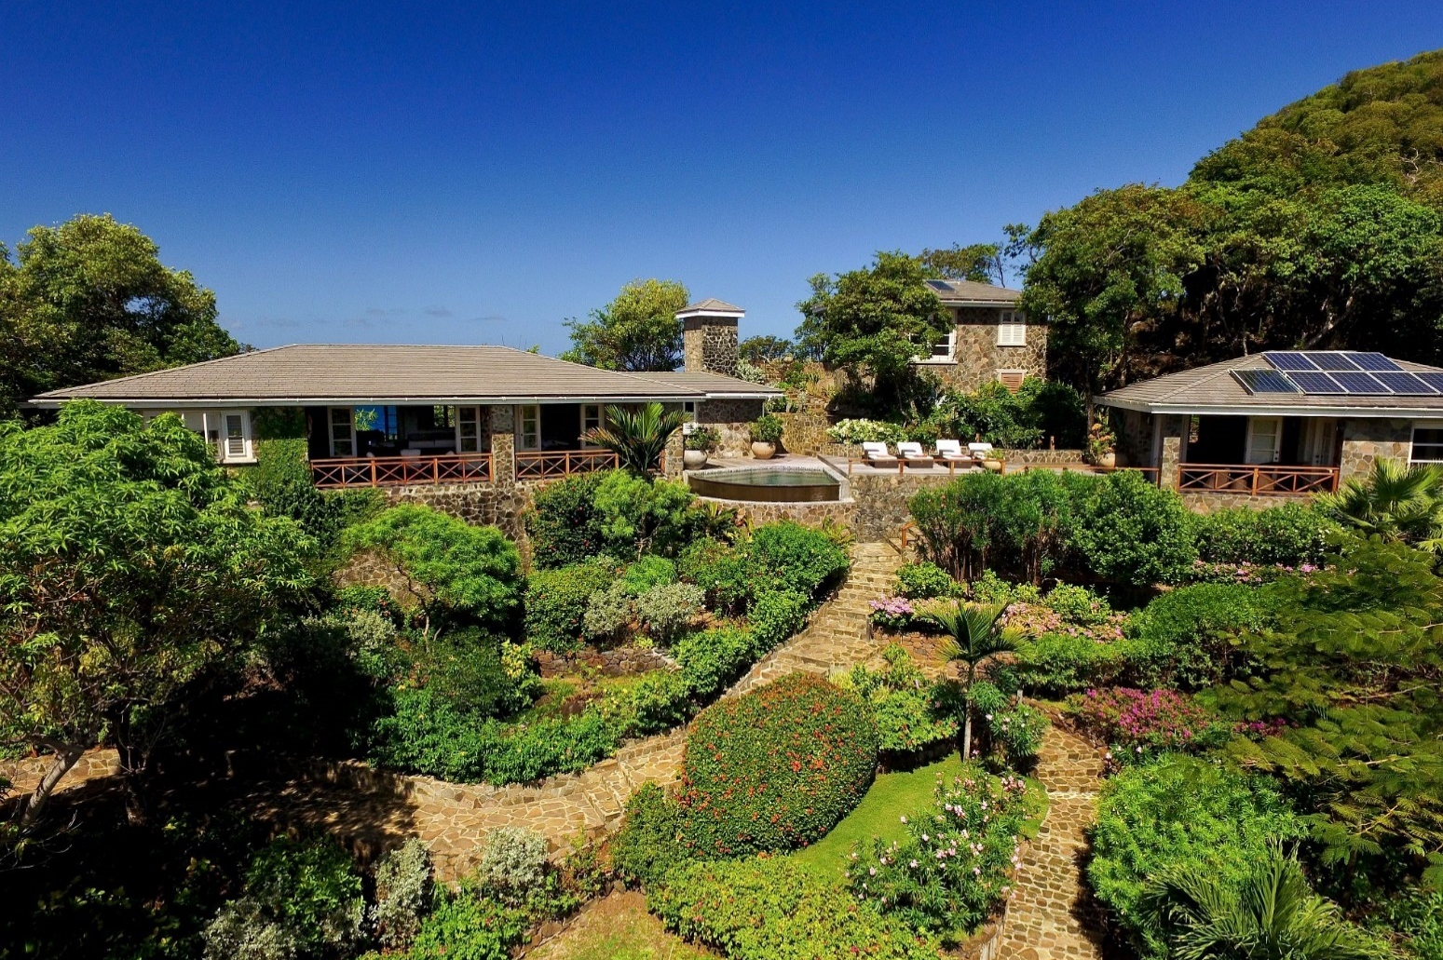



CONTENTS PAGE
- SANDROCK VILLA
Welcome letter Page 1
Contacts Page 2
Sandrock Villa Page 3
Floorplan/Fire Escape Plan Page 4
Amenities Page 5-6
Meal preparation and shopping fees Page 7
Moonhole Page 8

- BEQUIA
Bequia Island Page 9
Useful Information Page 10-11
Getting around Page 12-13
Admiralty Ferries Sailing Schedule @ Apr 25 Page 14
Bequia Express Sailing Schedule @ Apr 25 Page 15
Maps Page 16
Beaches Page 17-18
Supermarkets / Shops / ATM Page 19
Restaurants / Nightlife Page 20-21
Attractions / Activities Page 22-25
Sailing / Charters Page 26
Calendar of events Page 27-29

- ST VINCENT AND THE GRENADINES
St Vincent and The Grenadines Islands Page 30
Attractions / Activities Page 31-32

- TIPS AND REVIEW Page 33
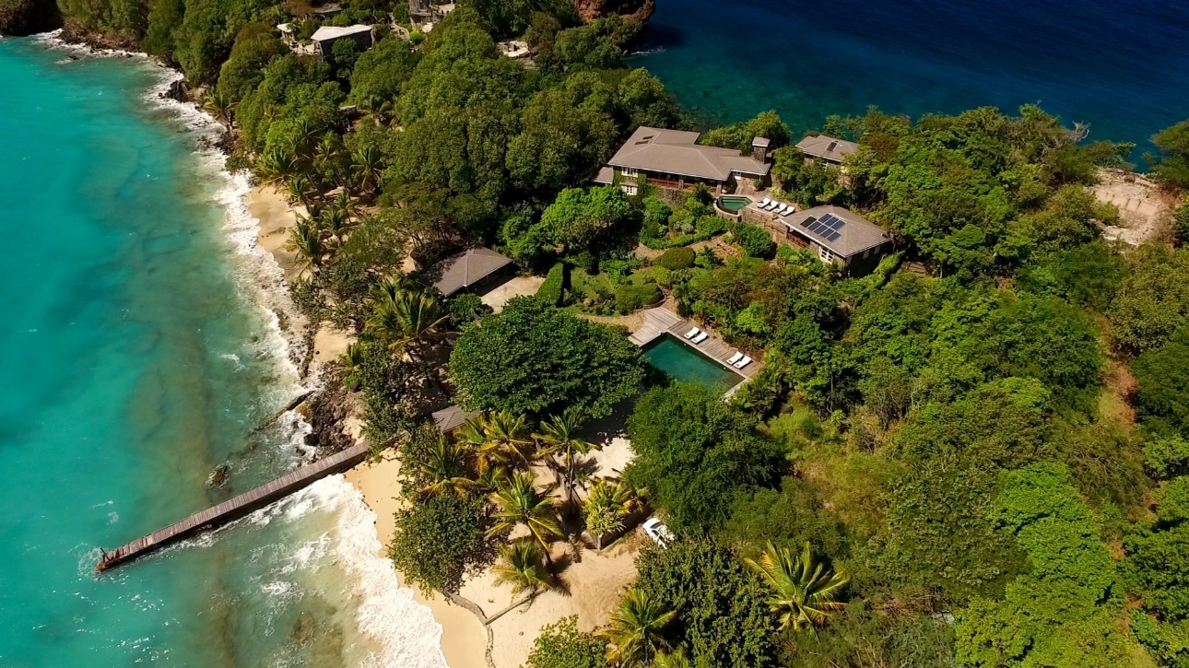
WELCOME TO SANDROCK VILLA
Thank you for choosing to stay at Sandrock Villa, situated on the beautiful Caribbean Island of Bequia. We hope you have had a pleasant and comfortable journey.

Now is the perfect time to relax and begin enjoying your holiday.

To welcome you, we have arranged a selection of welcome drinks and nibbles.

Please note this may vary.

Beers, soda water, tonic water, orange juice, bottled water and a bottle of red or white wine.
Fish cakes, samosas, hot wings or chips and a dip.

We wish you a pleasant and relaxing stay at Sandrock Villa. If there is anything we can do to improve your experience or if you require any additional information, please be assured that we are always here to help.

Before you leave, we also invite you to share your thoughts in the guestbook or leave a review via the QR code on the postcards provided which you will find located in the lounge area.

Yours faithfully

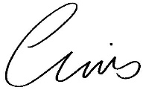

Chris and Claire Thompson
Sandrock Villa, Proprietors

CONTACTS

HOW TO CALL BEQUIA FROM THE UNITED KINGDOM

00 Exit code when making an international call from the United Kingdom

1 Bequia city code must be dialled next
784 Bequia city code

SANDROCK VILLA ADDRESS / TELEPHONE NUMBERS
Sandrock Villa, Moonhole, Bequia, St Vincent & the Grenadines, PO Box 321
Landline: +1 (784) 457 3968
Guest mob: +1 (784) 455 6020

SANDROCK VILLA CONTACTS
Property Manager - Cassie Hazel
Mob: +1 (784) 532 8309
Email: cassiehazell1@outlook.com

Housekeeper - Mathew Mc Intosh
Mob: +1 (784) 433 9169
Email: mmcintosh641@gmail.com

LOCAL EMERGENCY CONTACTS
IN ANY EMERGENCY DIAL 999
Police Station, Port Elizabeth +1 (784) 458 3350
Police Station, Paget Farm +1 (784) 458 3250
Hospital, Port Elizabeth +1 (784) 458 3294
Doctor Lugo (Private) +1 (784) 528 1955
Clinic, Paget Farm +1 (784) 458 3302
Imperial Pharmacy Ltd +1 (784) 458 3373

There is no hospital on Bequia. However, there is a small, but basic clinic with a trained doctor in attendance. Bequia is a small and relatively undeveloped island, and as such it does not have sophisticated health care facilities.

The nearest hospital is in St Vincent, which is accessible by boat.

We strongly recommend that you bring an adequate supply of any medication you regularly take and, as always, ensure you have comprehensive medical insurance before you travel.





If you need anything – just ask!

Thank you for choosing us, from your Sandrock Housekeeping Team

SANDROCK VILLA
Laid back luxury living from its perfectly located ridge-top position on the southern-most tip of Bequia. Guests can enjoy both sunrise & sunset views from the beautifully landscaped grounds. The position is truly unique, with the Caribbean Sea just steps behind the property and panoramic views of the Atlantic Ocean.
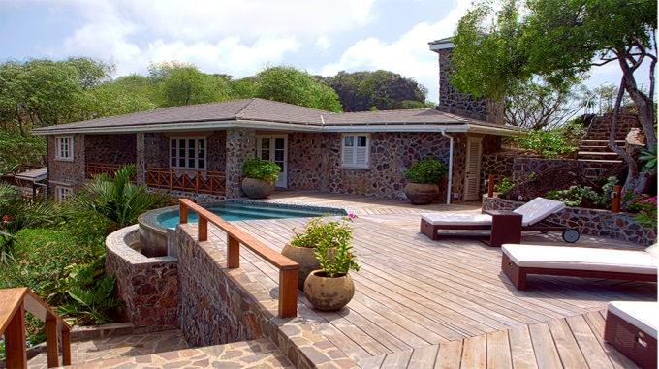
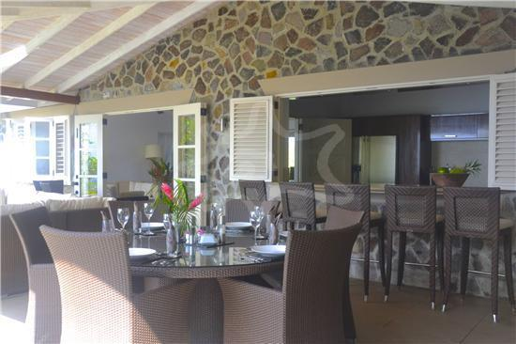
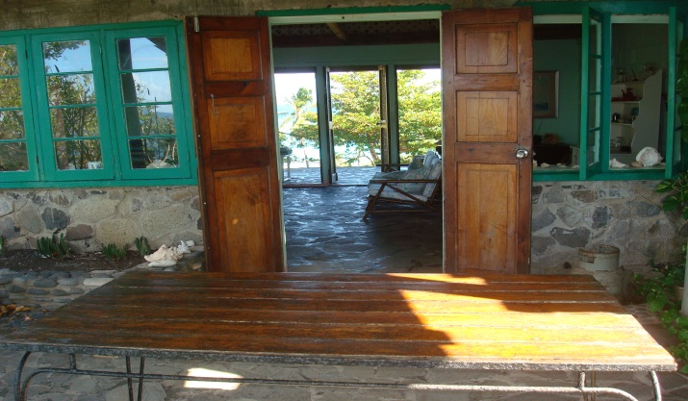
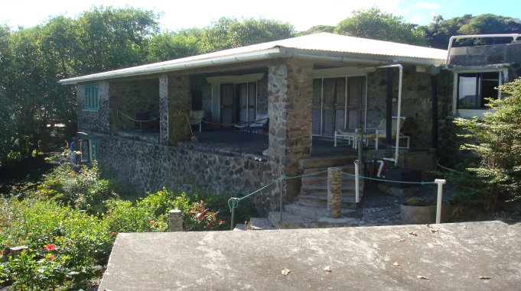
The villa comfortably sleeps ten with five spacious, air-conditioned bedrooms, each with an immaculate private bathroom and superlative ocean views. The main living space has a well-equipped kitchen and ample indoor/outdoor lounging space, dining area with comfortable, modern furnishings.
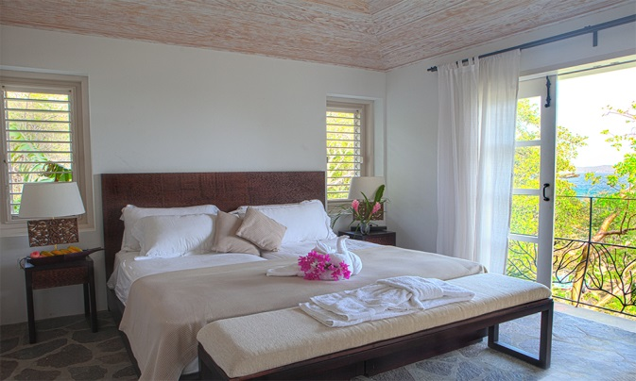
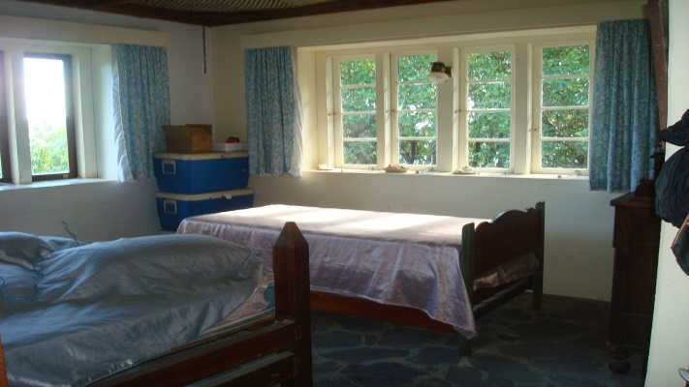
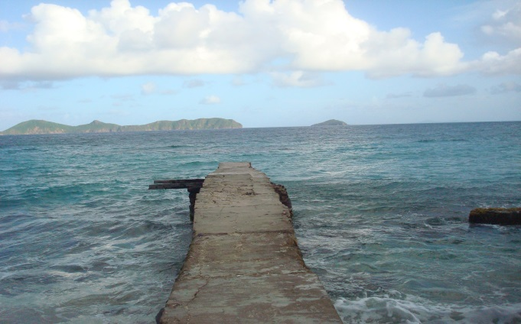
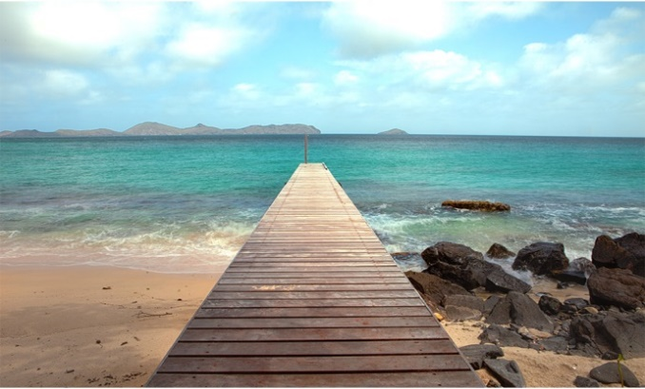
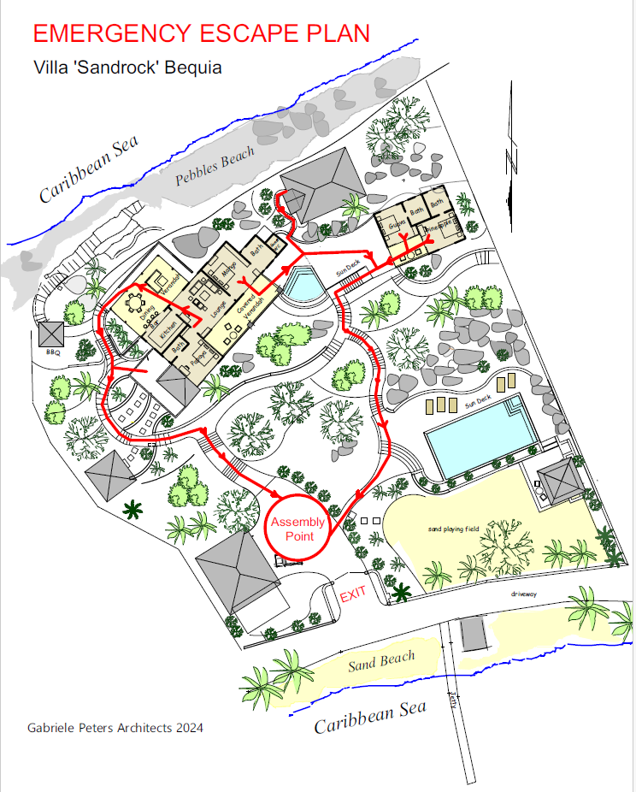
FLOORPLAN

AMENITIES

AIR CONDITIONING
Please only use the air conditioning when you are in your room and ensure all windows and shutters are closed to enjoy the maximum benefit. During the day, feel free to open the windows shutters to enjoy the Caribbean breeze.

You may leave all external doors in the lounge open overnight to enjoy the breeze.

BBQ
There is a BBQ located at the rear of the villa, outside – please enjoy it.

COOL BOX
A portable cool box is available for use by guests - please ask Matthew if you would like to use the cool box.

DISHWASHER
Please speak to Matthew for instructions on how to use the dishwasher.

FIRE EXTINGUISHERS/EVACUATION PLAN
One fire extinguisher is located within the tall cupboard in the kitchen.
One fire extinguisher is located in the generator room.
An evacuation plan is visible on the rear of each bedroom door (see a copy on page 4 also).

FIRST AID BOX
A first aid box is located in a drawer in the Guest WC next to the plunge pool.

HAIRDRYER
There is a hairdryer located in each bathroom.

IRON
The iron & ironing board is located in the tall cupboard in the kitchen.
Housekeeping also has an iron/ironing board if required.

LOCKS
Two keys to lock the main entrance door (handle lock & deadbolt key).
Two keys to lock bedrooms 3 & 4 (handle lock & deadbolt key).
Bedrooms 1 & 2 (in the main house) do not have locks.

MOSQUITO NETS
Please use the mosquito nets provided over your bed. Be careful not to sit on them as they tear easily. If you require your rooms to be sprayed with insect repellent and the air conditioning switched on before you retire for the evening, please let Matthew know.

SAFE
There is one safe located in Bedroom 1, please ask Matthew for the code.

SMOKING
Please do not smoke in the house – we want to ensure that Sandrock Villa is a smoke free zone.

SNORKELLLING/SWIMMING EQUIPMENT
Snorkelling equipment and swimming aids are located in the hut next to the large pool.

SONOS AUDIO SYSTEM
Sandrock villa is equipped with a Sonos audio system that can be connected to your device.

Sonos name: Sonos

SUN LOTION P20
Sun lotion with P20 causes non removable stains on the bed linen. If you do use this product, please shower before going to bed.

SUN LOUNGERS
Cushions for the sun loungers near the large pool are located in the hut next to the large pool and cushions for the sun loungers near the plunge pool are located in the cushion box on the veranda.

TELEPHONES
Most mobile phones will work in Bequia however it is advisable to check with your service provider before travelling to confirm roaming facilities and texting options.

TRAVEL COTS ARE AVAILABLE UPON REQUEST

WASHING MACHINE/LAUNDRY
Cleaning services to bedrooms and bathrooms will be 3 times a week.
(Tuesdays, Thursdays and Saturdays).

Bed sheets will be changed once weekly.
Bathroom and beach towels will be changed 2 times a week.
(to conserve water as all water for washing is collected natural rainwater).

ADDITIONAL CHANGES OF BED LINEN AND FRESH TOWELS ARE AVAILABLE IF REQUIRED

Laundry service is available for smaller items of clothing – place them in the laundry baskets provided in your room and housekeeping will deliver them back to the lounge area.

PLEASE SPEAK TO MATTHEW FOR INSTRUCTIONS ON HOW TO USE THE WASHING MACHINE FOR LARGER ITEMS.

On arrival sunbed cushions will be on the sunbeds and beach towels are provided.

WATER IS PRECIOUS IN BEQUIA, PLEASE USE IT CONSCIOUSLY

WI-FI

Free internet access for all guests to use throughout the villa.

Wi-Fi name: Sandrock
Password: Christopher

GENERAL GUIDE

Please shower before using the pools.

Please use the footbath and tap provided near the garage before ascending the steps to the villa.

We ask our guests to help us in our quest to recycle glass bottles, please keep them separate in one of the kitchen bins provided or in the crate they have been delivered in.

Feel free to use the washing up liquid/dishwasher tablets and other household items below the sink in the kitchen.


YOUR SAFETY AND WELLBEING ARE VERY IMPORTANT TO US AND WE ASK THAT CHILDREN ARE SUPERVISED BY AN ADULT AT ALL TIMES ESPECIALLY AROUND UNFENCED AREAS, SWIMMING POOLS, BALCONIES AND WATER.

SERVICE FEE FOR PREPARING ALL MEALS

MEALS CAN BE PREARRANGED DIRECTLY WITH MATTHEW IN ADVANCE OF YOUR STAY

2-4 GUESTS
Breakfast, lunch and dinner 200 USD
If only for dinner 100 USD, only breakfast 50 USD, only lunch 50USD

5-8 GUESTS (to include an assistant for dinner)
Breakfast, lunch and dinner 250 USD
If only dinner 150 USD, only breakfast 50 USD, only lunch 50 USD

9-10 GUESTS (to include an assistant for dinner)
Breakfast, lunch and dinner 300 USD
If only dinner 200 USD, only breakfast 50 USD, only lunch 50 USD

MEAL PREPERATION FEE TO BE PAID DIRECTLY TO MATTHEW

SHOPPING SERVICE FEE

Please let Matthew know if you require any provisions, Matthew has good local knowledge of what provisions and services are available – please feel to ask him.

A FEE OF 10% OF THE VALUE OF GROCERIES TO BE PAID DIRECTLY TO MATTHEW

PLEASE ASK IF YOU WOULD LIKE TO SEE SANDROCK VILLA’S GUIDELINE MENU

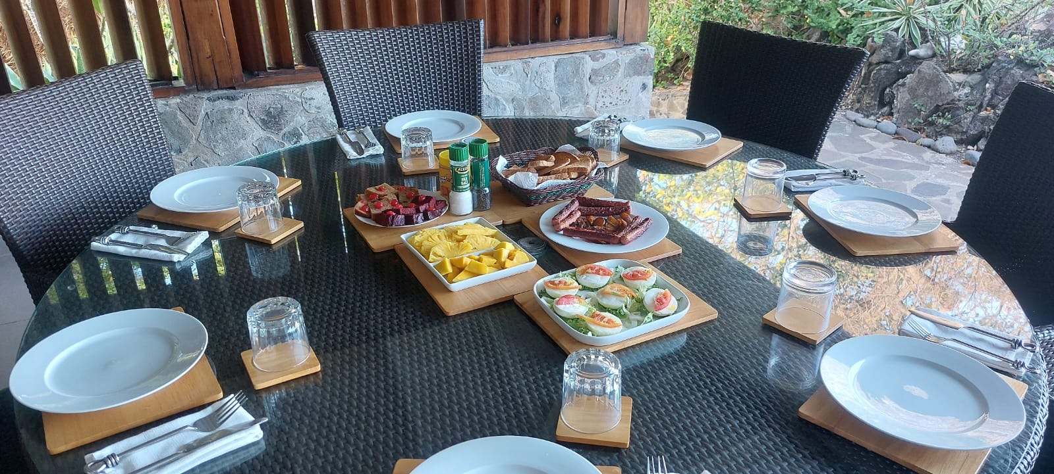

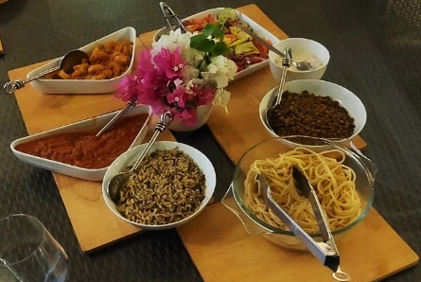
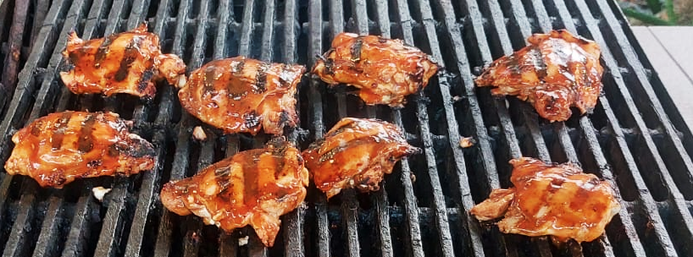

MOONHOLE HOUSE

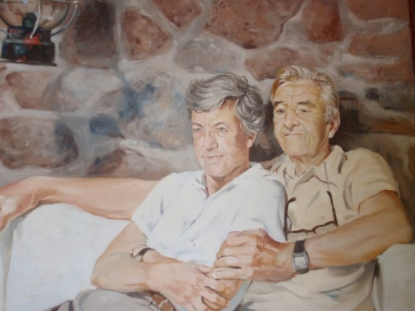
Tom and Gladdie Johnston retired from the advertising business in the United States and moved to Bequia to run the Sunny Caribbee Hotel in the late 1950s. The family that owned the uninhabited western end of Bequia invited them to visit the giant natural rock arch known as Moonhole. At the time that end of the island was accessible only by footpath or by boat.

Tom and Gladdie trekked to the site, picnicked beneath the arch, and followed the rough path to the western tip of the island. The rock arch soon became their favourite spot on Bequia.

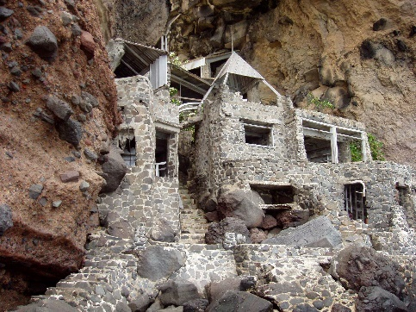
Tom lit on the idea of building a campsite underneath the rock arch. Landing supplies and building materials by boat and enlisting the assistance of some hardy men of Paget Farm, he began building, stone by stone. With no formal training as an architect, Tom relied on plans he sketched in the sand and a trial-and-error approach to construction. He picked up whalebones, driftwood and shells and incorporated them into the structure. The campsite soon evolved into a house with a working kitchen, dining area and bedrooms. After much cajoling, Tom eventually convinced Gladdie they should make Moonhole their home.

The Moonhole house caught the attention of curiosity-seekers and Tom’s reputation spread far and wide. Many publications, including The New York Times, National Geographic Society Publications, and Sports Illustrated, featured Tom's creations at Moonhole. At the urging of friends, Tom agreed to build houses for them. He aimed to develop the Moonhole property as what he called a "people preserve."

Tom and Gladdie formed Moonhole Company Limited in 1964 and transferred title to the lands to the company. Working side by side with carpenters and masons from Paget Farm over thirty years, Tom built sixteen more houses, a commissary and office, living quarters for the burgeoning Moonhole staff, and a Gallery where Moonholers congregated every Sunday.

Rather than cut down trees, Tom built around them. Trees still grow up through the middle of living rooms, bedrooms and decks. Every house was built with stones harvested from the land. Stone paths provide access to all houses, as Tom would not countenance putting a road into the property. Solar panels now power most houses and rain collected in huge cisterns supplies water.
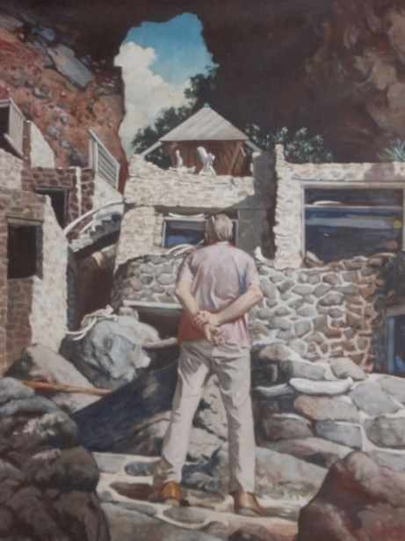
The Johnstons presided over the Moonhole community for more than 40 years with an indomitable spirit of "Happiness Now!" Gladdie took care of business matters, tempering with common sense some of Tom’s creative urges. An accomplished artist, Tom created scrimshaw sculptures from the bones of whales captured by Bequia whalers. His sculptures adorn houses at Moonhole and around the world.

Tom and Gladdie were devoted to the people of Paget Farm, who built and staffed Moonhole. The Johnstons provided not only jobs, but also assistance with medical and educational expenses. They set up a private charity called Moonhole Friends, Inc. which continues to help needy persons in Bequia today.

www.moonholecompany.com
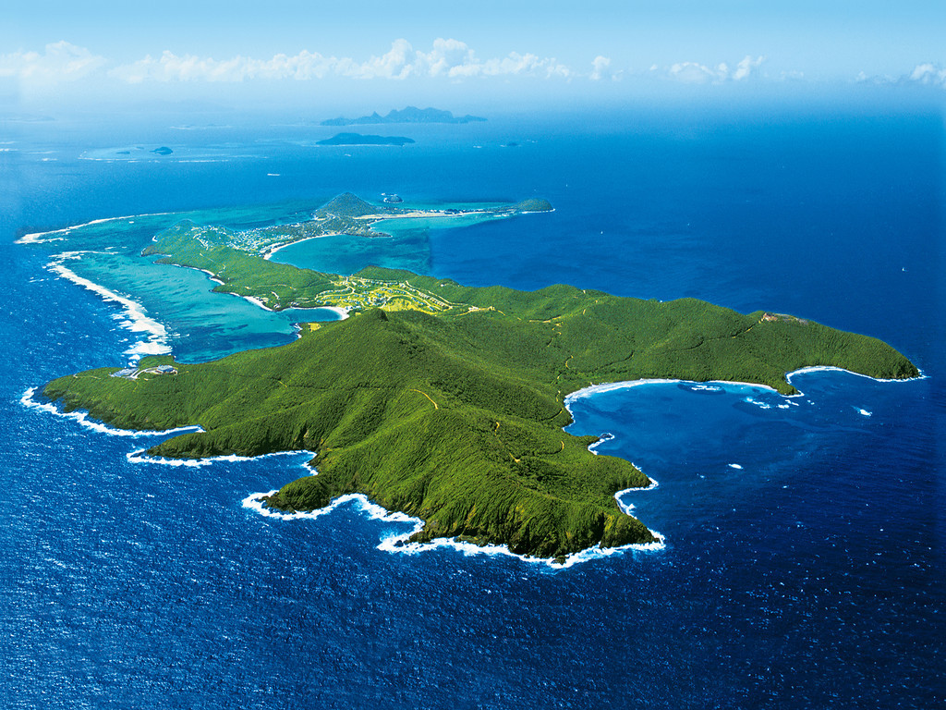
BEQUIA ISLAND

Beautiful Bequia (pronounced bek way) was named by the Arawak Caribs and means island of clouds. It is an undiscovered paradise, the Caribbean of 30 years ago. Covering an area of just 7 square miles and with a population of only 6000, Bequia lies in the warm tropical waters of the Caribbean Sea. It is just a short plane hop from the ever-popular Barbados and next to the renowned Mustique, both favourite islands of the rich and famous. It is the largest of the Grenadine Islands known also as the ‘Jewels of the Caribbean’ and is blessed with several pristine, white sandy beaches many of which are totally natural and undeveloped. The recently renovated Belmont Walkway joins three of these beautiful beaches together and meanders around two headlands offering both excellent
snorkelling and a leisurely 2-mile walk passing rum bars, cafes, restaurants and small boutique style shops.

Bequia truly is a unique Island. Large enough to be interesting and exciting, yet small enough to retain its local charm and uniqueness that only a small ‘off the beaten track’ Caribbean Island can offer. Wherever you go on Bequia, you will be given the warmest of welcomes. They know you are here to relax, and everyone is happy to help you have the holiday of a lifetime.
If you want resort hotels, nightclubs and beaches full of sunbeds, don’t come to Bequia. If you want to discover the undiscovered, visit our beautiful Island, enjoy the uncrowded pristine white sandy beaches, swim and snorkel in our safe and warm Caribbean waters and experience the genuine friendliness of the local Bequian people.

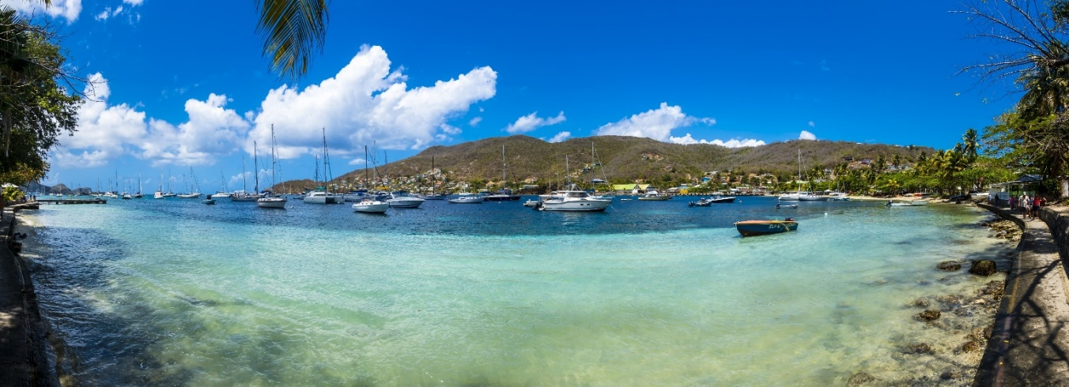

USEFUL INFORMATION

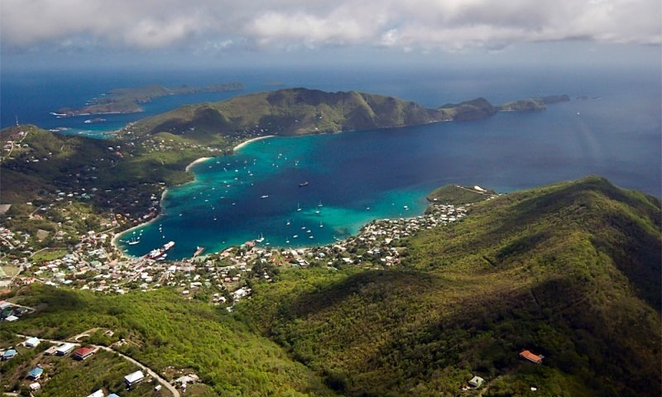

CLOTHING
Bequia is an informal island. Even the best restaurants are fine with smart casual. Women and men should wear swimsuit cover-ups in the town. Topless/nude sunbathing is not acceptable. Camouflage clothing is illegal wear for civilians, please do not wear it, to avoid problems.

CREDIT CARDS AND CURRENCY
Major credit cards are accepted by most hotels, car rental companies, and shops. The Eastern Caribbean Dollar (EC$) is the local currency and is tied in value to the US dollar. Many establishments will accept payments in US Dollars with change being given in local currency, but smaller establishments, or beach/street vendors, may only accept EC Dollars.

DIVE GEAR/C-CARD
There are currently two Dive Shops on Bequia and both have quality, well serviced gear waiting for you if you'd like to travel lightly. You are of course welcome to bring your own gear. Dive skins or light weight wetsuits are also available though not a necessity. Spear fishing is illegal by visitors.

ELECTRICITY
Electricity is 220V, the outlet format is the same as the UK (3-pin plug). Sandrock villa has 4 x multi adapters and 2 x USA adapters for use by guests.

Please also turn off any unnecessary lights when you retire for the night

LANGUAGE
English is the official language. French Pato is likewise spoken.

LOCATION
Nine miles south of St. Vincent (45 min. by ferry, 10 min. by air), 45 min. by air west of Barbados, 30 min. north of Grenada, 20 min. south of St. Lucia, 2 hr. 20 min. southeast of Puerto Rico.

PESTS AND ANIMALS
While Bequia has very few crawlies, tropical places do produce tropical insects, and mosquitoes can be a nuisance. We recommend corresponding protection against mosquito bites, e.g. mosquito nets, anti-mosquito sprays or liquids.

There are no poisonous snakes and very few wild mammals. The only wild mammal is the Manicou (Possum like), Geckos and larger iguanas can be seen sunning themselves if you take walks around the island. Mockingbirds, Bananaquits, Blackbirds, Frigates, and Antiguan hummingbirds, are a few of the many birds you'll see and hear around the island.

SAFETY
Virtually all the thousands of visitors to Bequia each year have happy and trouble-free holidays. This is a friendly island and visitors are very much welcomed. However, even in these idyllic surroundings you should not become complacent about safety and security.

SEASONS
The "dry" season from December/January to late April/early May coincides with the "high" season for visitors, with clear sunny skies, good sailing breezes, low humidity and minimal rainfall. The island is totally reliant on rain for its water, so the arrival of the "rainy" season in May/June is always a blessing.

The warmer, summer months of May to November are a welcome mixture of cooling showers, sunshine and light breezes, with the occasional heavy downpour.

Bequia is far south in the hurricane belt, and although tropical storms will occasionally approach in the peak months of August to October, most disturbances either pass to the north or dissipate before they reach.

TIME
The time difference with GMT is April to October -5 hours / November to March -4 hours

TIPPING
Usually, a 10% service charge will be added to your restaurant bill, but some do not, so check your bill before you settle. Additional gratuities are at your own discretion.
VALUABLES
Lock up as you would at home and we would advise you use the safe provided. It is sensible to only carry a minimum amount of cash with you when you are out, and we would suggest that you do not take valuables to the beach or leave possessions on view in your hire car.

WATER
Tap water is safe to drink but bottled water is recommended. There is no government water supply on Bequia, and rainwater is collected from the roof and stored in tanks. During the dry season (January to June), there is little rain, and water must be used carefully and sparingly.

WARNING
Manchineel is one of the most toxic trees in the world. The tree has a milky-white sap containing toxins that cause painful burns, and the sap is present in every part of the tree. The bark, the leaves and the fruit can cause severe blistering, and the burns spread when the blisters break open.

If you carelessly take shelter under a manchineel tree when it’s raining, the water dripping from the leaves will cause blistering wherever it touches you.

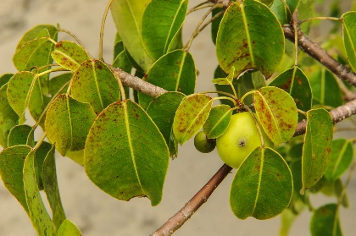
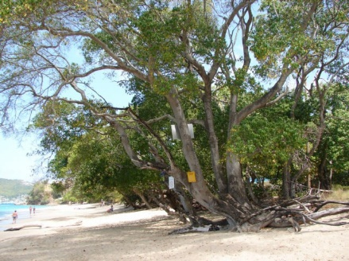
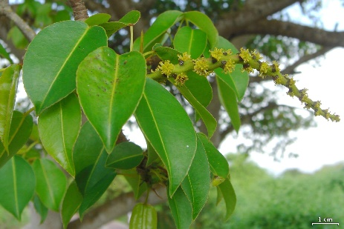
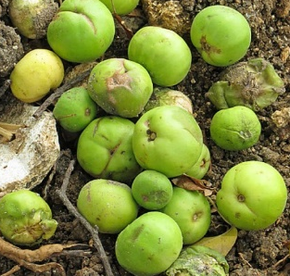
The manchineel apples, referred to by Christopher Columbus as “mazaniya de la muerte” (little apples of death) CAN BE FATAL IF INGESTED. They resemble harmless green crabapples, but if eaten will cause severe gastroenteritis with bleeding and terrible burns to the airway

WEATHER
Daytime temperatures consistently average between 26C (79F) and 30C (86F) throughout the year. A "chilly" evening in the winter months (January to March) might see a low of around 21C (70F) and in the summer months the temperature will occasionally reach 32C (90F). Tradewinds bring cooling breezes for most of the year; the famous Christmas Winds bring stiffer steady breezes, lively seas and perfect sailing weather.
GETTING AROUND
Bequia is only 7 square miles in size. To put into context, London’s Heathrow Airport is slightly bigger!

End to end, it’s around 5 miles long and as little as half a mile wide at it leanest point between the Caribbean Sea of Lower Bay & Atlantic Ocean at Friendship Bay!

Transport options are reliable & cost-effective on Bequia with “dollar vans” that cost from $1.50 and open-sided pickup truck taxis offering private transport for a price agreed with the driver (full & half day island tours also possible).

The roads on Bequia are in relatively good condition, but might seem challenging at times due to narrow passages and steep inclines. Do not let this deter you from driving on the island as drivers on Bequia are very friendly and usually drive slowly, giving way where necessary.

Due to its history as a British colony, driving is on the left-hand side throughout the country and on many other Caribbean islands.

CAR RENTAL’S
There are several companies that offer car, jeep and motorbike rental for both daily and weekly rates on the island. The rates depend on the size and additional amenities that the vehicle may come with.

D&N Car Rentals
Tel: +1 (784) 45830664 / 5937222
Email: noeltaxi@vincysurf.com
Web: www.bequiarentalcars.com

B&G (Gideon) Jeep Rental
Tel: +1 (784) 458 3760 / 5272092
Email: gideontaxi@vincysurf.com
Web: www.bequiajeeprentals.com

DOLLAR VANS
Often crowded, never dull, these closed vehicles are the cheapest way to get around to most parts of the island. Pick them up in Port Elizabeth (enquire at the Tourism Office for the regular routes and stop-offs) or simply hail one as it approaches and ask them if they are going you way! Fares vary from EC$1 to EC$5 per person (payable once on board) depending on the length of journey

DRIVING LICENCES
Drivers holding a foreign driving license are legally required to purchase a local driving permit for a nominal cost.

These are available from the Revenue Office in Port Elizabeth on production of a valid national or international driving licence from your own country, and payment of a fee of EC$100 (about US$ 40). It is valid for 6 months.

INTER-ISLAND FERRIES
A regular and efficient ferry service operates between Bequia and Kingstown, St. Vincent, with two Bequia based companies operating seven days a week. Each ferry has an air-conditioned saloon, bar and snack bar, or you can choose to sit up on deck and enjoy the sea air.

The boats carry passengers and cargo, trucks and supplies from "the mainland" to Bequia and the arrival and departure of each ferry in Port Elizabeth is a lively buzz of activity even at 6.30am in the morning!

Either one-way fares or return fares (any time - with the same ferry company) are available and you pay when you board.

TAXI’S

Bequia's famous open-backed taxis are well known for their courteous and friendly operators. Taxis are widely used for getting around and cost circa US50-60 per return trip anywhere on the island

Fat Man Taxi’s
Tel: +1 (784) 593 7336

Gideon's Taxi & Rentals
Tel: +1 (784) 458 3760 / 5272092
Email: gideontaxi@vincysurf.com
Web: www.bequiajeeprentals.com

WATER TAXIS
You will normally find a water taxi operator on the dock at the Frangipani or Gingerbread docks if there are none in sight just stand at the end of the dock and one will soon appear.



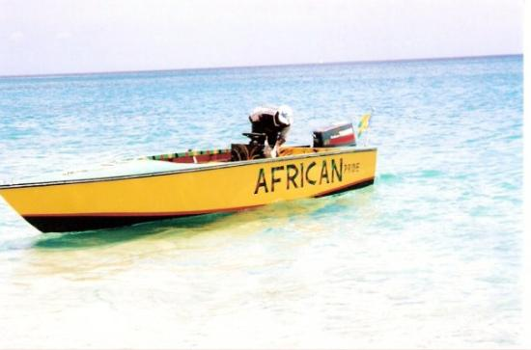
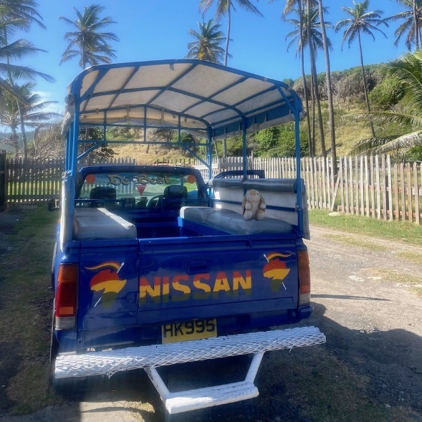
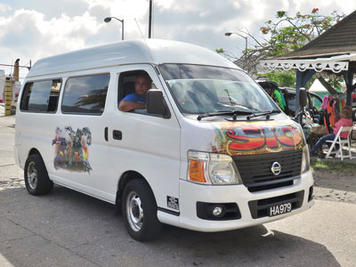

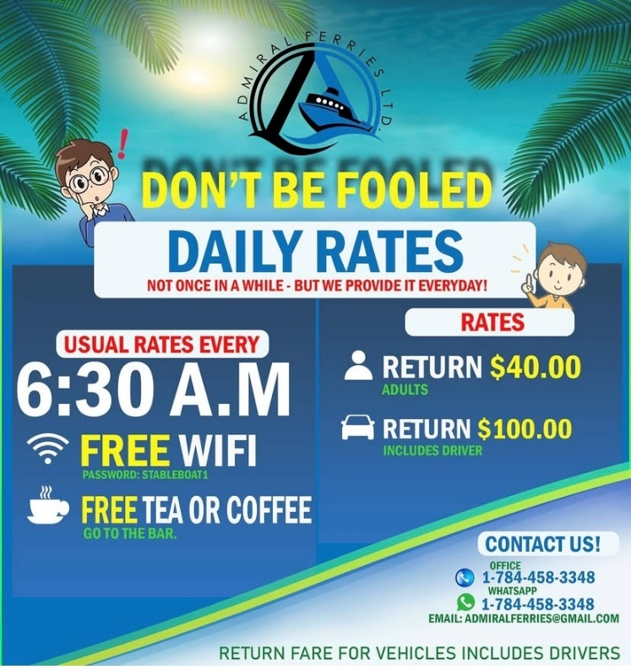
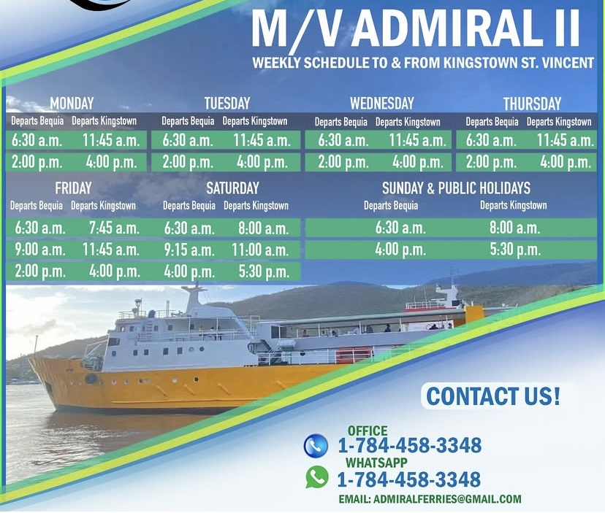
Admiralty Ferries (SCHEDULE AT APRIL 2025)
Tel: +1 (784) 458 3348
Whatsapp: +1 (784) 458 3348
Email: admiralferries@gmail.com

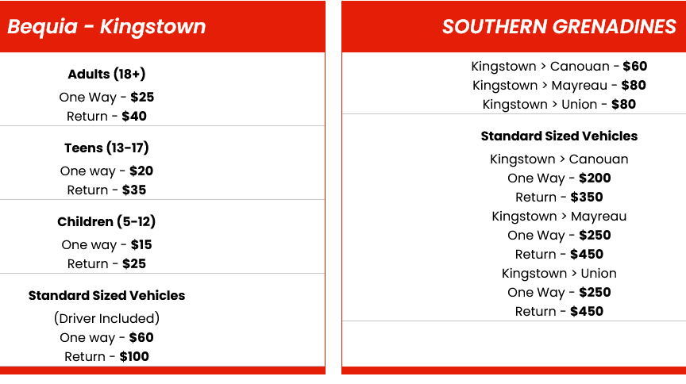
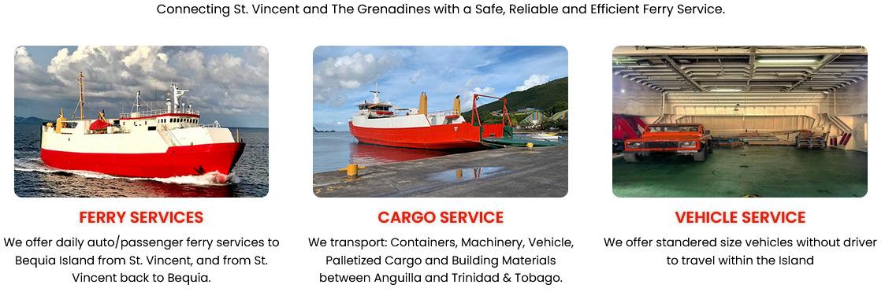
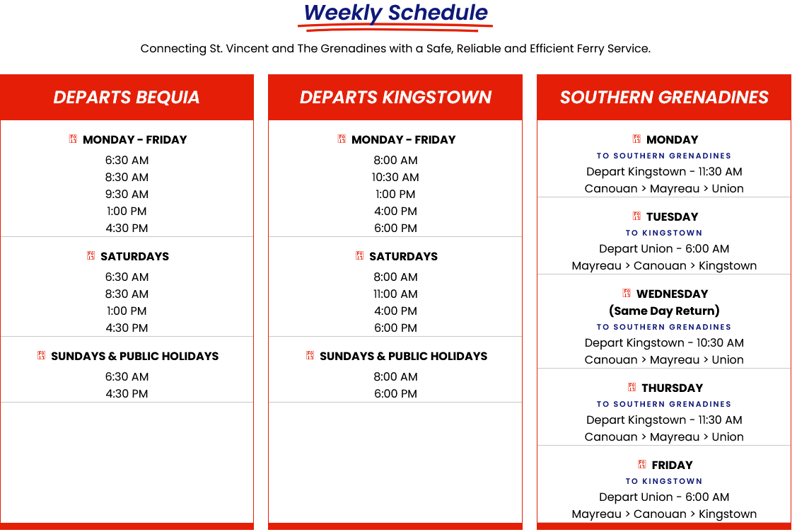

Bequia Express (SCHEDULE AT APRIL 2025)
Tel: +1 (784) 457 3539
Email: info@bequiaexpress.com
Web: www.bequiaexpress.com
MAPS
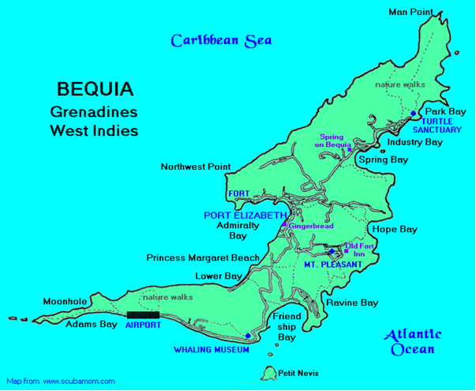

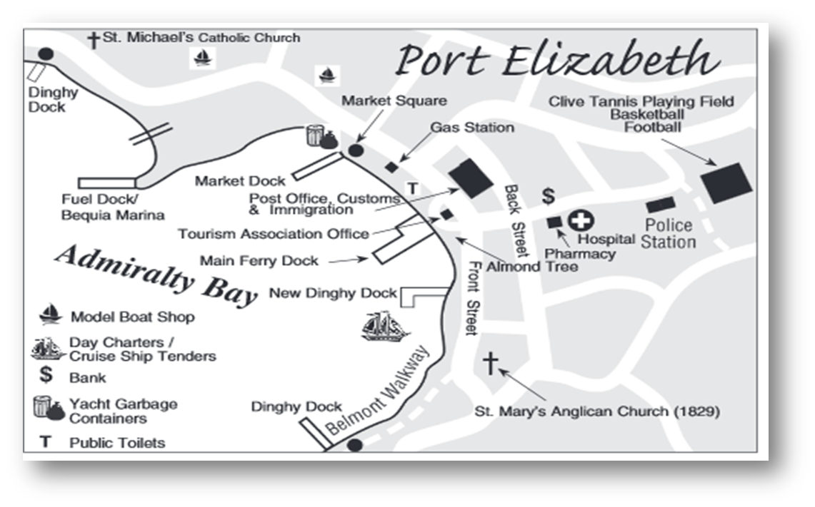

BEACHES

Bequia has a wonderful and varied assortment of beaches for swimming, snorkelling, and sunning. Their best feature is you will never find a crowd! Below are some of the beaches Bequia has to offer. Inquire locally for current conditions and characteristics, as they can change due to weather and other factors. If you plan to hike to a remote beach, let someone know where you are going and ask for directions. One other note, nude and topless sunbathing is against the law. Sunscreen, hats and cover-up are advised and drink plenty of water, to remain hydrated.

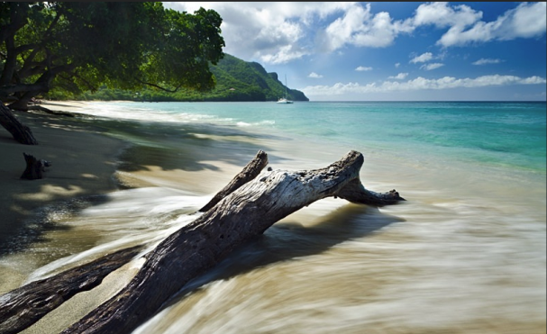
LOWER BAY

On the Caribbean side Lower Bay and Princess Margaret beach are the calmest beaches. Good for snorkelling off the headland. Sometimes you can feel you have the whole beach to yourself, but don't miss the Sunday buzz and its chilled and friendly atmosphere down at the beach with a mix of locals, visitors and music.

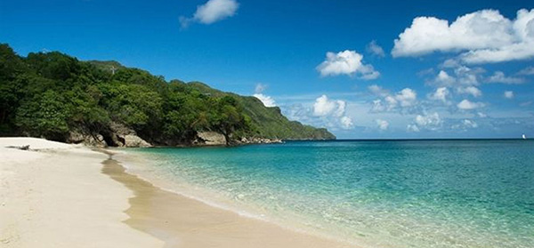
PRINCESS MARGARET BEACH
Called this since her honeymoon swim here in 1958, it is a short walk over the bluff from Lower Bay. Here you will find calm, clear sea and white sand with shade from trees along the beach, good swimming and some snorkelling. Head to Jack's Bar for lunch or a cold beer as you watch the sun go down

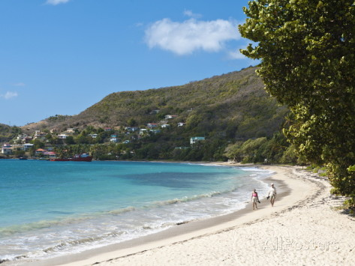
FRIENDSHIP BAY
Easy access by vehicle or walking, there are restaurants and beach bars, a long sweeping white sandy beach with shade on the Atlantic side with sometimes more movement in the sea, but waves rarely more than a foot high, also good for snorkelling along the right hand side nearer the village. Lovely views of Mustique across Whale Cay (The Whaling Station), Semple Island and Petit Nevis beyond.

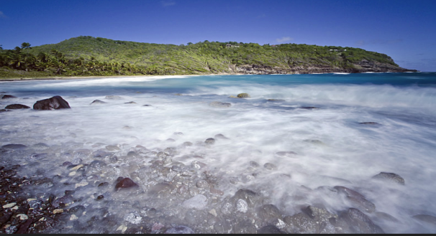
HOPE BAY
Hike in to this remote picturesque semi-secluded romantic white sand beach, good for body surfing. As there are no facilities don't forget to take water and a picnic. Be careful as sometimes there is a strong undertow, an offshore current and a powerful surf.

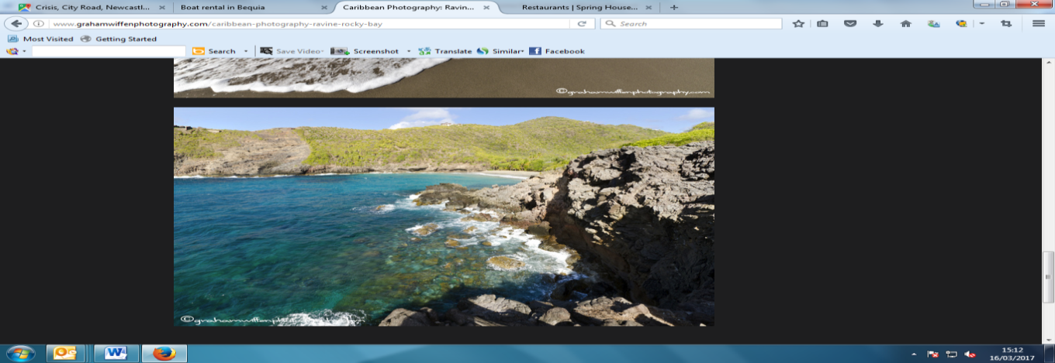
RAVINE & ROCKY BAY
Hike in to this secluded dark sand beach, picturesque with rough surf, a blow hole, and no facilities but some shade, on the Atlantic side.

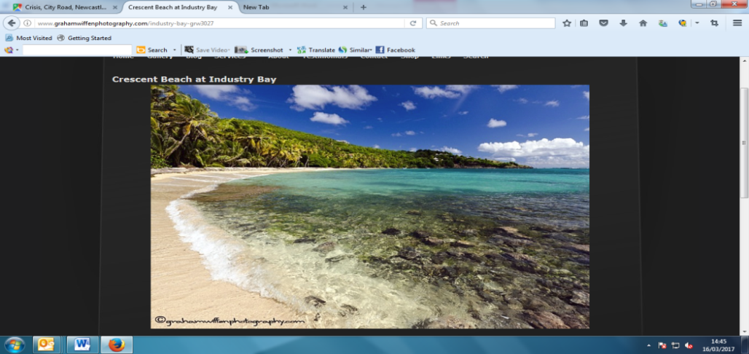
INDUSTRY BAY (CRESCENT BEACH)
Hike in or come by vehicle to this semi-secluded white sand beach with a restaurant/beach bar, shade from palms, snorkel sites and picturesque with generally calm waters as it is protected by a reef from the Atlantic waves. Cottagey, whitewashed rooms sit on the beach next to a green tin-roofed building housing a bar and restaurant.

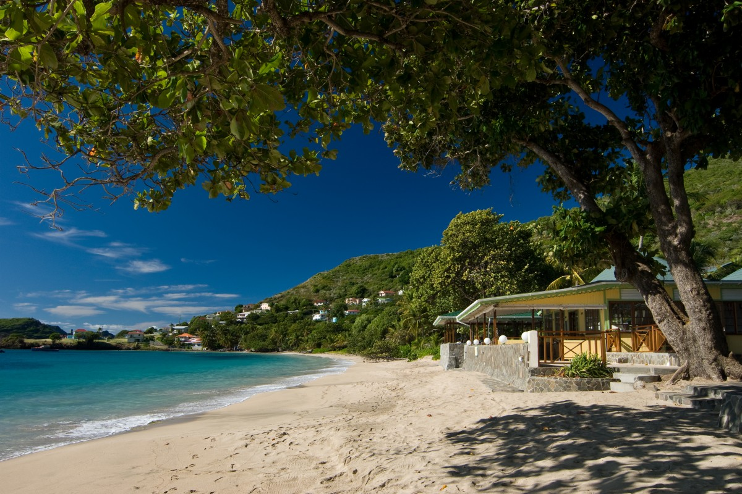
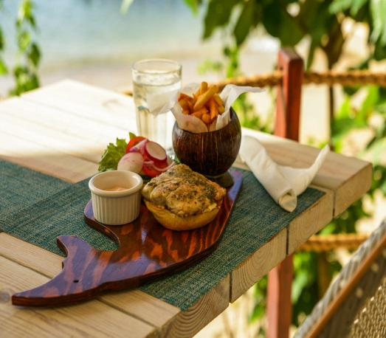
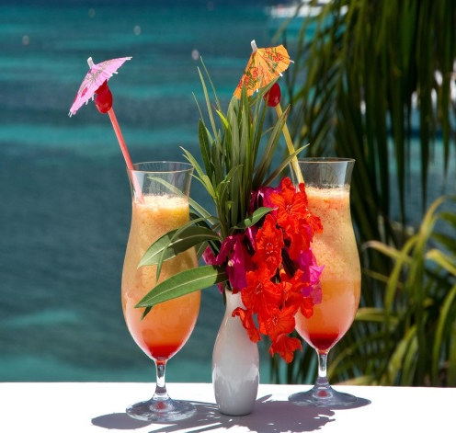
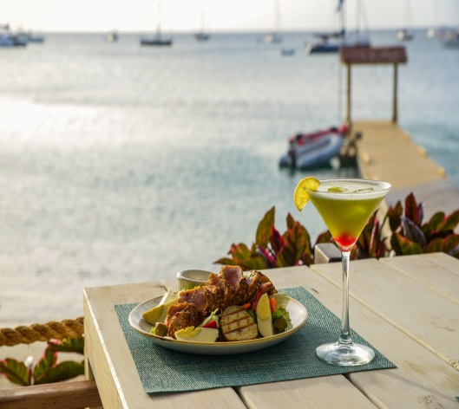

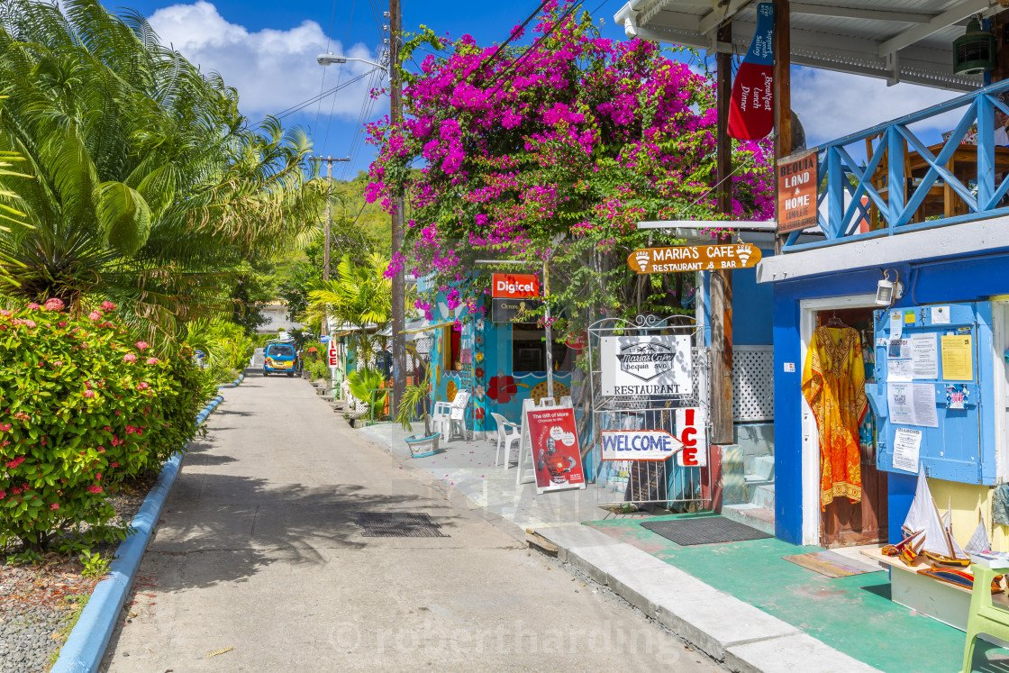
SUPERMARKETS / SHOPS / ATM

There are a few small supermarkets on Bequia and several food stores selling everything from fresh bread and cheese to breakfast cereals and milk. Fresh fruit and vegetables are available from the friendly vendors who have their stores and tables along the main street and for the experienced haggler you can venture into the Rasta vegetable market for a colourful and memorable shopping experience. Several of the small restaurants also have an adjoining store selling everyday items like fresh bread, tinned produce and frozen goods.

GROCERIES
Doris Fresh Food, Port Elizabeth Tel: +1 (784) 458 3625
Knights Trading, Port Elizabeth Tel: +1 (784) 458 3379
Knights Mini Market, Hamilton Tel: +1 (784) 458 3152
Lina’s Bakery & Deli, Port Elizabeth Tel: +1 (784) 458 3181
Mac’s Pizzeria, Belmont Tel: +1 (784) 458 3474

There are two 24-hour ATM machines in Port Elizabeth at the BOSVG bank.
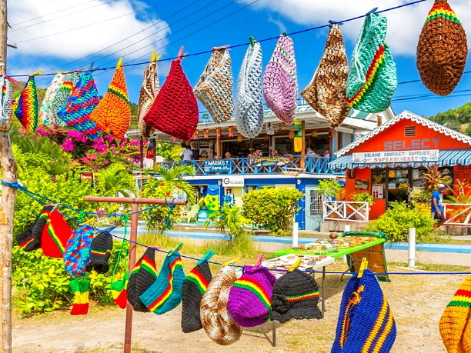
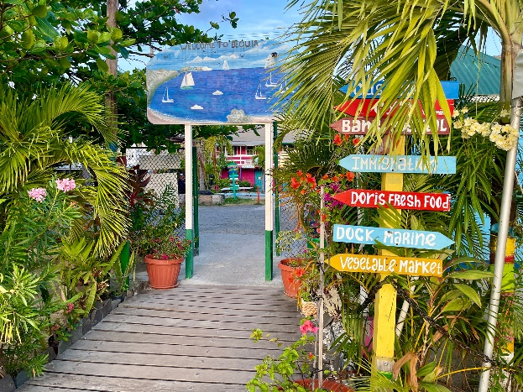

RESTAURANTS AND NIGHTLIFE

Bequia has several great restaurants, bars and cafés. Whether your preference is for international or regional dishes, there is sure to be something for you. A selection of excellent eateries serves everything from simple snacks and light bites to full Caribbean lunches and delicious fine dining. Freshly caught seafood including fish, lobster and conch is always a great option, but you will find everything from Italian pizzas, American hamburgers and world class French cuisine.

OWNER’S RECOMMENDATIONS
JACK'S BAR, Princess Margaret Beach
Cuisine: Caribbean, Seafood
Tel: +1 (784) 458 3809
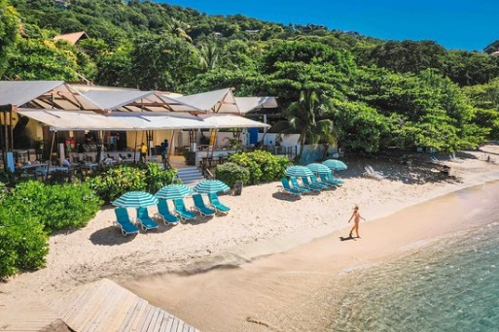
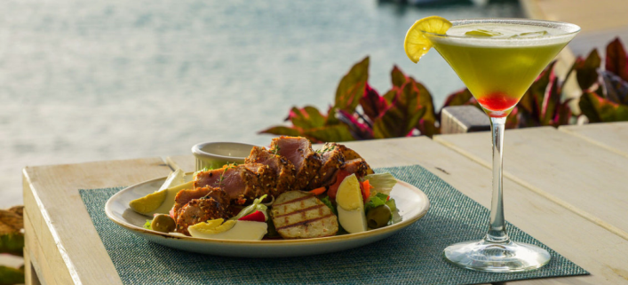
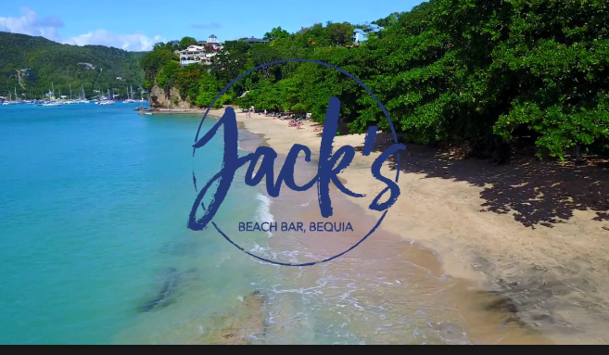
Web: www.jacksbeachbar.com

MAC'S PIZZERIA , Belmont Walkway
Cuisine: Pizza
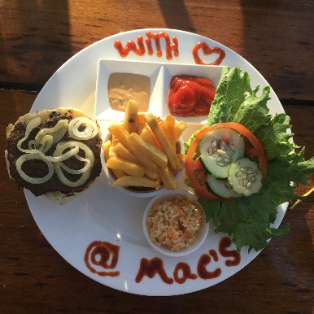
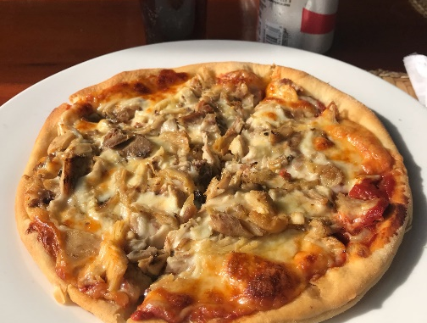
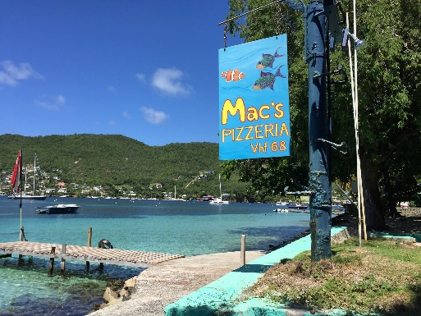
Tel: +1 (784) 458 3474

MARIA'S CAFÉ, Port Elizabeth
Cuisine: Caribbean
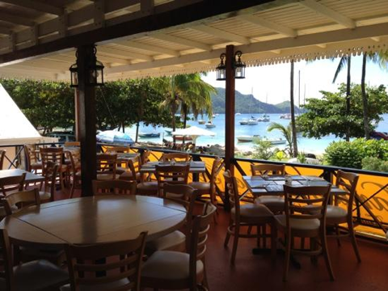
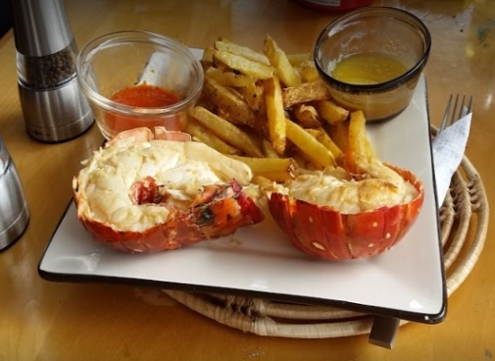
Tel: +1 (784) 458 3116
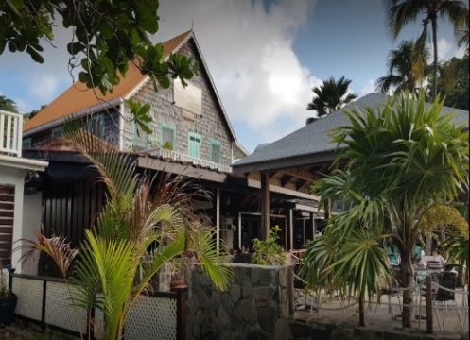

THE LIMING, Near Sandrock | Cuisine: Caribbean | Tel: +1 (784) 5330398

COCO'S PLACE, Port Elizabeth | Cuisine: Caribbean | Tel: +1 (784) 458 3463

THE FIG TREE, Belmont Walkway | Cuisine: Caribbean | Tel: +1 (784) 457 3008

FIREFLY PLANTATION, Spring | Cuisine: Caribbean | Tel: +1 (784) 532 5134

FRANGIPANI HOTEL, Belmont Walkway | Cuisine: West Indian | Tel: +1 (784) 458 3255

GINGERBREAD, Waterfront | Cuisine: Caribbean | Tel: +1 (784) 458 3800

KEEGANS, Lower Bay | Cuisine: Caribbean | Tel: +1 (784) 458 3530

WHALEBONER, Waterfront | Cuisine: Caribbean, Seafood | Tel: +1 (784) 458 3233

DAWN'S CREOLE, Lower Bay | Cuisine: Authentic creole cooking | Tel: +1 (784) 492 6508

CHERIS ROOFTOP TERRACE, Port Elizabeth | Cuisine: happy-hour food | Tel: +1 784 433 9054

DE REEF, Lower Bay | Cuisine: Caribbean | Tel: +1 784 528 4958

FERNANDOS HIDEAWAY, Lower Bay reservation only | Cuisine: Caribbean | Tel: +1 784 458 3758

PROVISION, Lower Bay | Cuisine: Global flavours | Tel: +1 784 431 0457

BAGATELLE, Bequia Beach Hotel | Cuisine: internationally inspired | Tel: +1 784 458 1600

LAURAS, Port Elizabeth | Cuisine: Caribbean | Tel: +1 784 457 3779

“COCKTAIL LAB”, Bequia Marina Ocar, only drinks no food | Tel: +1 784-433-8218

“Figtree”, Belmont waterfront | Cuisine: Caribbean, Seafood | Tel: +1 784 457 3008

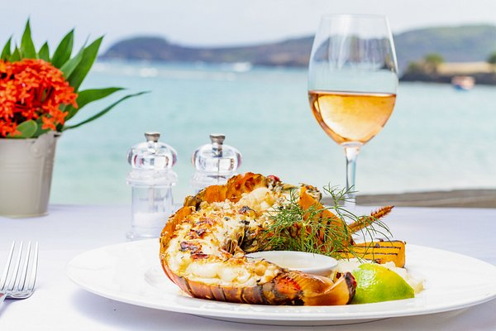

It is always best to make a reservation for restaurants.
In the low season they may change opening hours or reduce the menu.
ATTRACTIONS / ACTIVITIES

THE BELMONT WALKWAY & PRINCESS MARGARET TRAIL
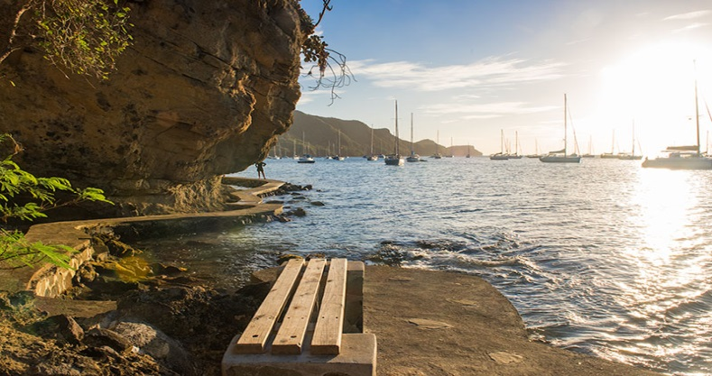
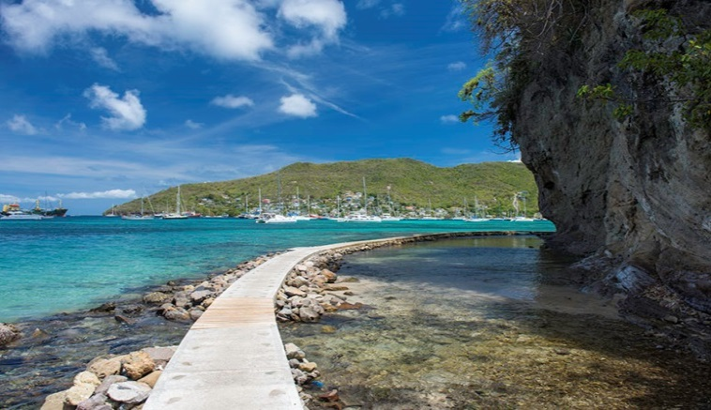
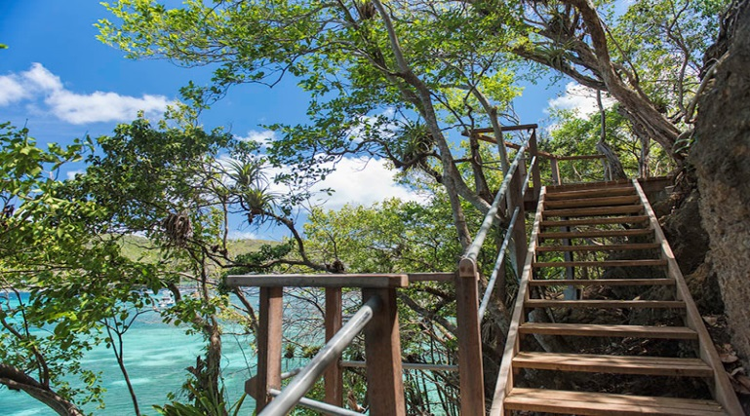
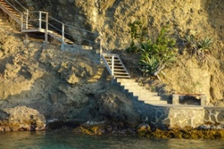
Restored in 2012 by Action Bequia, this stunning beachfront walkway is now a major attraction in Bequia. The trail has been extended over headland to Princess Margaret Beach and people can now walk close to the shore, all the way from Fort Hamilton to Lower Bay and Beyond. Over 3 miles of heritage and natural beauty. The new Princess Margaret Trail is not only better than the road, it competes with the best coastal trails in Barbados, Mustique and other world class destinations.

HAMILTON FORT
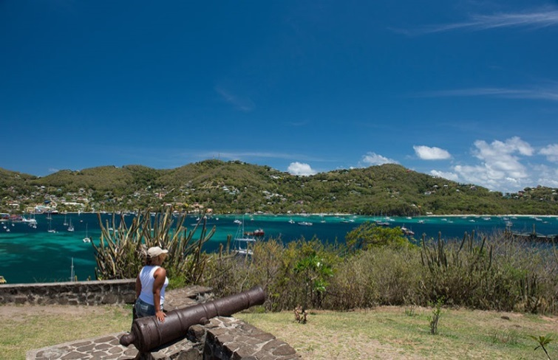
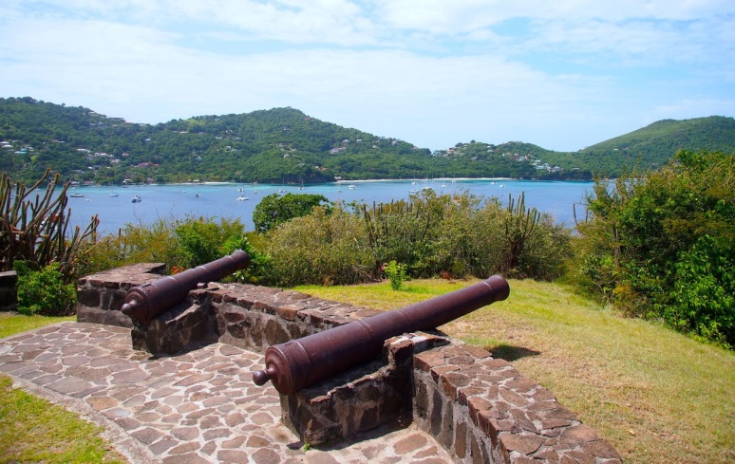
Hamilton Fort was used by the British to protect Admiralty Bay. The cannons are the only remnants of this powerful ancient Fort. Today the location is a popular spot for photographs and views of the Island, one can easily see why the British choose this location. While visiting Bequia ask for a tour or enjoy a walk to the Hamilton Fort.

TURTLE SANCTUARY
Email: oldhegg@vincysurf.com Tel: +1 (784) 458 3245 or +1 (784) 458 3596
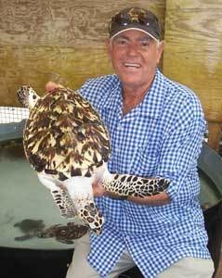
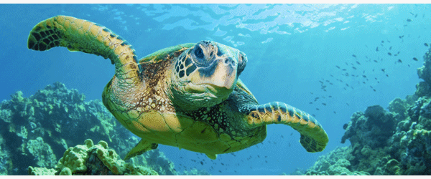
Bequia is home to an amazing turtle sanctuary run by Orton (Brother) King. This extraordinary man has dedicated himself to saving the Hawksbill turtle from extinction and his sanctuary has been in existence since 1997. Only one hatched turtle in a thousand survive in the wild – Orton’s work is to rescue threatened hatchlings and raise them in safety for three years then release them into the ocean. So far he has released more than 2,000 thus making huge progress in his bid to save this turtle from extinction. The sanctuary is a must to visit.

BEQUIA'S FIREFLY PLANTATION
Email: fireflystatebequia.gmail.com Tel: +1 (784) 532 5134
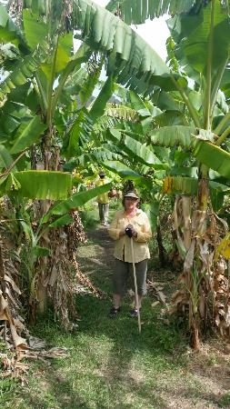
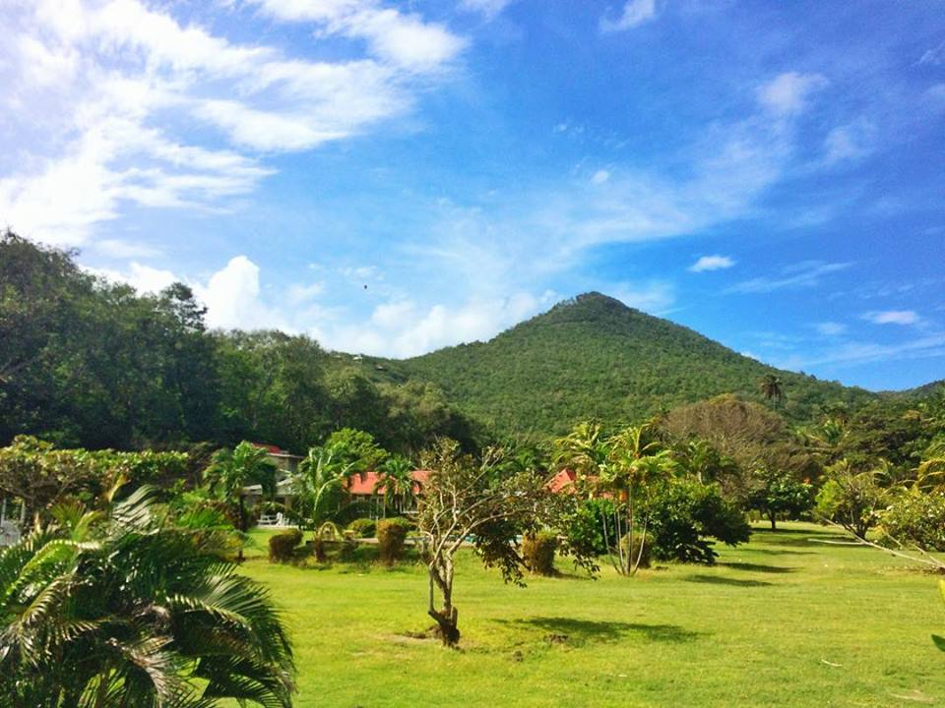
This 200 year old working plantation overlooking Spring Bay used to have a 19th century sugar factory whose ruins stand at the entrance to the Firefly Hotel. Wide lanes of swaying coconut palms still grace the access path to Spring Beach and beyond. Enjoy a leisurely guided walk through the grounds with the head groundsman who will give a brief history of the plantation and sugar mill. Sample fruits and vegetables in season and learn about the various crops, herbs and flowers.
THE BEQUIA HERITAGE MUSEUM Tel: +1 (784) 532 9544
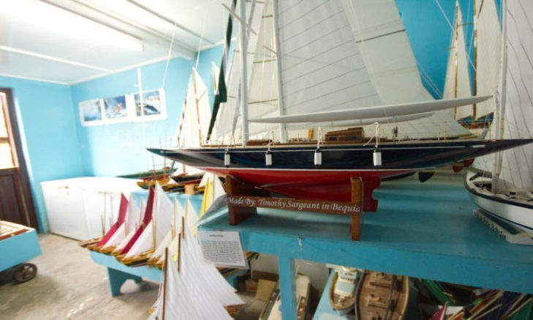
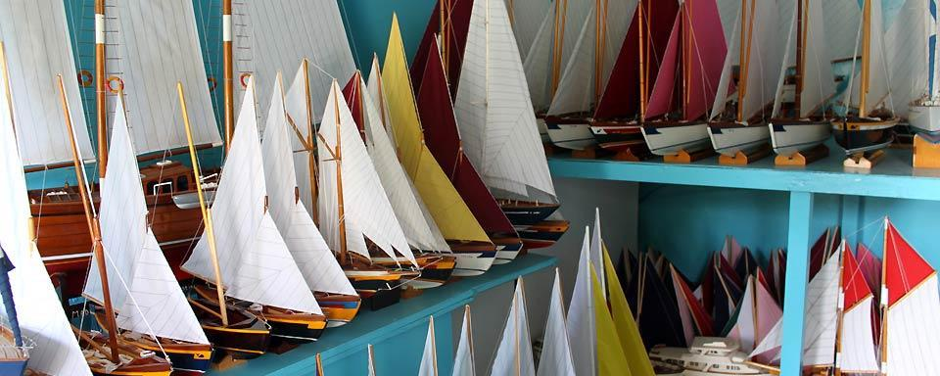
The Bequia Maritime Museum is located on the road from Port Elizabeth to Hamilton. Here you can enjoy an informative guided tour and learn how our Scottish ancestors introduced the art of boat building, as well as how the tradition of whaling began and continues to this day.

MOUNT PLEASANT
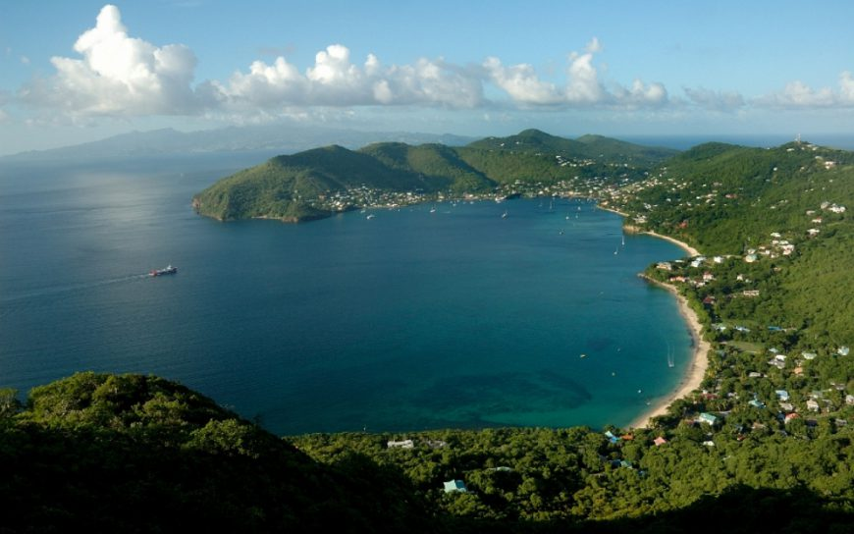
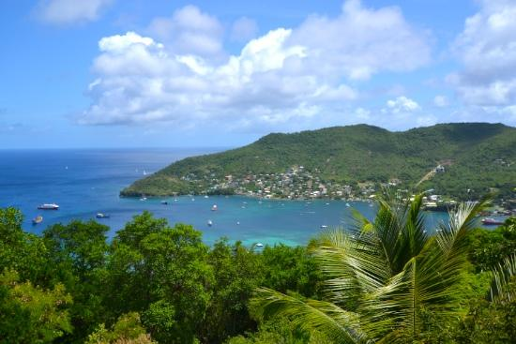
The highest point on Bequia is Mount Pleasant at 760 ft / 231.7 m. the 360° view from the top is well worth the trip and the area is popular with locals and visitors. Stop at the sugar hill bar and restaurant near the top for a cold beer and enjoy a view from St. Vincent to Canouan. You will soon appreciate why so many fine homes are built at the top of this mountain.
PAGET FARM
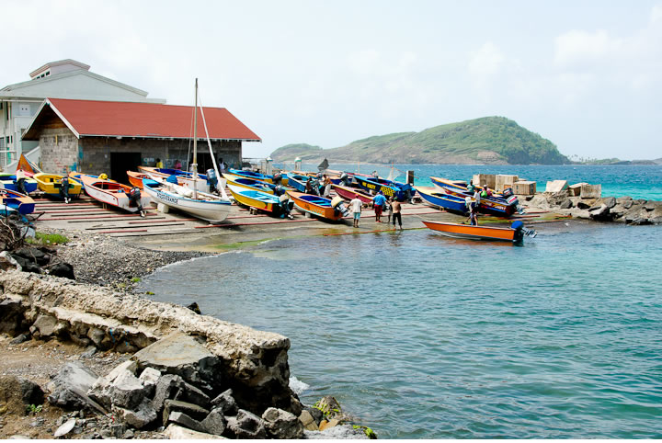
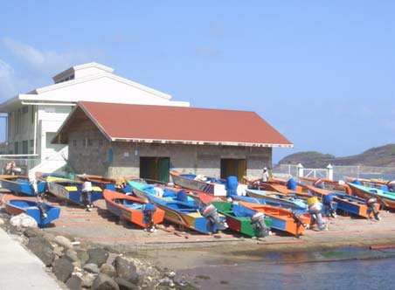
A small fishing community near the airport, and home to the Banana Patch Studio featuring scrimshaw and other artwork, is another worthwhile stop. At Paget Farm, you will be sure to see the colourful fishing boats lined up outside the fish market. If you can arrange a trip to Petit Nevis you can see the old whaling station and find out more about Bequia’s whaling tradition.
PORT ELIZABETH
The heart of Bequia, along the shores of the harbour in Admiralty Bay, is its capital Port Elizabeth - the main location for shops of all types, mostly clustered along "Front Street". New signposts, installed by the Bequia Tourism Association, will help you find your way around.

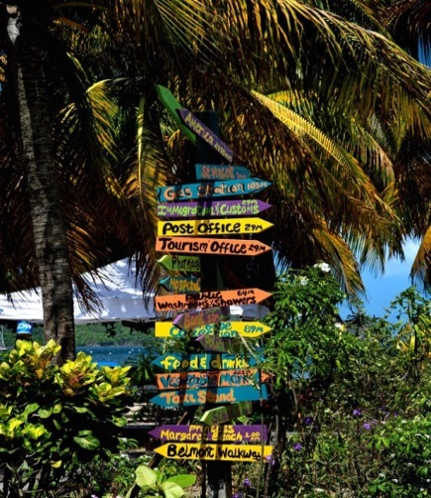
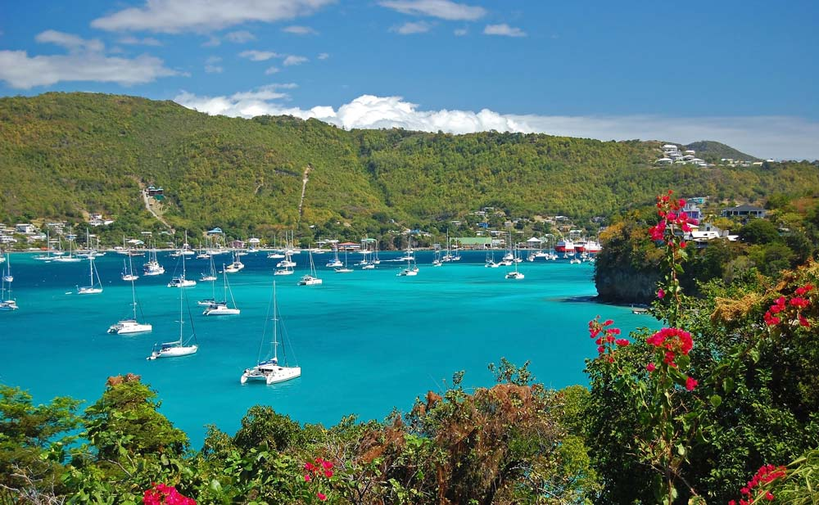
The main dock in the centre of the town bustles with activity when the ferries arrive and unload their passengers and daily supplies. Everything, from building supplies to groceries, arrives by boat.

DIVING
There are over 30 excellent and easily accessible sites in the sparklingly clear waters around the island or within easy reach, offering drift dives with intriguing caverns and holes, walls and overhangs, all teeming with wonderful coral formations and marine life. For the more experienced diver, exciting wreck and night dives are also available.

For those seeking a slightly less adventurous but no less fascinating experience, snorkelling trips are offered by all Bequia's Dive Shops, with equipment available for hire or purchase.

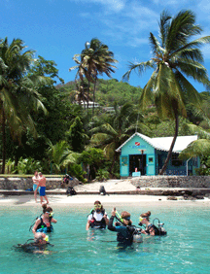
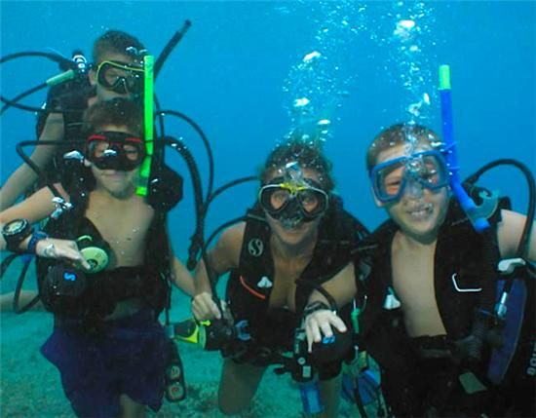
Bequia Dive Adventures
Tel: +1 (784) 458 3826
Web: www.bequiadiveadventures.com
Dive Bequia
Tel: +1 (784) 495 9929
Web: www.divebequia.com

WATERSPORTS
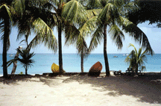
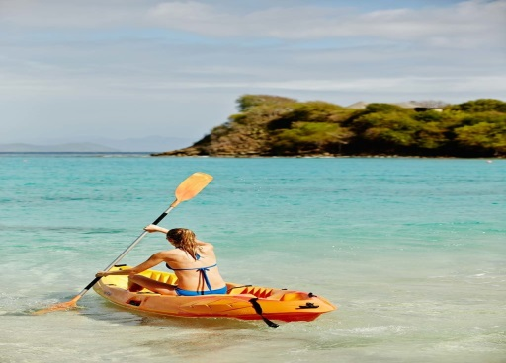
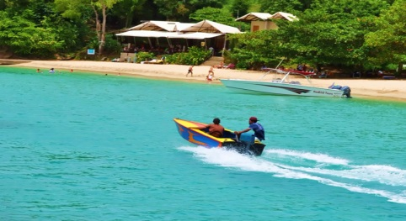
With the Trade Winds providing almost year-round breezes, and brisk winds in the winter, Bequia offers great conditions for windsurfers. Windsurfers and kayaks are available for rent from several outlets, and lessons can also be arranged.

FISHING
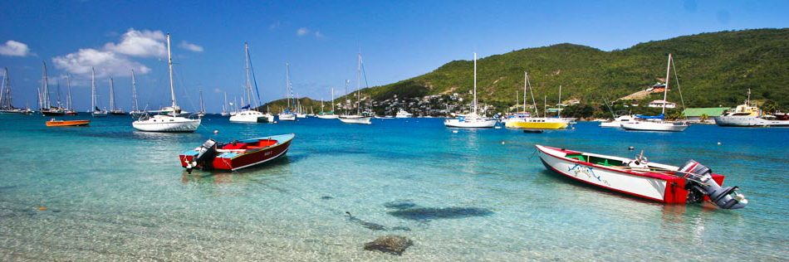
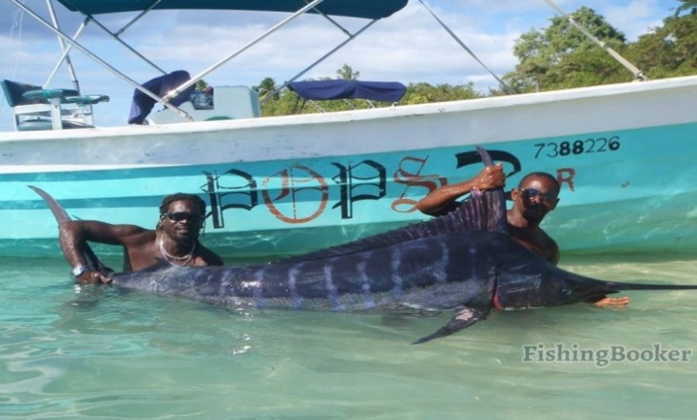
The waters surrounding the island are inhabited by various fish. Along the coast of Bequia, you can fish marlin, kingfish, tuna, mahi mahi and barracuda among many others. You can choose between different levels of fishing. If you just want to relax, you might want to keep it simple, and in that case, all you need is a line and a lure. If you are a skilled fisher, and need more advanced equipment, a boat and professional help around the Belmont Walkway and Paget Farm.

SAILING AND CHARTERS

Bequia has a long tradition associated with the sea, from boat building to fishing, from sailing the Caribbean Islands to Bequian’s crewing on cargo and cruise ships around the world.

The Grenadine Islands are an absolutely stunning cruising ground and if you would like to visit another island while you are here, by sail or by power boat, you will be rewarded with an exhilarating experience and a wonderful day out.

Friendship Rose, 100ft Local Classic Sailing Schooner
Tel: +1 (784) 495 0886/9
Web: www.friendshiprose.com
Email: friendshiprose@mac.com

For catamaran day/overnight trips – contact “African”
Email: captainsimmons@hotmail.com

For speedboat day trips / fishing trips/sunset cruises – contact Michael Tours
Tel: +1 (784) 4976448/4551154
Web: www.michaeltoursbequia.weebly.com
Email: michaeltoursbequia@yahoo.com

Gusto, 54 ft. Trimaran
Tel: +1 (784) 458-3884
WhatsApp: + 1 (784) 433-1371
Email: GustoBequia@gmail.com

Octopus Yacht
Tel / WhatsApp: + 1 (784) 432 5201
Email: hello@octopus-caribbean.com

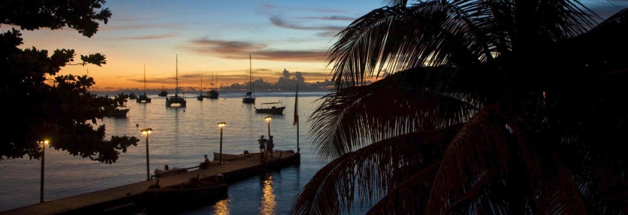

CALENDAR OF EVENTS

BEQUIA MOUNT GAY MUSIC FEST – JANUARY

One of the hottest and coolest festivals in the region.

The Bequia Music Fest started in 2000 when the BTA worked with Basil Charles to bring his world-famous Mustique Blues Festival to Bequia for one glorious evening in January.
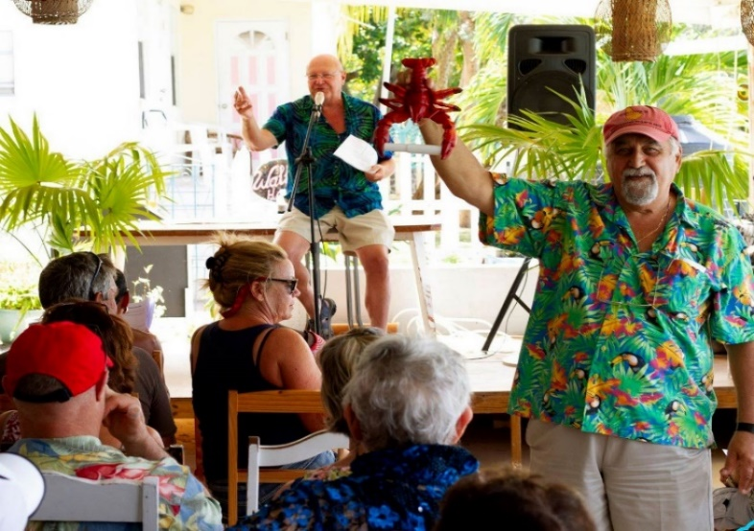
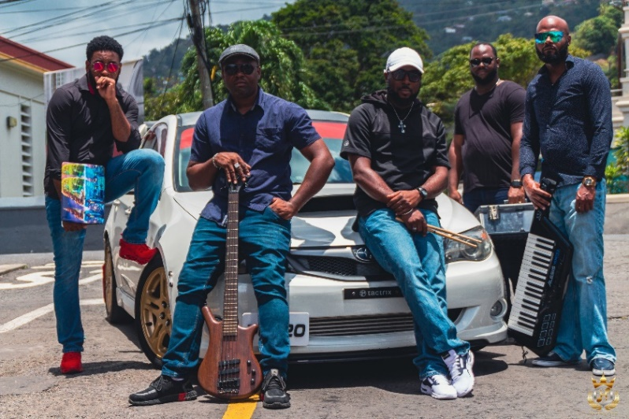
In the ensuing years, the Bequia Music Fest expanded into a four-day event, still including one night of world class Blues from the Mustique Blues Festival, but also with a wide range of international, regional and local artistes of all musical genres coming together to bring a feast of entertainment to the islands' and nations' residents and visitors alike.

SUNSHINE SCHOOL AUCTION – FEBRUARY
The Bequia Sunshine School for Children with Special Needs holds its annual Sunday fund-raising auction in mid-February. This very special school is a privately funded educational institution administered primarily by a local board of directors. Currently the government pays the salary of one teacher only; all other costs have to be raised by private donation and fundraisers - thus the need for funds is constant.

The annual auction is now in its 20th year and is fast becoming one of the most fun events of the season. Items for the auction, and for the Jumble Sale which follows later in March, are all donated by well-wishers and energetically amassed and sorted by the auction organisers in the weeks before.

There could be literally anything up for sale - jewellery, antique prints, artwork, clothing, furniture, household items, marine items, donated dinners and services and handicrafts made by the students at the school are all likely to be on offer.

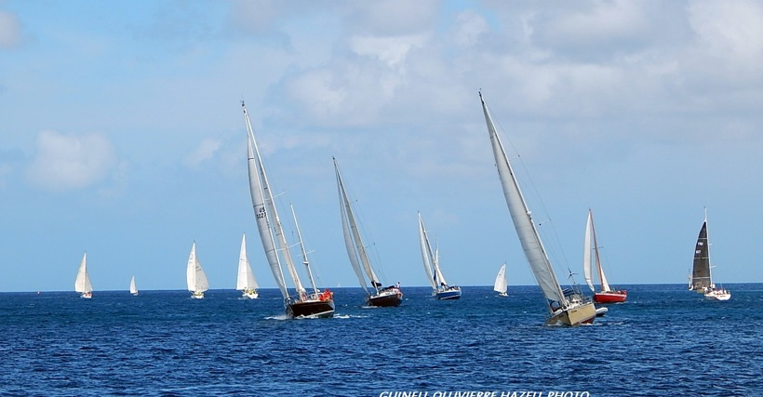
ANNUAL EASTER REGATTA – MARCH/APRIL
Bequia's Regatta is rightly famous for its unique blend of local boat racing, yacht racing shore side activities and Bequia hospitality.

A fleet of more than thirty traditional local boats from Bequia and her neighbouring islands compete out on the sparkling waters around Bequia.
It's a fabulous, colourful weekend, full of fun and camaraderie, skill and tradition, with the whole island caught up in regatta fever. Sunday's Regatta Lay Day on Lower Bay beach sees a grand fete for boatloads of visitors from the mainland, while Friendship Bay Beach hosts a family Layday with Sandcastle and Crazy Craft competitions, and easter activities organised by regatta sponsors Bequia Beach Hotel.
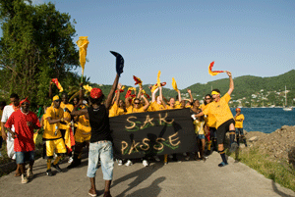
BEQUIA CARNIVAL – JUNE
Bequia Carnival takes places at the end of June, and is a delightfully informal and spontaneous affair.
With St. Vincent's "Vincy Mas" now the nation's premier tourism event, Bequia's own Carnival looks set to move forward as well and become a true small island carnival and a permanent fixture in the island's cultural calendar.

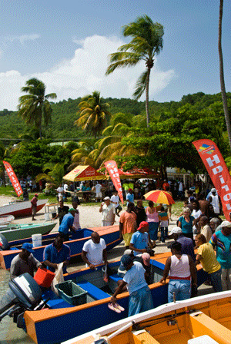
FISHERMAN’S DAY – JULY
If Bequia Regatta is a celebration of Bequia's traditions of boat-building and seamanship, Bequia's Fisherman's Day is a lively and fiercely contested demonstration of the island's abundant skills at harvesting the waters that surround the island.
Once again the Rotary Club of Bequia are the organizers, with the famous "Rotary Wives" doing a fine job in cooking up the catches and providing delicious fresher-than-fresh barbecue and baked fish lunches, complete with rice'n'peas, dasheen, yams, plantains, green bananas, coucou, breadfruit and coleslaw.

NATIONAL NINE MORNINGS CHRISTMAS FESTIVAL - DECEMBER
The unique Vincentian cultural tradition of "Nine Mornings" is enthusiastically celebrated in Bequia. For the nine nights before Christmas, music, singing and revels takes place up and down the island in an exuberant countdown to Christmas.
Nine days before Christmas musical activities and carols often take place under the Almond Tree - sometimes starting at 4am in the morning - to the surprise and delight of many visitors longing for a good carol or two!
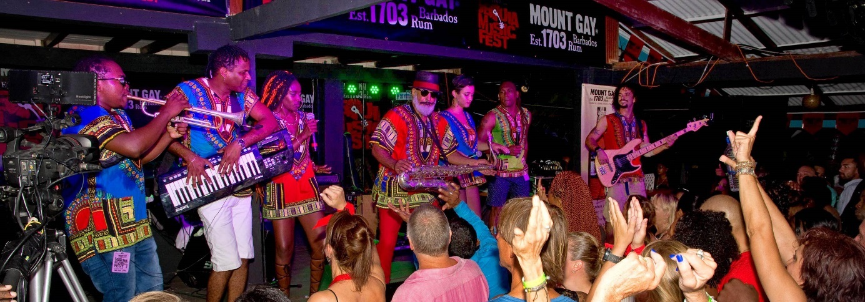
Bequians take their carolling very seriously. Shortly before Christmas groups representing the islands villages and communities compete in an evening carol competition attended by most of the island and its visitors.

CHRISTMAS
The only thing that is missing from Christmas on Bequia is snow! The Christmas spirit is the same on the island - good will and season's greetings abound, families and friends get together, and shops are full of unusual gifts and delicious treats. Midnight services on Christmas Eve at both the Anglican Church in Port Elizabeth and the tiny Catholic Church in Hamilton welcome all worshippers.

On Christmas Day, as on Christmas Eve, hotels and restaurants offer traditional Christmas fare with all the familiar trimmings - with that extra West Indian flair.

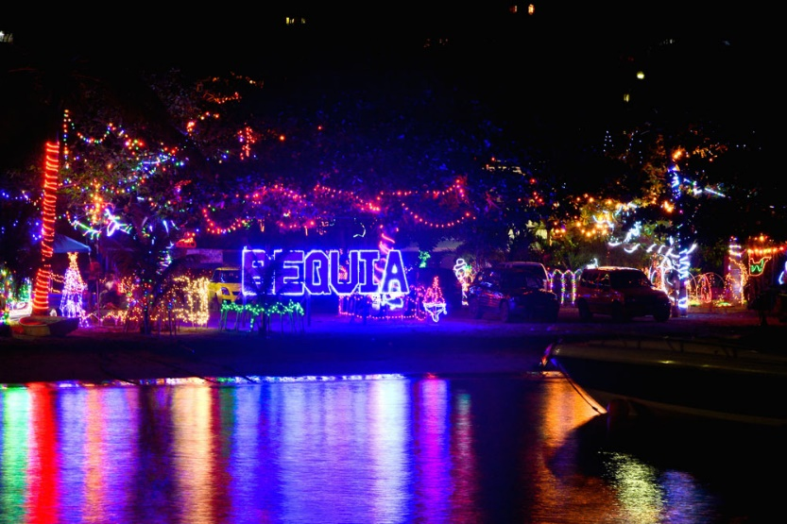
NEW YEARS
New Year's Eve in St. Vincent & the Grenadines is more commonly known as Old Year's Night, and Bequia really knows how to "ring out the old and ring in the new"!

The harbour fills with visiting yachts, and ashore there are celebrations in every restaurant and bar - all the stops are pulled out for this one special night of the year. A spectacular firework display over Bequia Harbour is the highlight of the evening. Made possible by the generosity of private individuals and Bequia's business community.

ST VINCENT AND THE GRENADINES


A necklace of 32 islands and cays, only nine of them inhabited, St. Vincent and the Grenadines is one of the most popular destinations in the world for leisure sailors, who flock here for its numerous uncrowded anchorages and charming ports of call.

BEQUIA
The largest of the Grenadines islands has only one real town, Port Elizabeth; it's a charming, sleepy port of call with a pedestrian footpath that stretches around most of the bay. Shops feature the works of model shipbuilders.
CANOUAN
Home of Grenadines Estate Golf Club; a challenging and exhilarating Jim Fazio 18 hole championship golf course with every hole overlooking the Caribbean Sea. Deemed “Best Golf Course” (Robb Report, June 2005).
MAYREAU
Just northeast of the Tobago Cays; this tiny 1.25 sq. miles island has scarcely 300 residents, but its lovely palm-lined beach, Saltwhistle Bay is dreamy and magical.
MUSTIQUE
This renowned 1,400-acre private island in the Grenadines is known as a favourite hideaway for the world's most discerning travellers. Scattered around the island are 74 extraordinary designer villas each with its own distinctive architecture and atmosphere.
PALM ISLAND
135 acres of tropical paradise; this island houses the exclusive Palm Island Resort with its huge expanse of tropical white sand beach, shaded by cooling palms.
PETITE ST. VINCENT
Home of the ultra-exclusive Petit St. Vincent (PSV) Resort; the island offers the ultimate in barefoot elegance and unobtrusive attentive service.
TOBAGO CAYS
Justly famous for its protected waters is a favourite with yachters and has been identified as a national marine park. The waters of the Tobago Cays are populated with sea turtles which provide friendly swimming companions, making the experience of swimming in the Tobago Cays a magical and memorable one.
UNION ISLAND
With its colourful market and mountain peaks is the ideal place for provisioning your yacht. The island also is a great jump-off point for visiting the nearby Tobago Cays.
YOUNG ISLAND
Situated on this tiny island, just 200 yards off the southern shores of the mainland (St. Vincent). The resort is a haven for rest and relaxation but guests can take part in a range of watersports, sailing, hiking and other activities.

ATTRACTIONS/ACTIVITIES

FORT DUVERNETTE
Beautiful Fort Duvernette is located south of mainland St. Vincent. It is a 195 foot high volcanic plug comprised of hard columnar basalt. It is also known locally as ‘Rock Fort’. One can find two batteries with cannons, which were constructed during the colonial era of St. Vincent and the Grenadines, for the defense of the then important town of Calliaqua. The site is also rich with flora and fauna.
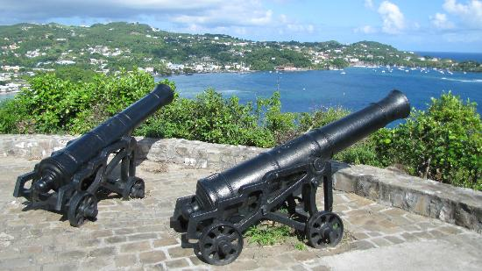

TOBAGO CAYS MARINE PARK
The Tobago Cays Marine Park (TCMP), located in St. Vincent and the Grenadines, houses a series of globally significant habitats including coral reefs, sea turtle nesting sites and feeding areas, and small systems of mangroves. The marine portion of the park surrounds five uninhabited cays, the populated island of Mayreau, and three islets. The four-kilometer long Horseshoe Reef, the longest of the four main reef systems in the TCMP, encloses four of the cays (Petit Bateau, Petit Rameau, Baradal, and Jamesby) with the fifth cay (Petit Tabac) lying just outside the reef to the east.

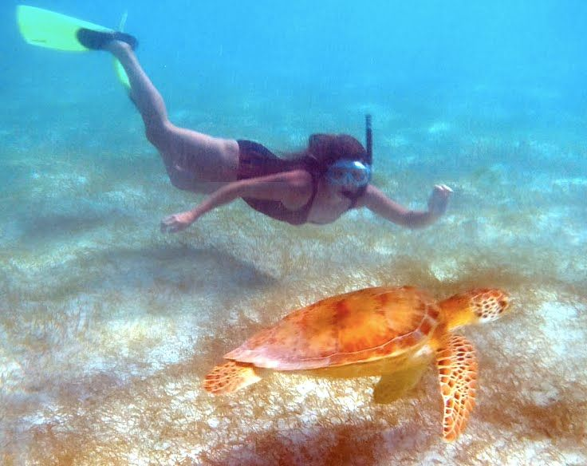
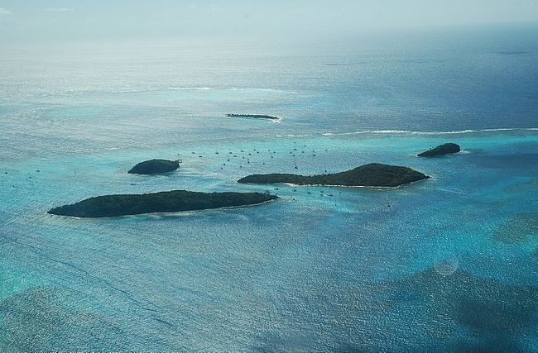
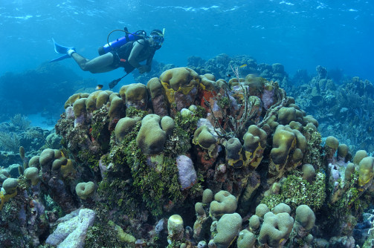

MONTREAL GARDENS

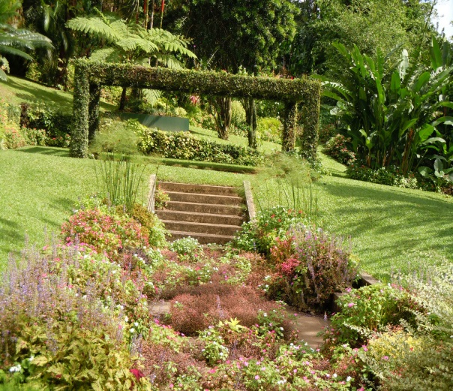
The St. Vincent Montreal Gardens is located at the Montreal Estate, and this attraction is a must see for anyone who enjoys lush natural beauty and a variety of plants. These gardens are situated at 1,500 feet above sea level, and they are surrounded by the rain forest and banana plantations. The Montreal Gardens cover seven and a half acres of the island and the public is always welcome. There are 3 different sections of garden to walk through. The Rain Forest Garden, the Colour Garden, and the Formal Garden all offer something different and appealing to visitors, and each has its own charm and a variety of plant species.
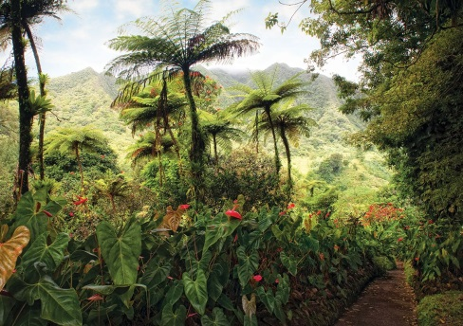
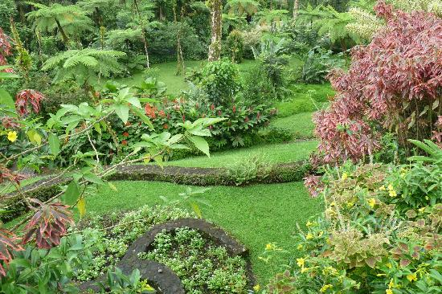
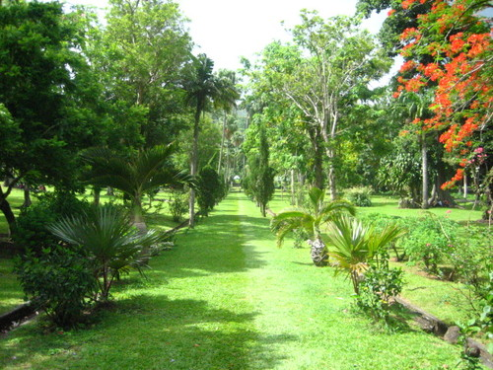

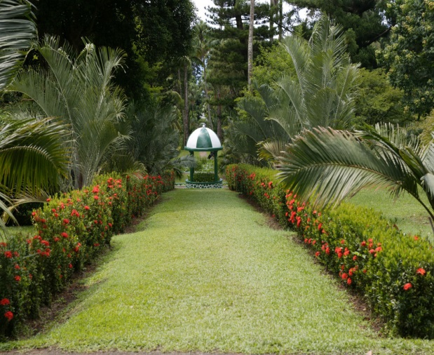
BOTANICAL GARDENS
Occupying 20 acres in St Vincent,, the Gardens were created in 1765 by General Robert Melville, governor of the British Caribbean islands, as a plant breeding centre and 'to provide medicinal plants for the military and improve the life and economy of the colony'. Three acres were set aside for the established of a Government House. The Botanical Gardens is the oldest of its kind in the western hemisphere, and celebrated its 250th anniversary in 2015.
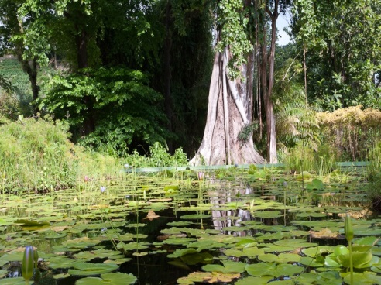
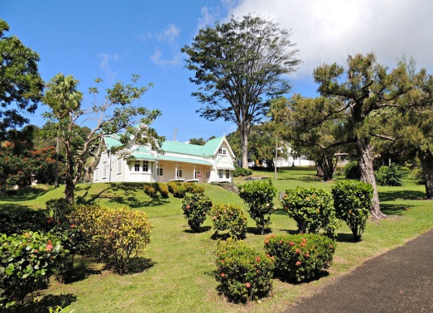
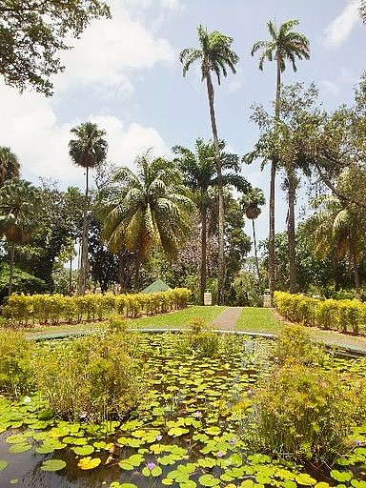

A GUIDE TO GRATUITIES FOR VILLA STAFF


It is common practice in the Caribbean to leave gratuities for staff.

If you feel you would like to leave a gratuity for the housekeeping staff, a guide is $US10- $US15 per day of your stay.

If you do not require Matthew to cook for you but would like to reward his service, a guide is UD$25-US$30 per day of your stay.

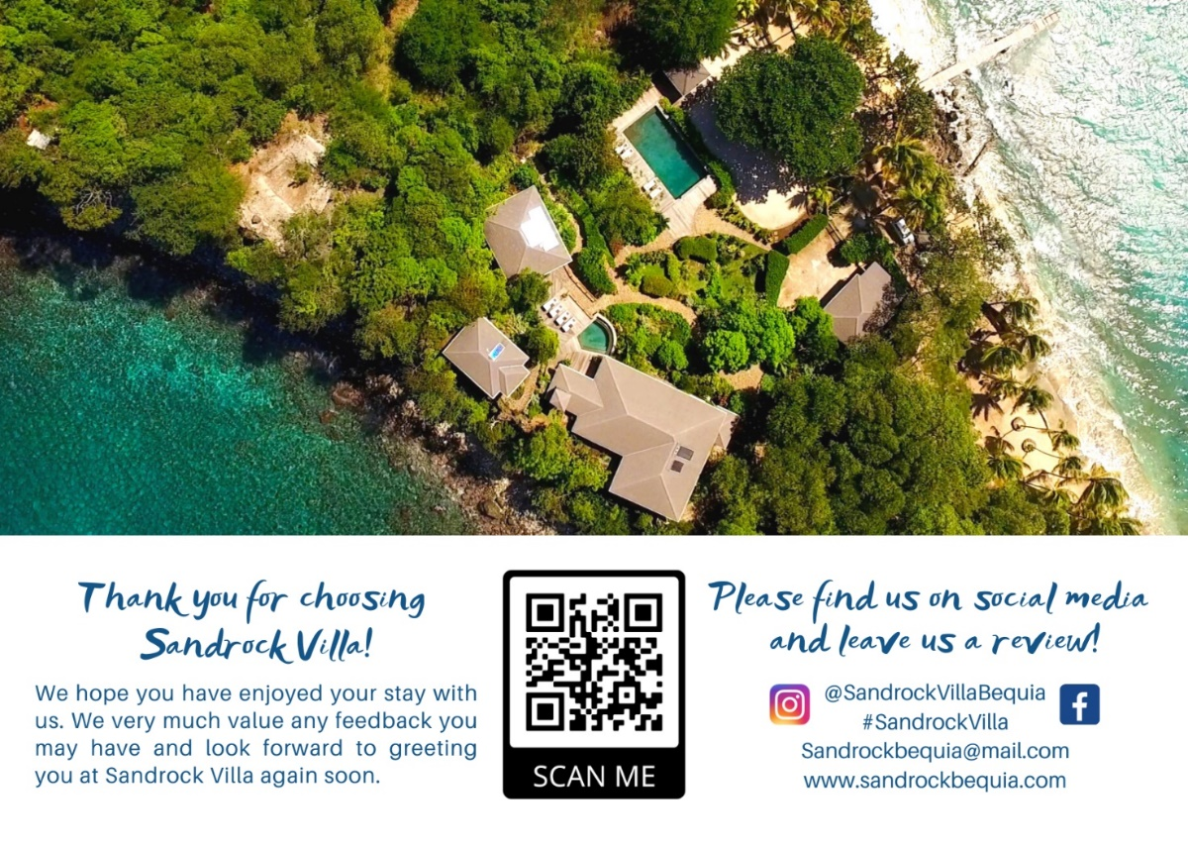
Thank you for choosing to stay at Sandrock Villa - a reminder for the end of your stay

We don’t like to mention coming to the end of your stay with us ☹ - but - this is just a reminder that on departure from Bequia airport you will be required to complete the immigration departure slip that you were given on arrival and you will be required to pay a departure tax of EC$50 cash per person.

Please also note that Bequia airport does not have luggage scanning machines therefore all luggage is hand searched by the airport staff.

Please leave us a review and we hope you see you again.

