SANDROCK VILLA
BEQUIA
WELCOME BOOK

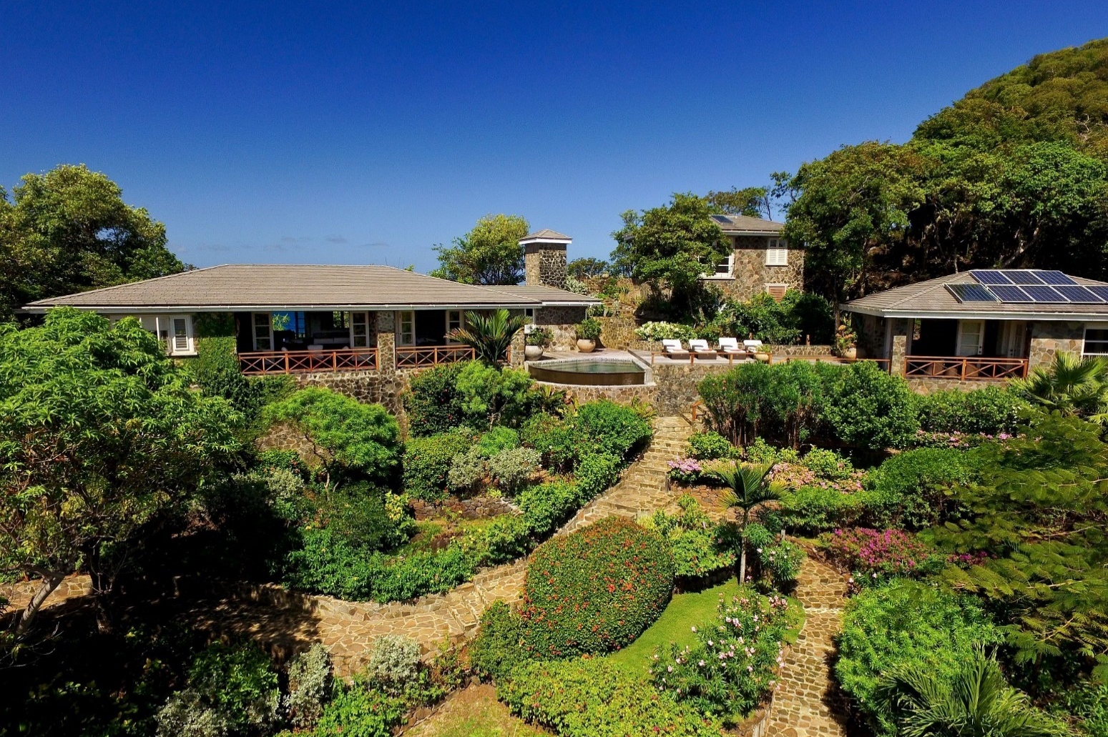

CONTENTS PAGE
- SANDROCK VILLA
Welcome letter Page 1
Contacts Page 2
Sandrock Villa Page 3
Floorplan/Fire Escape Plan Page 4
Amenities Page 5-6
Moonhole Page 7

- BEQUIA
Bequia Island Page 8
Useful Information Page 9-10
Getting around Page 11-12
Admiralty Ferries Sailing Schedule @ Feb 24 Page 13
Bequia Express Sailing Schedule @ Feb 24 Page 14
Maps Page 15
Beaches Page 16-17
Supermarkets / Shops / ATM Page 18
Restaurants / Nightlife Page 19-20
Attractions / Activities Page 21-24
Sailing / Charters Page 25
Calendar of events Page 26-28

- ST VINCENT AND THE GRENADINES
St Vincent and The Grenadines Islands Page 29
Attractions / Activities Page 30-31

- REVIEW Page 32
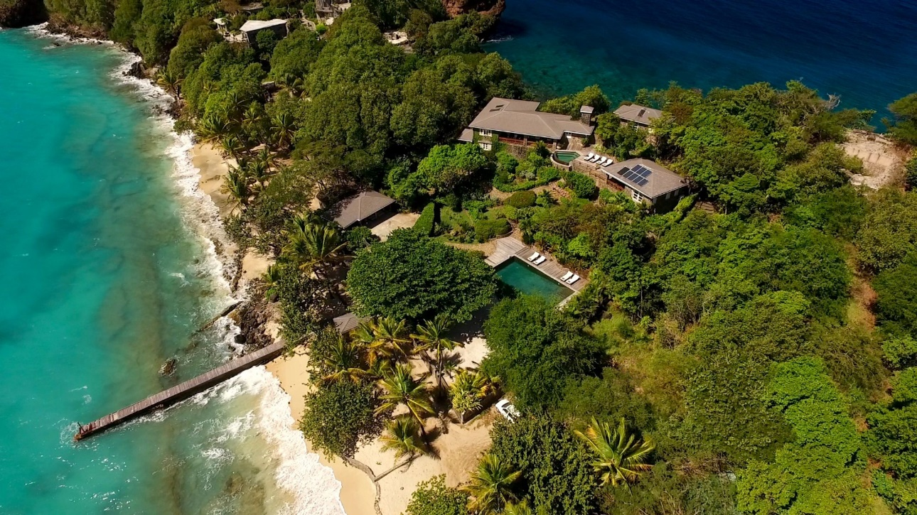
WELCOME TO SANDROCK VILLA

Thank you for choosing to stay at Sandrock Villa situated on the beautiful Caribbean Island of Bequia, I hope you have a pleasant and comfortable journey.

It is important now for you to relax and begin enjoying your holiday.

We have arranged a welcome pack for you with some essential provisions.

We wish you a pleasant and relaxing stay at Sandrock Villa and if there is anything we can do to improve your stay or any additional information you require please be assured we are always here to help.

We also invite you to leave your comments in the guestbook on departure or add your own comments to our website via the QR code on the postcards provided which you will find located in the lounge.

Yours faithfully

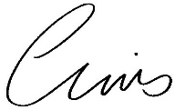

Chris and Claire Thompson
Sandrock Villa, Proprietors

CONTACTS

HOW TO CALL BEQUIA FROM THE UNITED KINGDOM

00 Exit code when making an international call from the United Kingdom

1 Bequia city code must be dialled next
784 Bequia city code

SANDROCK VILLA ADDRESS / TELEPHONE NUMBERS
Sandrock Villa, Moonhole, Bequia, St Vincent & the Grenadines, PO Box 321
Landline: +1 (784) 457 3968
Guest Mob: +1 (784) 455 6020

SANDROCK VILLA CONTACTS
Property Manager - Gabriele Peters
Tel: +1 (784) 457 3082
Mob: +1 (784) 593 7272
Email: gabriele.peters@vincysurf.com

Housekeeper - Mathew Mc Intosh
Tel: +1 (784) 457 3393
Mob: +1 (784) 433 9169

LOCAL EMERGENCY CONTACTS
IN ANY EMERGENCY DIAL 999
Police Station, Port Elizabeth +1 (784) 458 3350
Police Station, Paget Farm +1 (784) 458 3250
Hospital, Port Elizabeth +1 (784) 458 3294
Doctor Lugo (Private) +1 (784) 528 1955
Clinic, Paget Farm +1 (784) 458 3302
Imperial Pharmacy Ltd +1 (784) 458 3373

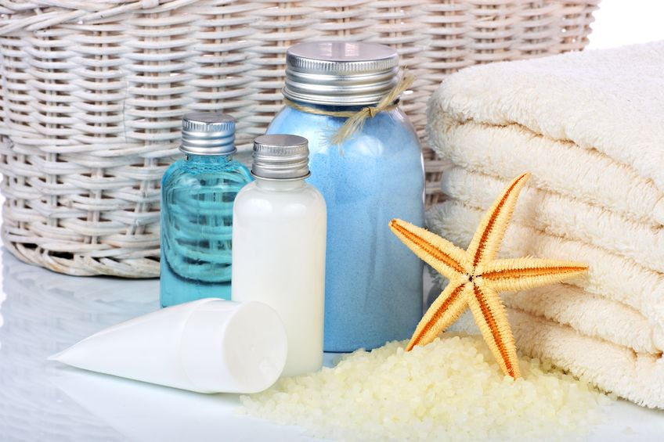

We are pleased to help you in all aspects during your time with us at Sandrock and wish you a comfortable and pleasant stay.
If you need anything – just ask
Thankyou for choosing us, from your Sandrock Housekeeping Team

SANDROCK VILLA

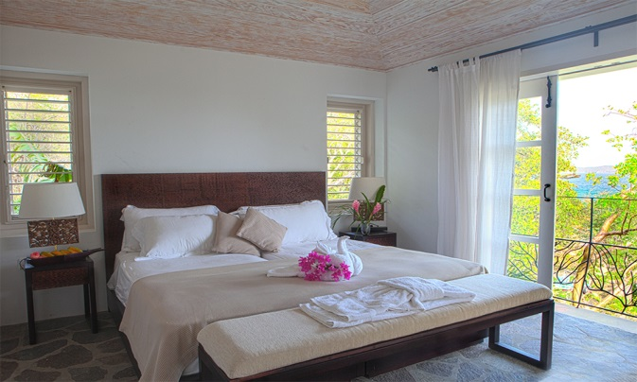
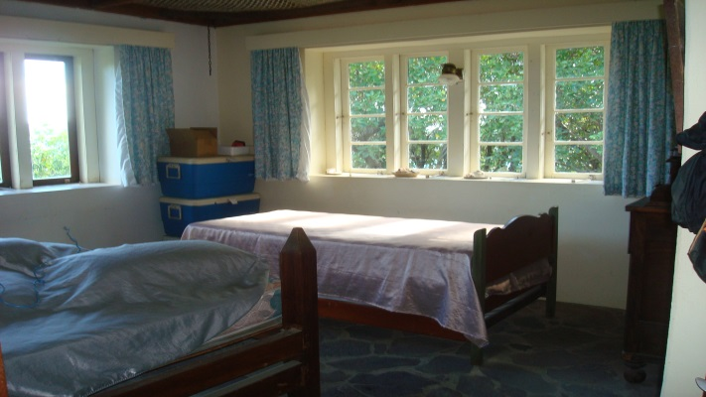
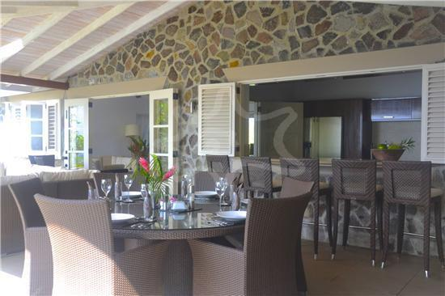
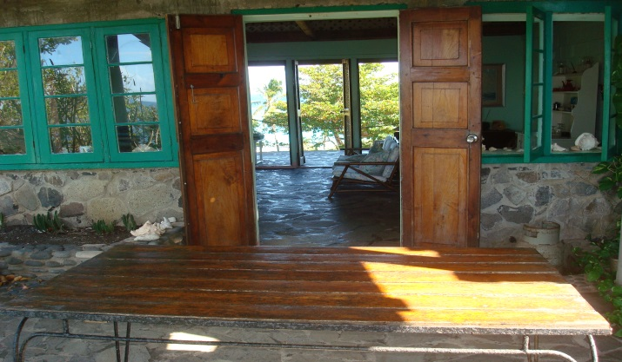
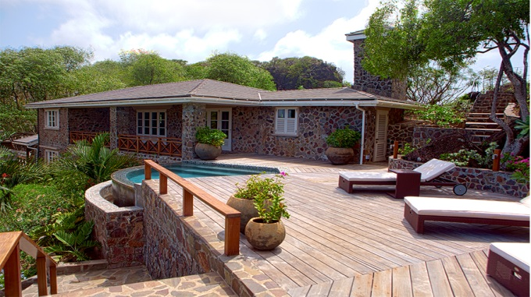
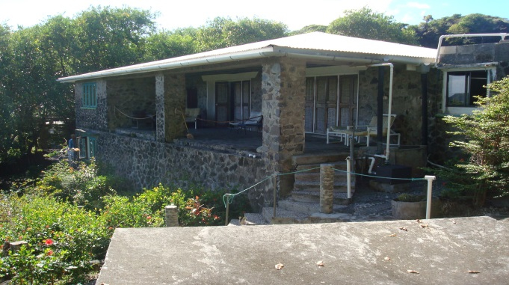
Sandrock Villa is a luxurious property, refurbished to an extremely high standard and from its perfectly located ridge-top position on the southern-most tip of Bequia, guests can enjoy both sunrise & sunset views from the beautifully landscaped grounds. The position is truly unique, with the Caribbean Sea just steps from the property and panoramic views of the Atlantic Ocean. (Before & after pictures below).

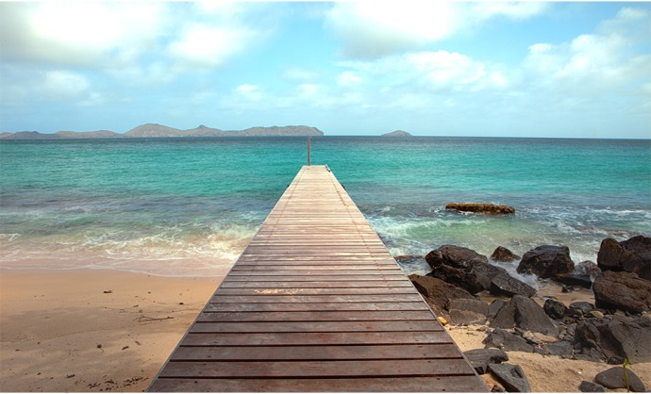
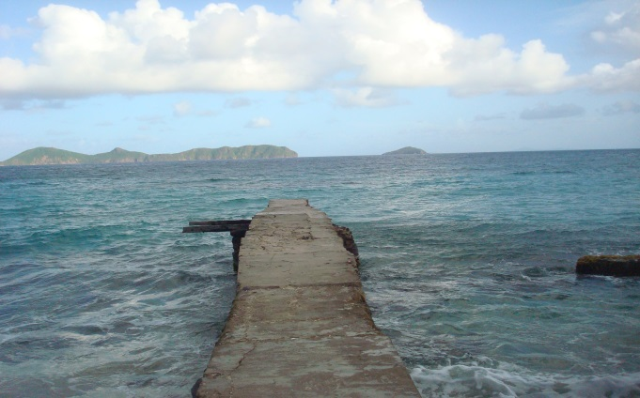
FLOORPLAN

AMENITIES
AIR CONDITIONING
- To keep our carbon footprint small, please only use the air conditioning when you are in your
room and ensure all windows and shutters are closed to enjoy the maximum benefit it has to offer. During the day, feel free to open the windows shutters to enjoy the Caribbean breeze. Please also turn off any unnecessary lights when you retire for the night. You may leave all external doors in the lounge open overnight to enjoy the breeze.
BBQ
- There is a BBQ located at the rear of the villa, outside – please enjoy it.
COOLBOX
- A portable cool box is available for use by guests - please ask Matthew, the Housekeeper.
DISHWASHER
- Please speak to Matthew for instructions on how to use the dishwasher.
FIRE EXTINGUISHERS/EVACUATION PLAN
- One fire extinguisher is located within the tall cupboard in the kitchen.
- One fire extinguisher is located in the generator room.
- An evacuation plan is visible on the rear of each bedroom door (see a copy on page 4 also).
FIRST AID BOX
- A first aid box is located in a drawer in the Guest WC next to the plunge pool.
HAIRDRYER
- There is a hairdryer located in each bathroom.
IRON
- The iron & ironing board is located in the tall cupboard in the kitchen.
- Housekeeping also has an iron / ironing board if required.
LOCKS
- Two keys to lock the main entrance door (Handle lock & deadbolt key).
- Two keys to lock bedrooms 3 & 4 (Handle lock & deadbolt key).
- Bedrooms 1 & 2 (in the main house) do not have locks.
MOSQUITO NETS
- Please use the mosquito nets provided over your bed, to ensure a good night’s sleep. Be careful not to sit on them when they are open on the bed as they tear easily. We also suggest you spray the room each evening, with the insect repellent room spray provided, at least one hour before you retire for bed.
SAFE
- There is one safe located in Bedroom 1, please ask Matthew for the code.
SMOKING
- Please do not smoke in the house – we want to ensure that the interior of Sandrock Villa is a
smoke free zone for all our guests to enjoy.
SNORKELLLING/SWIMMING EQUIPMENT
- Snorkelling equipment and swimming aids are located in the hut next to the large pool.
SONOS AUDIO SYSTEM
- Sandrock villa is equipped with a Sonos audio system that can be connected to your device.
Sonos name: Sonos

SUN LOTION P20
- Sun lotion with P20 causes non removable stains on the bed linen. If you do use this product,
please shower before going to bed.
SUN LOUNGERS
- Cushions for the sun loungers near the large pool are located in the hut next to the large pool.
- Cushions for the sun loungers near the plunge pool are located in the cushion box on the veranda.
WASHING MACHINE/LAUNDRY
- Housekeeping will be in attendance every 2 days during your stay. To help us preserve our water
resources and to be kind to the environment, we ask guests to place only the towels they require to be washed, in the laundry baskets provided.
- Laundry service is available for smaller items of clothing – place them in the laundry baskets provided in your room and housekeeping will deliver them back to the lounge area.
- Beach towels are provided by housekeeping and we ask guests to place ones to be washed in the bedroom laundry baskets.
- Please speak to Matthew for instructions on how to use the washing machine.
WI-FI
- Free internet access for all guests to use throughout the villa.
Wi-Fi name: sandrock
Password: Christopher
Travel cots are available upon request.

A General Guide
- Please shower before using the pools.
- Please use the footbath and tap provided near the garage before ascending the steps to the villa.
- We ask our guests to help us in our quest to recycle glass bottles, please keep them separate in one of the kitchen bins provided or in the crate they have been delivered in.
- Water is precious in Bequia, please use it consciously.

- Feel free to use the washing up liquid/dishwasher tablets and other household items below the sink in the kitchen.

A reminder for the end of your stay

We don’t like to mention coming to the end of your stay with us ☹ - but - this is just a reminder that on departure from Bequia airport you will be required to complete the immigration departure slip that you were given on arrival and you will be required to pay a departure tax of EC$50 cash per person.

Please also note that Bequia airport does not have luggage scanning machines therefore all luggage is hand searched by the airport staff.

MOONHOLE
Moonhole House
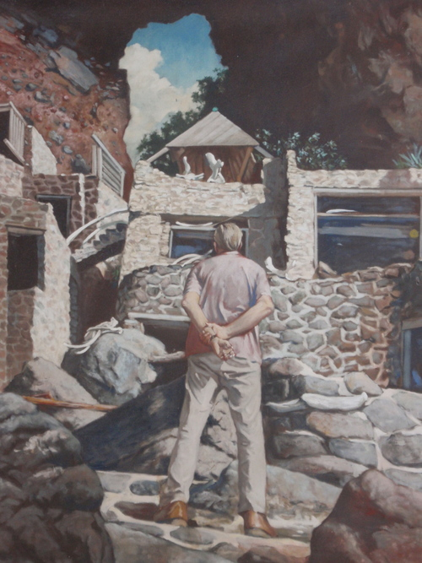
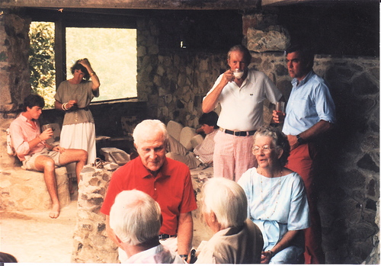
Tom and Gladdie Johnston started Moonhole Company Limited in the 1960s. They acquired the entire western tip of Bequia and built their home under the enormous rock arch known as "Moonhole." Working side by side with carpenters and masons from nearby Paget Farm, they created an architectural wonder, surrounded by the sea. As time went on, they built an office, commissary, living quarters for the growing staff, and a Gallery where homeowners and friends congregated for lunch each Sunday. Today the original Moonhole house may only be viewed from the sea and there are no public tours.
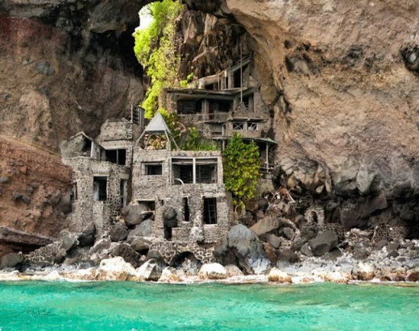

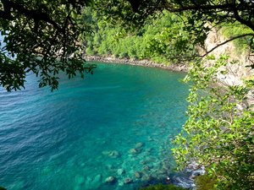
Moon hole and Sandrock have beautiful beaches where you can enjoy activities such as snorkelling, fishing and Diving.
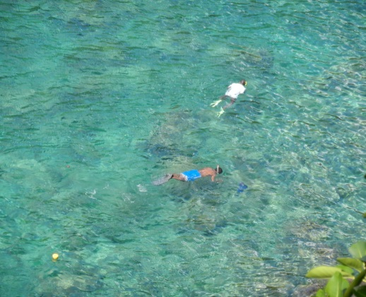
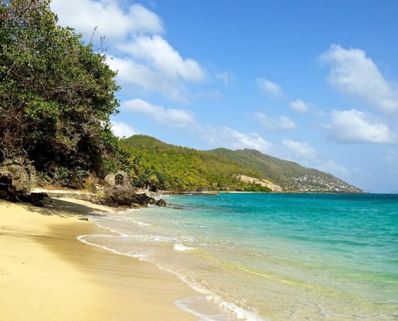

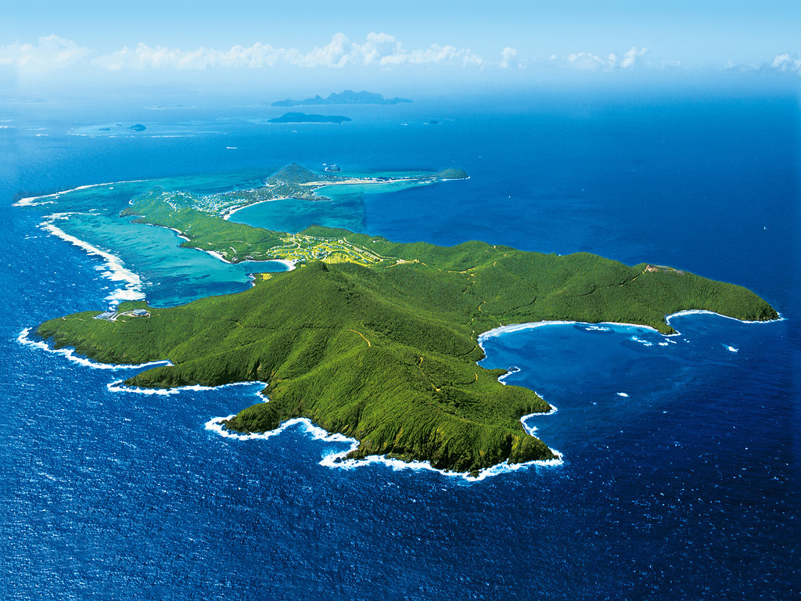
BEQUIA ISLAND

Beautiful Bequia (pronounced bek way) was named by the Arawak Caribs and means island of clouds. It is an undiscovered paradise, the Caribbean of 30 years ago. Covering an area of just 7 square miles and with a population of only 6000, Bequia lies in the warm tropical waters of the Caribbean Sea. It is just a short plane hop from the ever popular Barbados and next to the renowned Mustique, both favourite islands of the rich and famous. It is the largest of the Grenadine Islands known also as the ‘Jewels of the Caribbean’ and is blessed with several pristine, white sandy beaches many of which are totally natural and undeveloped. The recently renovated Belmont Walkway joins three of these beautiful beaches together and meanders around two headlands offering both excellent
snorkelling and a leisurely 2 mile walk passing rum bars, cafes, restaurants and small boutique style shops.

Bequia truly is a unique Island. Large enough to be interesting and exciting, yet small enough to retain its local charm and uniqueness that only a small ‘off the beaten track’ Caribbean Island can offer. Wherever you go on Bequia, you will be given the warmest of welcomes. They know you are here to relax and everyone is happy to help you have the holiday of a lifetime.
If you want resort hotels, nightclubs and beaches full of sunbeds, don’t come to Bequia. If you want to discover the undiscovered, visit our beautiful Island, enjoy the uncrowded pristine white sandy beaches, swim and snorkel in our safe and warm Caribbean waters and experience the genuine friendliness of the local Bequian people.

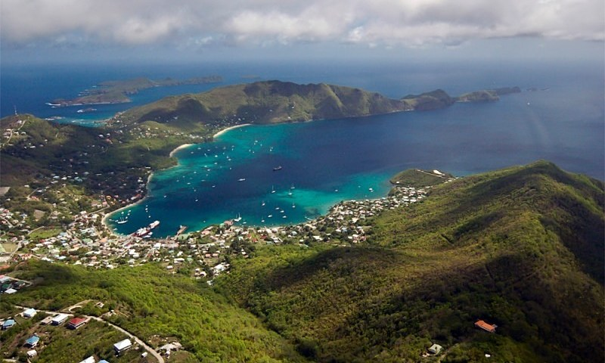
USEFUL INFORMATION

CLOTHING
Bequia is an informal island. Even the best restaurants are fine with smart casual. Women and men should wear swimsuit cover-ups in the town. Topless/nude sunbathing is not acceptable. Camouflage clothing is illegal wear for civilians, please do not wear it, to avoid problems.
CURRENCY/MONEY
The official currency of Bequia is the Eastern Caribbean Dollar (EC$). Most restaurants, shops, and hotels will accept payment in U.S. Dollars.
DIVE GEAR/C-CARD
There are currently two Dive Shops on Bequia and both have quality, well serviced gear waiting for you if you'd like to travel lightly. You are of course welcome to bring your own gear. Dive skins or light weight wetsuits are also available though not a necessity. Spear fishing is illegal by visitors.
ELECTRICITY
Electricity is 220V, the outlet format is the same as the UK. Sandrock villa has X4 Multi adapters and X2 USA adapters for use by guests.
LOCATION
Nine miles south of St. Vincent (45 min. by ferry, 10 min. by air), 45 min. by air west of Barbados, 30 min. north of Grenada, 20 min. south of St. Lucia, 2 hr. 20 min. southeast of Puerto Rico.
LANGUAGE
English is the official language. French Patois is likewise spoken.
MOSQUITOES / PESTS AND ANIMALS
While Bequia has very few crawlies, tropical places do produce tropical insects, and mosquitoes can be a nuisance. We recommend corresponding protection against mosquito bites, e.g. mosquito nets, anti-mosquito sprays or liquids.

There are no poisonous snakes and very few wild mammals. The only wild mammal is the Manicou (Possum like), Geckos and larger iguanas can be seen sunning themselves if you take walks around the island. Mockingbirds, Bananaquits, Blackbirds, Frigates, and Antiguan hummingbirds, are a few of the many birds you'll see and hear around the island.
TIME
The time difference with GMT is;
- April to October -5 hours / November to March -4 hours

TIPPING
Usually a 10 % service charge will be added to your restaurant bill. If no service charge is added, leave 10% of the bill, for excellent service larger amounts are always appreciated.
WATER
Tap water is safe to drink but bottled water is recommended. There is no government water supply on Bequia and rainwater is collected from the roof and stored in tanks. During the dry season (January to June), there is little rain, and water must be used carefully and sparingly.

WARNING
Watch out for Manchineel Trees which have a greyish bark, shiny green leaves and spikes of small greenish flowers. Its fruits, which are similar in appearance to an apple (Green or greenish-yellow when ripe).

- Touching the tree can cause blistering as can standing under the tree during rain
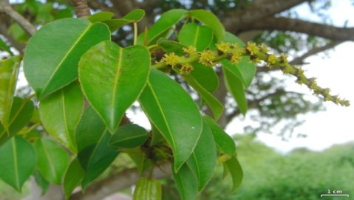
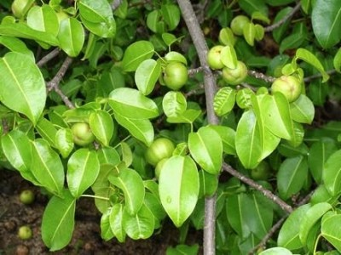
- Ingesting the fruit can be fatal.
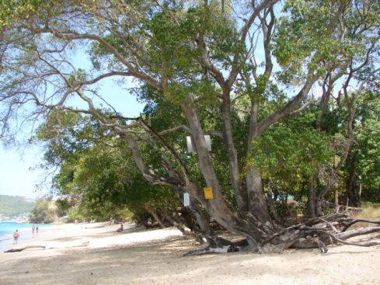

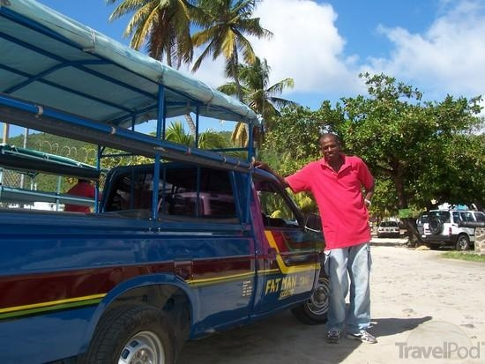
GETTING AROUND

DRIVING LICENCES
Driving on Bequia’s narrow roads is on the LEFT. If you are renting a vehicle on the island you will need to get a local Driving Permit, these are available from the Revenue Office in Port Elizabeth on production of a valid national or international driving licence from your own country, and payment of a fee of EC$100 (about US$ 40). It is valid for 6 months.

CAR RENTAL’S
D&N Car Rentals
Tel: +1 (784) 45830664 / 5937222
Email: noeltaxi@vincysurf.com
Web: www.bequiarentalcars.com

B&G (Gideon) Jeep Rental
Tel: +1 (784) 458 3760 / 5272092
Email: gideontaxi@vincysurf.com
Web: www.bequiajeeprentals.com

TAXI’S

Bequia's famous open-backed taxis are well known for their courteous and friendly operators. Taxis are widely used for getting around and cost circa US50-60 per return trip anywhere on the island

Fat Man Taxi’s
Tel: +1 (784) 593 7336

Gideon's Taxi & Rentals
Tel: +1 (784) 458 3760 / 5272092
Email: gideontaxi@vincysurf.com
Web: www.bequiajeeprentals.com

DOLLAR VANS
Often crowded, never dull, these closed vehicles are the cheapest way to get around to most parts of the island. Pick them up in Port Elizabeth (enquire at the Tourism Office for the regular routes and stop-offs) or simply hail one as it approaches and ask them if they are going you way! Fares vary from EC$1 to EC$10 per person (payable once on board) depending on the length of journey.

WATER TAXIS
You will normally find a water taxi operator on the dock at the Frangipani or Gingerbread docks if there are none in sight just stand at the end of the dock and one will soon appear.

INTER-ISLAND FERRIES
A regular and efficient ferry service operates between Bequia and Kingstown, St. Vincent, with two Bequia based companies operating seven days a week. Each ferry has an air-conditioned saloon, bar and snack bar, or you can choose to sit up on deck and enjoy the sea air.

The boats carry passengers and cargo, trucks and supplies from "the mainland" to Bequia and the arrival and departure of each ferry in Port Elizabeth is a lively buzz of activity even at 6.30am in the morning!

Either one-way fares or return fares (any time - with the same ferry company) are available and you pay when you board.

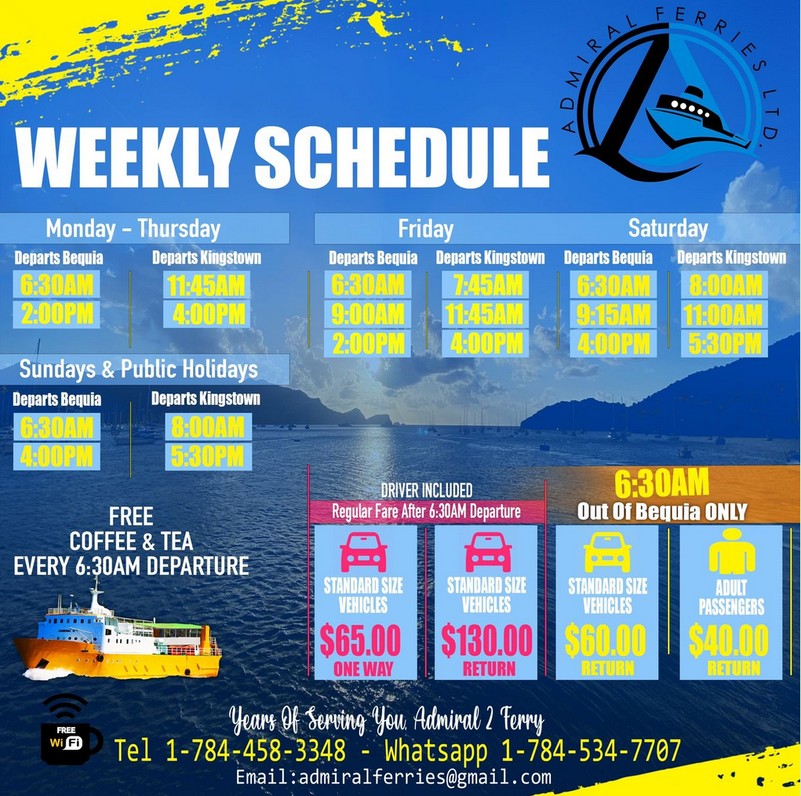

Admiralty Ferries Ltd (SCHEDULE AT FEBRUARY 2024)
Tel: +1 (784) 458 3348
Whatsapp: +1 (784) 534 7707
Email: admiralferries@gmail.com
Web: https://www.admiralferries.net/schedule

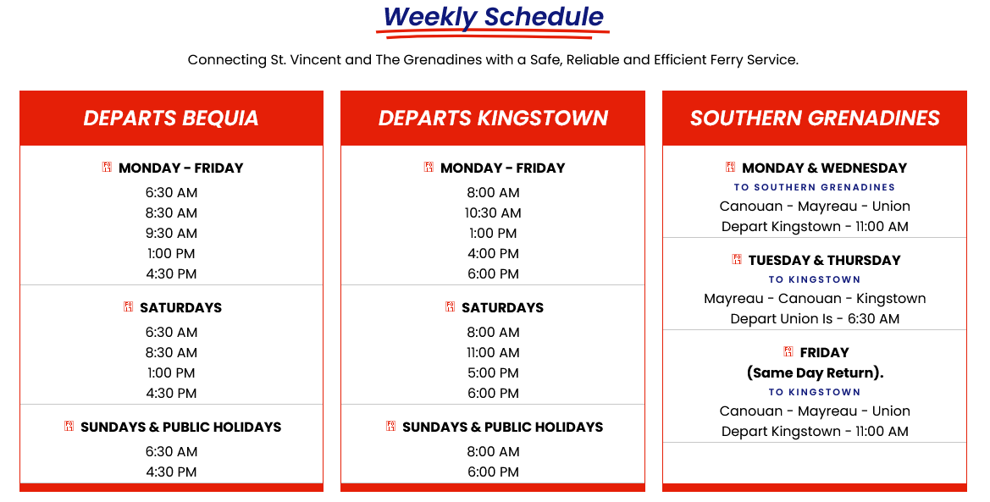
Bequia Express (SCHEDULE AT FEBRUARY 2024)
Tel: +1 (784) 457 3539
Email: info@bequiaexpress.com
Web: www.bequiaexpress.com

MAPS
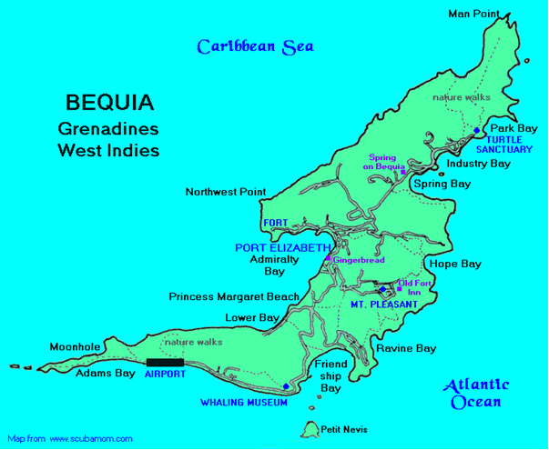

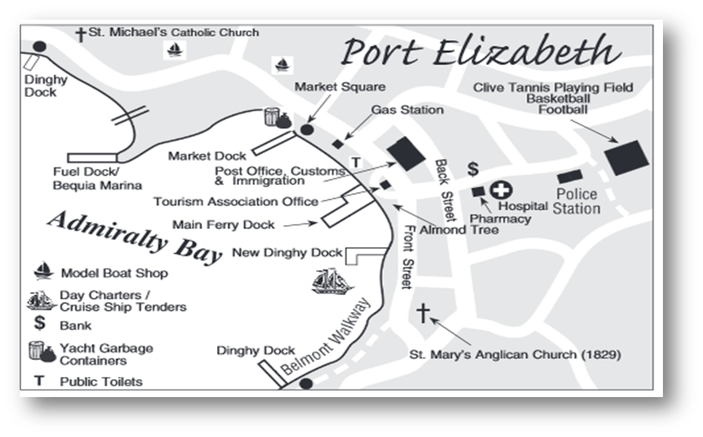

BEACHES

Bequia has a wonderful and varied assortment of beaches for swimming, snorkelling, and sunning. Their best feature is you will never find a crowd! Below are some of the beaches Bequia has to offer. Inquire locally for current conditions and characteristics, as they can change due to weather and other factors. If you plan to hike to a remote beach, let someone know where you are going and ask for directions. One other note, nude and topless sunbathing is against the law. Sunscreen, hats and cover-up are advised and drink plenty of water, to remain hydrated.

LOWER BAY

On the Caribbean side Lower Bay and Princess Margaret beach are the calmest beaches. Good for snorkelling off the headland. Sometimes you can feel you have the whole beach to yourself, but don't miss the Sunday buzz and its chilled and friendly atmosphere down at the beach with a mix of locals, visitors and music.

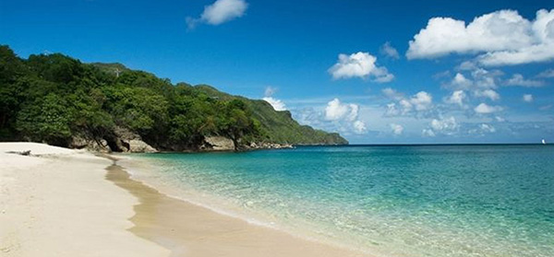
PRINCESS MARGARET BEACH
Called this since her honeymoon swim here in 1958, it is a short walk over the bluff from Lower Bay. Here you will find calm, clear sea and white sand with shade from trees along the beach, good swimming and some snorkelling. Head to Jack's Bar for lunch or a cold beer as you watch the sun go down

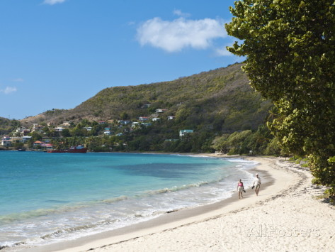
FRIENDSHIP BAY
Easy access by vehicle or walking, there are restaurants and beach bars, a long sweeping white sandy beach with shade on the Atlantic side with sometimes more movement in the sea, but waves rarely more than a foot high, also good for snorkelling along the right hand side nearer the village. Lovely views of Mustique across Whale Cay (The Whaling Station), Semple Island and Petit Nevis beyond.

HOPE BAY
Hike in to this remote picturesque semi-secluded romantic white sand beach, good for body surfing. As there are no facilities don't forget to take water and a picnic. Be careful as sometimes there is a strong undertow, an offshore current and a powerful surf.

RAVINE & ROCKY BAY
Hike in to this secluded dark sand beach, picturesque with rough surf, a blow hole, and no facilities but some shade, on the Atlantic side.

INDUSTRY BAY (CRESCENT BEACH)
Hike in or come by vehicle to this semi-secluded white sand beach with a restaurant/beach bar, shade from palms, snorkel sites and picturesque with generally calm waters as it is protected by a reef from the Atlantic waves. Cottagey, whitewashed rooms sit on the beach next to a green tin-roofed building housing a bar and restaurant.

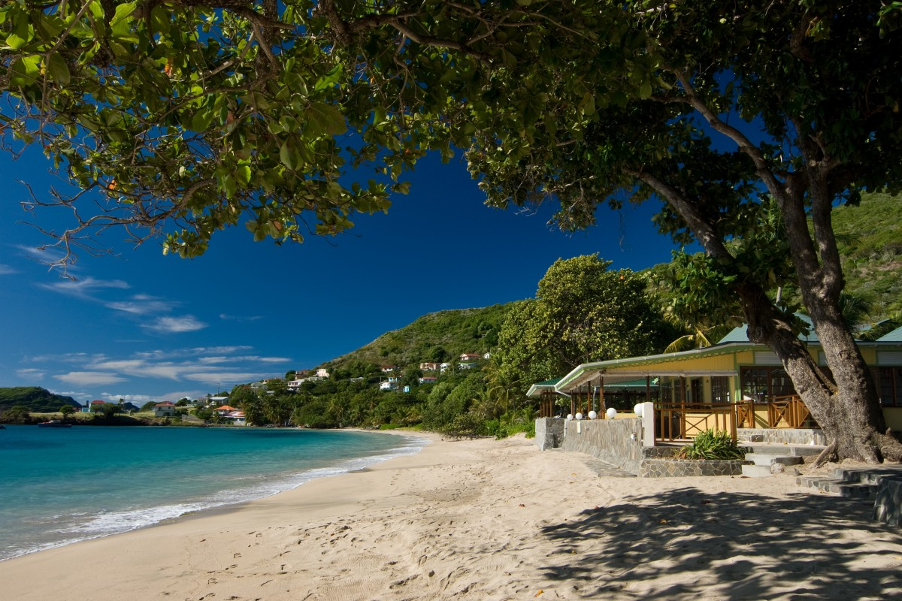
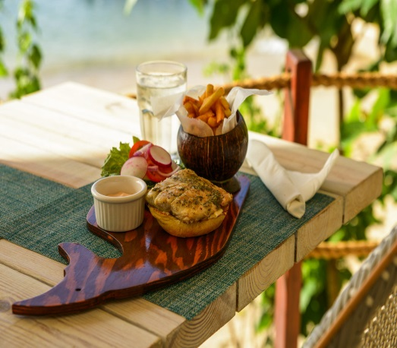
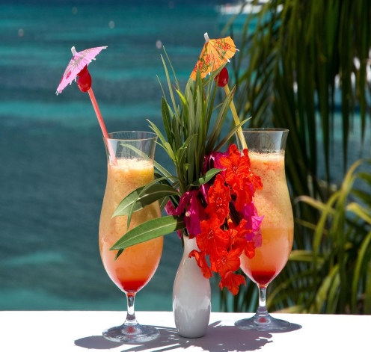
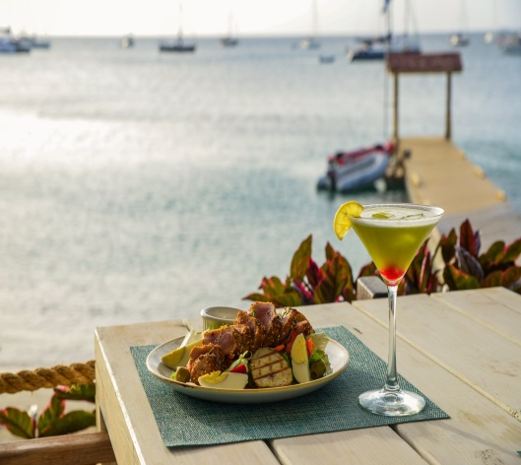

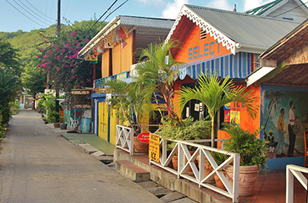
SUPERMARKETS / SHOPS / ATM

There are a few small supermarkets on Bequia and several food stores selling everything from fresh bread and cheese to breakfast cereals and milk. Fresh fruit and vegetables are available from the friendly vendors who have their stores and tables along the main street and for the experienced haggler you can venture into the Rasta vegetable market for a colourful and memorable shopping experience. Several of the small restaurants also have an adjoining store selling everyday items like fresh bread, tinned produce and frozen goods.

GROCERIES
Doris Fresh Food, Port Elizabeth Tel: +1 (784) 458 3625
Knights Trading, Port Elizabeth Tel: +1 (784) 458 3379
Knights Mini Market, Hamilton Tel: +1 (784) 458 3152
Lina’s Bakery & Deli, Port Elizabeth Tel: +1 (784) 458 3181
Mac’s Pizzeria, Belmont Tel: +1 (784) 458 3474

There are two 24-hour ATM machines in Port Elizabeth at the BOSVG bank.

RESTAURANTS AND NIGHTLIFE

Bequia has a number of great restaurants, bars and cafés. Whether your preference is for international or regional dishes, there is sure to be something for you. A selection of excellent eateries serves everything from simple snacks and light bites to full Caribbean lunches and delicious fine dining. Freshly caught seafood including fish, lobster and conch is always a great option, but you will find everything from Italian pizzas, American hamburgers and world class French cuisine.

OWNER’S RECOMMENDATIONS
JACK'S BAR, Princess Margaret Beach
Cuisine: Caribbean, Seafood
Tel: +1 (784) 458 3809
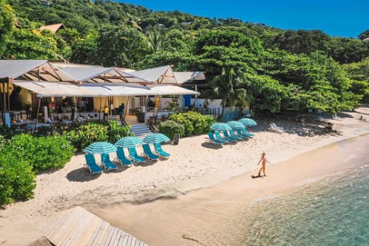
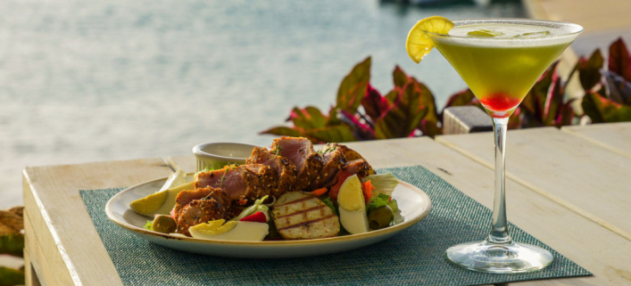
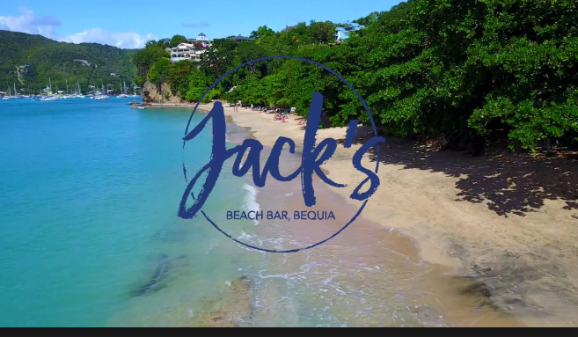
Web: www.jacksbeachbar.com

MAC'S PIZZERIA , Belmont Walkway
Cuisine: Pizza
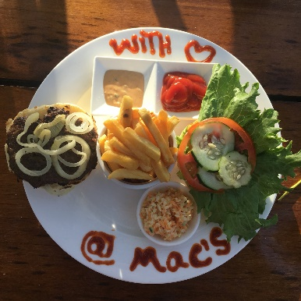
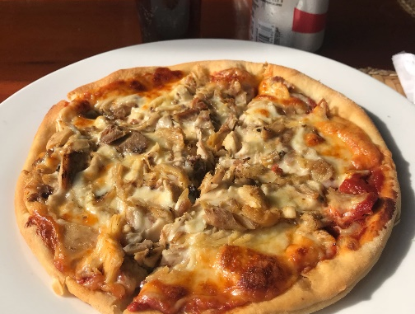
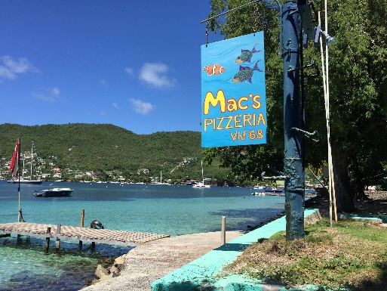
Tel: +1 (784) 458 3474

MARIA'S CAFÉ, Port Elizabeth
Cuisine: Caribbean
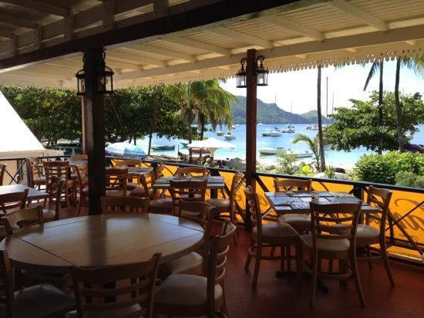
Tel: +1 (784) 458 3116

THE LIMING, Near Sandrock | Cuisine: Caribbean | Tel: +1 (784) 5330398

COCO'S PLACE, Port Elizabeth | Cuisine: Caribbean | Tel: +1 (784) 458 3463

THE FIG TREE, Belmont Walkway | Cuisine: Caribbean | Tel: +1 (784) 457 3008

FIREFLY PLANTATION, Spring | Cuisine: Caribbean | Tel: +1 (784) 532 5134

FRANGIPANI HOTEL, Belmont Walkway | Cuisine: West Indian | Tel: +1 (784) 458 3255

GINGERBREAD, Waterfront | Cuisine: Caribbean | Tel: +1 (784) 458 3800

KEEGANS, Lower Bay | Cuisine: Caribbean | Tel: +1 (784) 458 3530

WHALEBONER, Waterfront | Cuisine: Caribbean, Seafood | Tel: +1 (784) 458 3233

DAWN'S CREOLE, Lower Bay | Cuisine: Authentic creole cooking | Tel: +1 (784) 492 6508

CHERIS ROOFTOP TERRACE, Port Elizabeth | Cuisine: happy-hour food | Tel: +1 784 433 9054

DE REEF, Lower Bay | Cuisine: Caribbean | Tel: +1 784 528 4958

FERNANDOS HIDEAWAY, Lower Bay reservation only | Cuisine: Caribbean | Tel: +1 784 458 3758

PROVISION, Lower Bay | Cuisine: Global flavours | Tel: +1 784 431 0457

BAGATELLE, Bequia Beach Hotel | Cuisine: internationally inspired | Tel: +1 784 458 1600

LAURAS, Port Elizabeth | Cuisine: Caribbean | Tel: +1 784 457 3779

“COCKTAIL LAB”, Bequia Marina Ocar, only drinks no food | Tel: +1 784-433-8218

“Figtree”, Belmont waterfront | Cuisine: Caribbean, Seafood | Tel: +1 784 457 3008

It is always best to make a reservation for restaurants.
In the low season they may change opening hours or reduce the menu.

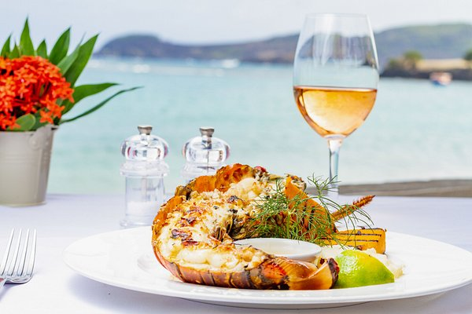

ATTRACTIONS / ACTIVITIES

THE BELMONT WALKWAY & PRINCESS MARGARET TRAIL
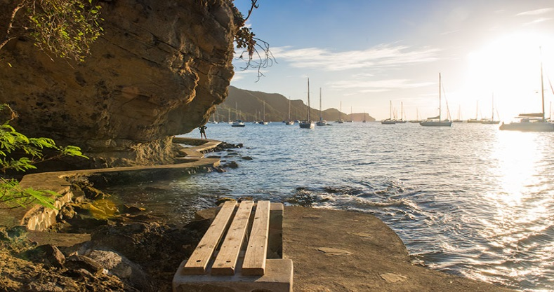
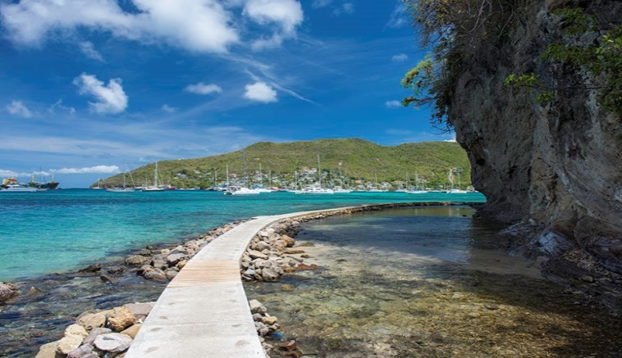
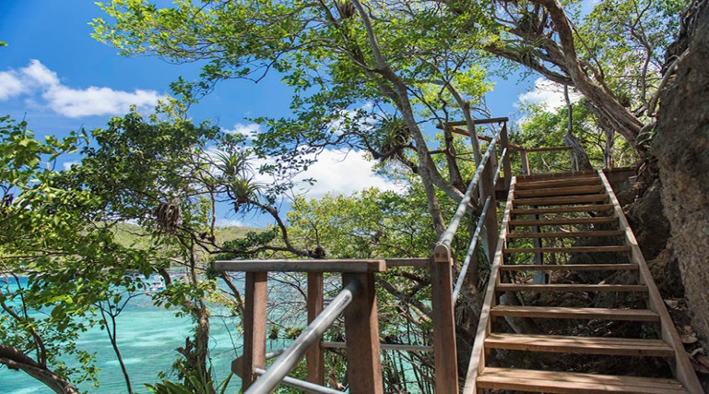
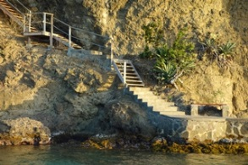
Restored in 2012 by Action Bequia, this stunning beachfront walkway is now a major attraction in Bequia. The trail has been extended over headland to Princess Margaret Beach and people can now walk close to the shore, all the way from Fort Hamilton to Lower Bay and Beyond. Over 3 miles of heritage and natural beauty. The new Princess Margaret Trail is not only better than the road, it competes with the best coastal trails in Barbados, Mustique and other world class destinations.

HAMILTON FORT
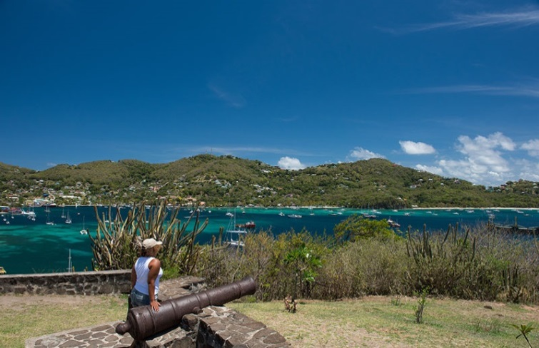
Hamilton Fort was used by the British to protect Admiralty Bay. The cannons are the only remnants of this powerful ancient Fort. Today the location is a popular spot for photographs and views of the Island, one can easily see why the British choose this location. While visiting Bequia ask for a tour or enjoy a walk to the Hamilton Fort.
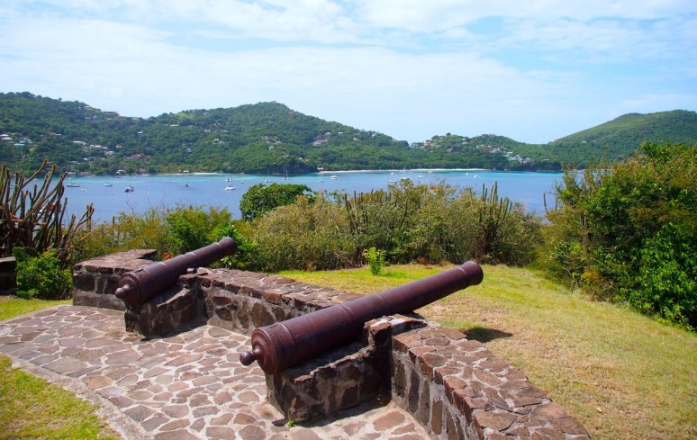
TURTLE SANCTUARY
Email: oldhegg@vincysurf.com Tel: +1 (784) 458 3245 or +1 (784) 458 3596
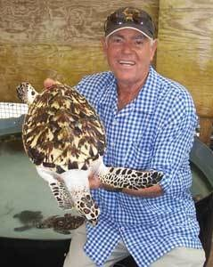
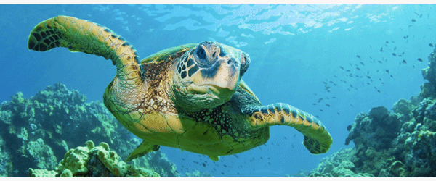
Bequia is home to an amazing turtle sanctuary run by Orton (Brother) King. This extraordinary man has dedicated himself to saving the Hawksbill turtle from extinction and his sanctuary has been in existence since 1997. Only one hatched turtle in a thousand survive in the wild – Orton’s work is to rescue threatened hatchlings and raise them in safety for three years then release them into the ocean. So far he has released more than 2,000 thus making huge progress in his bid to save this turtle from extinction. The sanctuary is a must to visit.

BEQUIA'S FIREFLY PLANTATION
Email: fireflystatebequia.gmail.com Tel: +1 (784) 532 5134
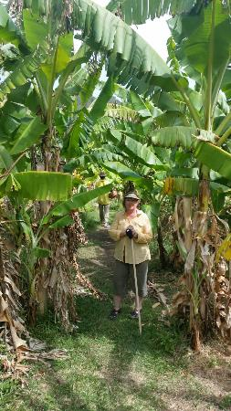
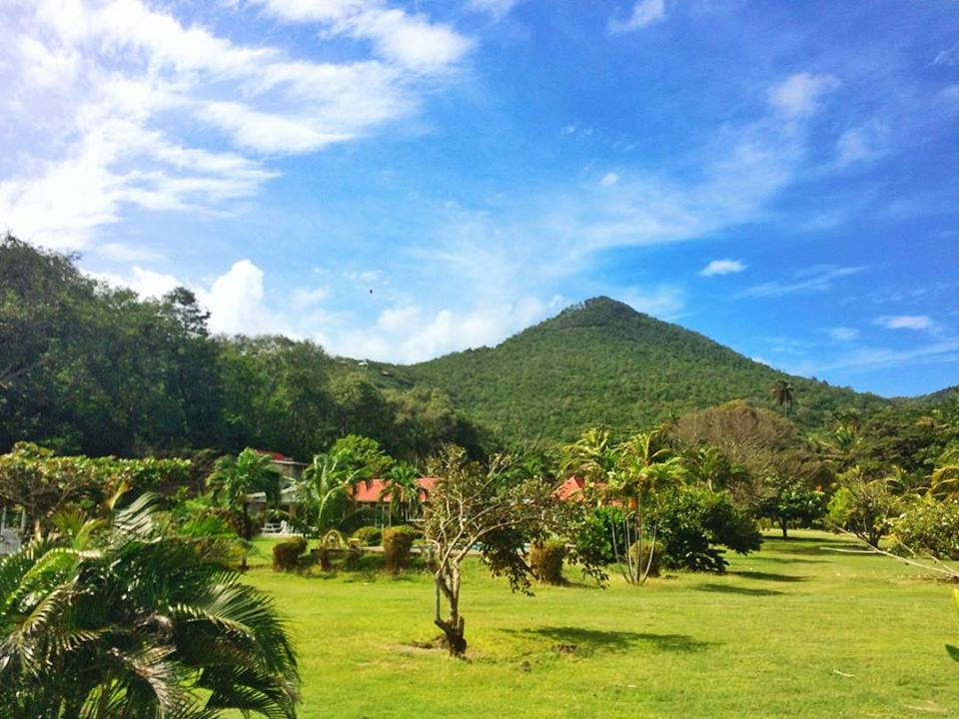
This 200 year old working plantation overlooking Spring Bay used to have a 19th century sugar factory whose ruins stand at the entrance to the Firefly Hotel. Wide lanes of swaying coconut palms still grace the access path to Spring Beach and beyond. Enjoy a leisurely guided walk through the grounds with the head groundsman who will give a brief history of the plantation and sugar mill. Sample fruits and vegetables in season and learn about the various crops, herbs and flowers.
THE BEQUIA HERITAGE MUSEUM Tel: +1 (784) 532 9544
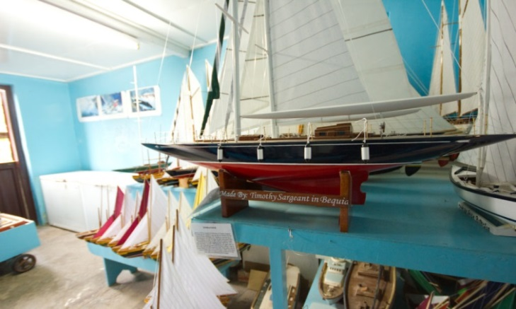
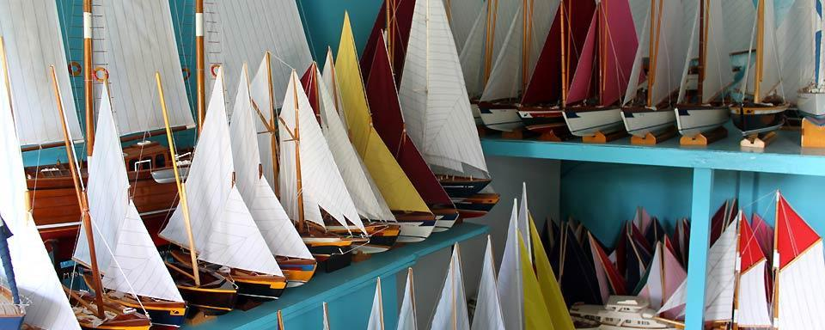
The Bequia Maritime Museum is located on the road from Port Elizabeth to Hamilton. Here you can enjoy an informative guided tour and learn how our Scottish ancestors introduced the art of boat building, as well as how the tradition of whaling began and continues to this day.

MOUNT PLEASANT
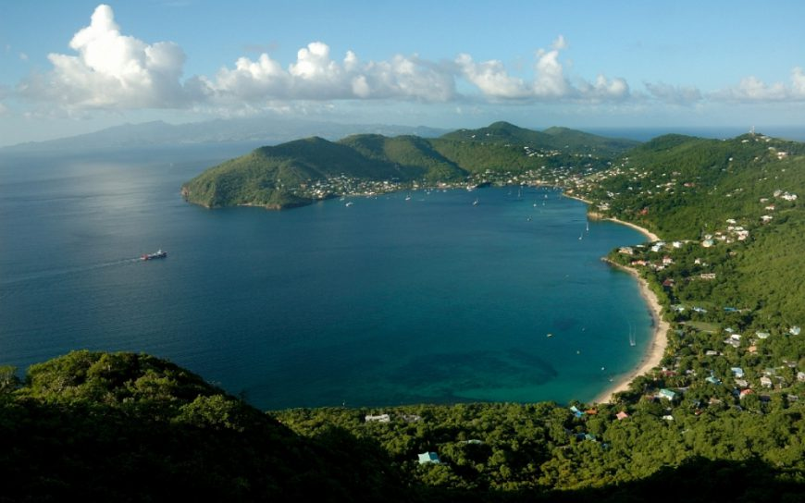
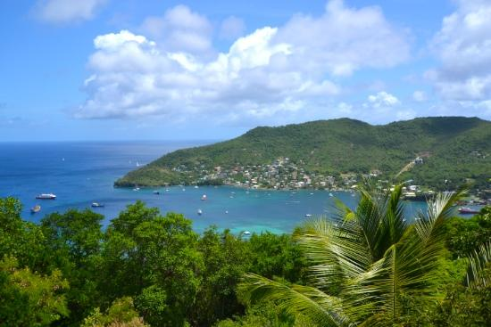
The highest point on Bequia is Mount Pleasant at 760 ft / 231.7 m. the 360° view from the top is well worth the trip and the area is popular with locals and visitors. Stop at the sugar hill bar and restaurant near the top for a cold beer and enjoy a view from St. Vincent to Canouan. You will soon appreciate why so many fine homes are built at the top of this mountain.
PAGET FARM
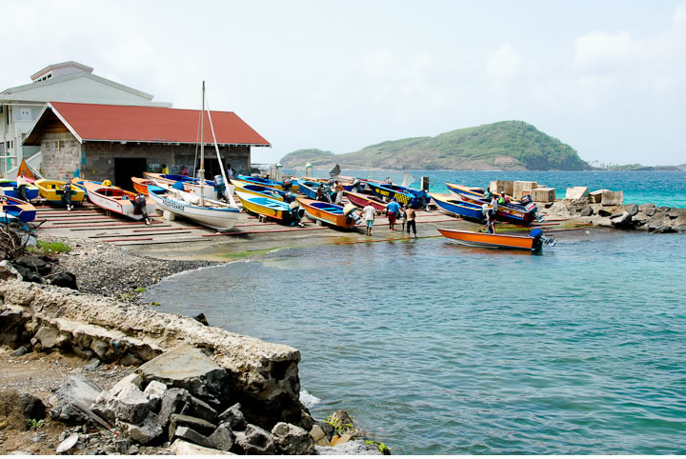
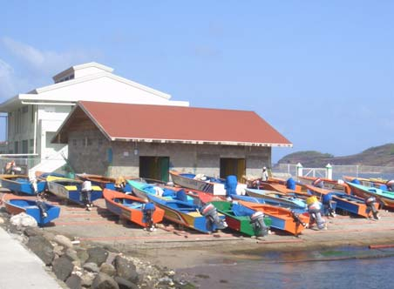
A small fishing community near the airport, and home to the Banana Patch Studio featuring scrimshaw and other artwork, is another worthwhile stop. At Paget Farm, you will be sure to see the colourful fishing boats lined up outside the fish market. If you can arrange a trip to Petit Nevis you can see the old whaling station and find out more about Bequia’s whaling tradition.
PORT ELIZABETH
The heart of Bequia, along the shores of the harbour in Admiralty Bay, is its capital Port Elizabeth - the main location for shops of all types, mostly clustered along "Front Street". New signposts, installed by the Bequia Tourism Association, will help you find your way around.

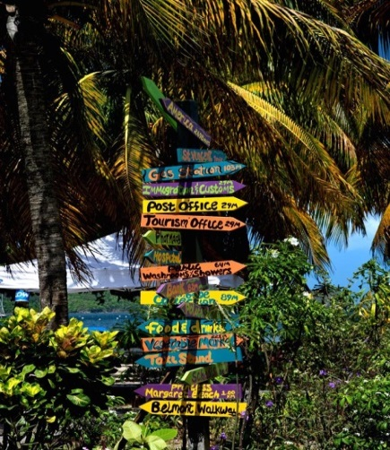
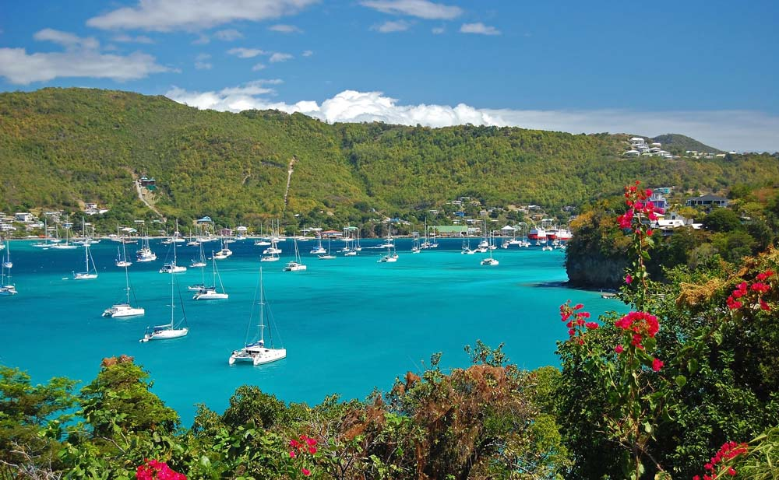
The main dock in the centre of the town bustles with activity when the ferries arrive and unload their passengers and daily supplies. Everything, from building supplies to groceries, arrives by boat.

DIVING
There are over 30 excellent and easily accessible sites in the sparklingly clear waters around the island or within easy reach, offering drift dives with intriguing caverns and holes, walls and overhangs, all teeming with wonderful coral formations and marine life. For the more experienced diver, exciting wreck and night dives are also available.

For those seeking a slightly less adventurous but no less fascinating experience, snorkelling trips are offered by all Bequia's Dive Shops, with equipment available for hire or purchase.

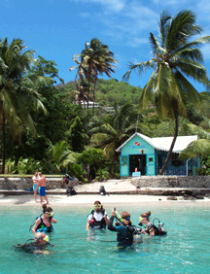
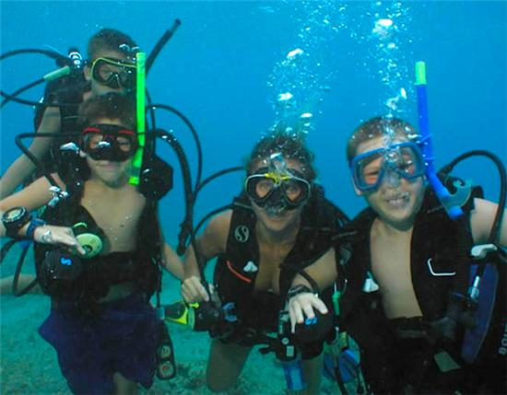
Bequia Dive Adventures
Tel: +1 (784) 458 3826
Web: www.bequiadiveadventures.com
Dive Bequia
Tel: +1 (784) 495 9929
Web: www.divebequia.com

WATERSPORTS
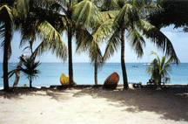
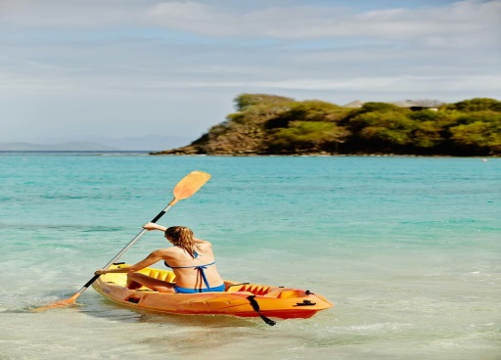
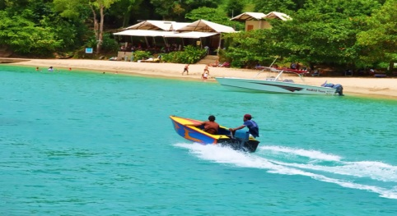
With the Trade Winds providing almost year-round breezes, and brisk winds in the winter, Bequia offers great conditions for windsurfers. Windsurfers and kayaks are available for rent from several outlets, and lessons can also be arranged.

FISHING
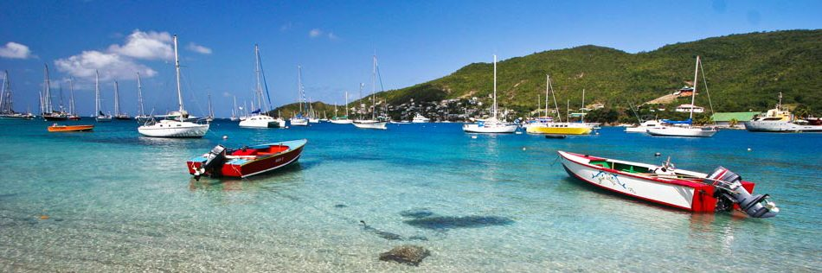
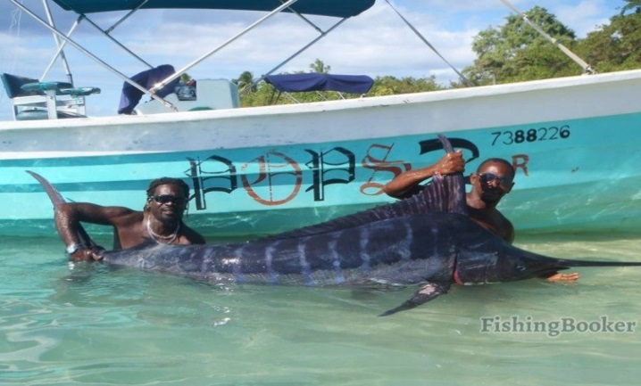
The waters surrounding the island are inhabited by various fish. Along the coast of Bequia, you can fish marlin, kingfish, tuna, mahi mahi and barracuda among many others. You can choose between different levels of fishing. If you just want to relax, you might want to keep it simple, and in that case, all you need is a line and a lure. If you are a skilled fisher, and need more advanced equipment, a boat and professional help around the Belmont Walkway and Paget Farm.

SAILING AND CHARTERS

Bequia has a long tradition associated with the sea, from boat building to fishing, from sailing the Caribbean Islands to Bequian’s crewing on cargo and cruise ships around the world.

The Grenadine Islands are an absolutely stunning cruising ground and if you would like to visit another island while you are here, by sail or by power boat, you will be rewarded with an exhilarating experience and a wonderful day out.

Friendship Rose, 100ft Local Classic Sailing Schooner
Tel: +1 (784) 495 0886/9
Web: www.friendshiprose.com
Email: friendshiprose@mac.com

For catamaran day/overnight trips – contact “African”
Email: captainsimmons@hotmail.com

For speedboat day trips / fishing trips/sunset cruises – contact Michael Tours
Tel: +1 (784) 4976448/4551154
Web: www.michaeltoursbequia.weebly.com
Email: michaeltoursbequia@yahoo.com

Gusto, 54 ft. Trimaran
Tel: +1 (784) 458-3884
WhatsApp: + 1 (784) 433-1371
Email: GustoBequia@gmail.com

Octopus Yacht
Tel / WhatsApp: + 1 (784) 432 5201
Email: hello@octopus-caribbean.com

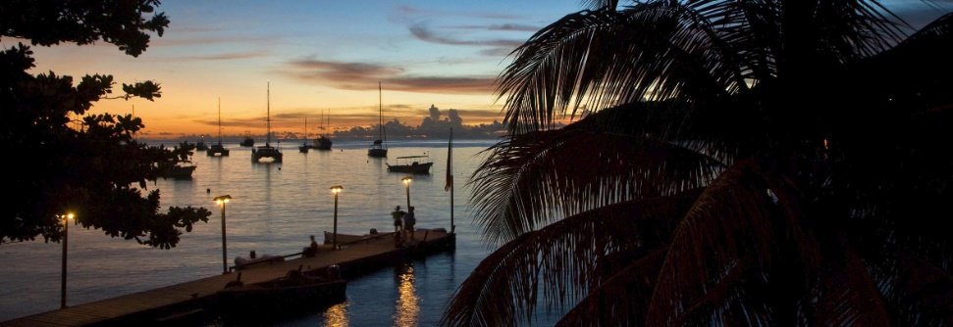

CALENDAR OF EVENTS

BEQUIA MOUNT GAY MUSIC FEST – JANUARY

One of the hottest and coolest festivals in the region.

The Bequia Music Fest started in 2000 when the BTA worked with Basil Charles to bring his world-famous Mustique Blues Festival to Bequia for one glorious evening in January.
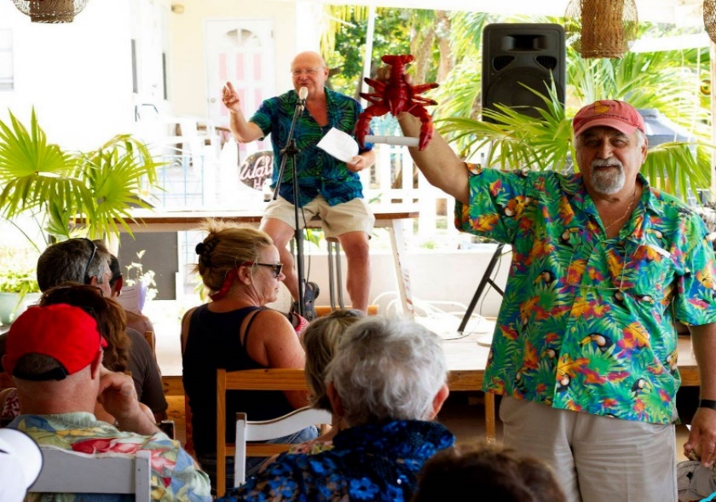
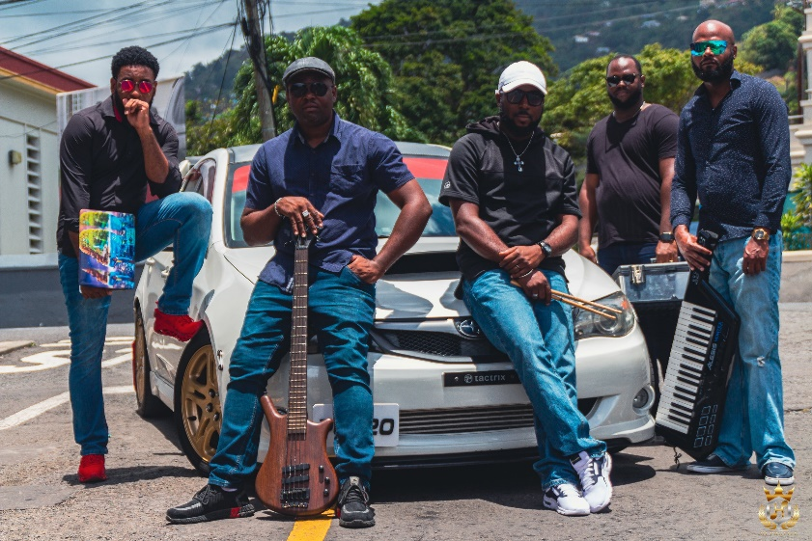
In the ensuing years, the Bequia Music Fest expanded into a four-day event, still including one night of world class Blues from the Mustique Blues Festival, but also with a wide range of international, regional and local artistes of all musical genres coming together to bring a feast of entertainment to the islands' and nations' residents and visitors alike.

SUNSHINE SCHOOL AUCTION – FEBRUARY
The Bequia Sunshine School for Children with Special Needs holds its annual Sunday fund-raising auction in mid-February. This very special school is a privately funded educational institution administered primarily by a local board of directors. Currently the government pays the salary of one teacher only; all other costs have to be raised by private donation and fundraisers - thus the need for funds is constant.

The annual auction is now in its 20th year and is fast becoming one of the most fun events of the season. Items for the auction, and for the Jumble Sale which follows later in March, are all donated by well-wishers and energetically
amassed and sorted by the auction organisers
in the weeks before.

There could be literally anything up for sale - jewellery, antique prints, art work, clothing, furniture, household items, marine items, donated dinners and services and handicrafts made by the students at the school are all likely to be on offer.

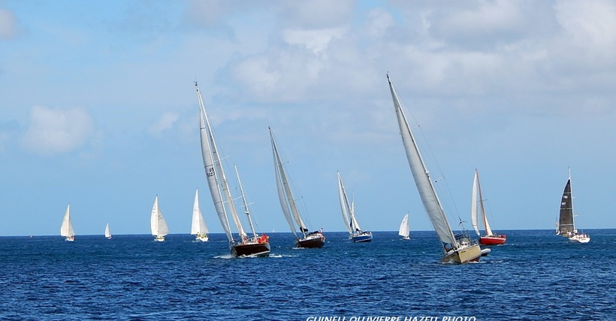
ANNUAL EASTER REGATTA – MARCH/APRIL
Bequia's Regatta is rightly famous for its unique blend of local boat racing, yacht racing shore side activities and Bequia hospitality.

A fleet of more than thirty traditional local boats from Bequia and her neighbouring islands compete out on the sparkling waters around Bequia.
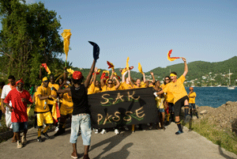
It's a fabulous, colourful weekend, full of fun and camaraderie, skill and tradition, with the whole island caught up in regatta fever. Sunday's Regatta Lay Day on Lower Bay beach sees a grand fete for boatloads of visitors from the mainland, while Friendship Bay Beach hosts a family Layday with Sandcastle and Crazy Craft competitions, and easter activities organised by regatta sponsors Bequia Beach Hotel.

BEQUIA CARNIVAL – JUNE
Bequia Carnival takes places at the end of June, and is a delightfully informal and spontaneous affair.
With St. Vincent's "Vincy Mas" now the nation's premier tourism event, Bequia's own Carnival looks set to move forward as well and become a true small island carnival and a permanent fixture in the island's cultural calendar.
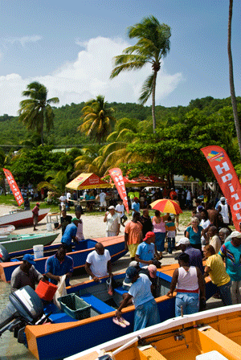
FISHERMAN’S DAY – JULY
If Bequia Regatta is a celebration of Bequia's traditions of boat-building and seamanship, Bequia's Fisherman's Day is a lively and fiercely contested demonstration of the island's abundant skills at harvesting the waters that surround the island.
Once again the Rotary Club of Bequia are the organizers, with the famous "Rotary Wives" doing a fine job in cooking up the catches and providing delicious fresher-than-fresh barbecue and baked fish lunches, complete with rice'n'peas, dasheen, yams, plantains, green bananas, coucou, breadfruit and coleslaw.

NATIONAL NINE MORNINGS CHRISTMAS FESTIVAL - DECEMBER
The unique Vincentian cultural tradition of "Nine Mornings" is enthusiastically celebrated in Bequia. For the nine nights before Christmas, music, singing and revels takes place up and down the island in an exuberant countdown to Christmas.
Nine days before Christmas musical activities and carols often take place under the Almond Tree - sometimes starting at 4am in the morning - to the surprise and delight of many visitors longing for a good carol or two!
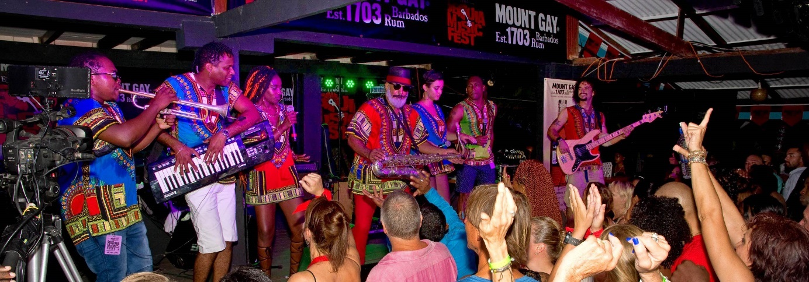
Bequians take their carolling very seriously. Shortly before Christmas groups representing the islands villages and communities compete in an evening carol competition attended by most of the island and its visitors.

CHRISTMAS
The only thing that is missing from Christmas on Bequia is snow! The Christmas spirit is the same on the island - good will and season's greetings abound, families and friends get together, and shops are full of unusual gifts and delicious treats. Midnight services on Christmas Eve at both the Anglican Church in Port Elizabeth and the tiny Catholic Church in Hamilton welcome all worshippers.

On Christmas Day, as on Christmas Eve, hotels and restaurants offer traditional Christmas fare with all the familiar trimmings - with that extra West Indian flair.

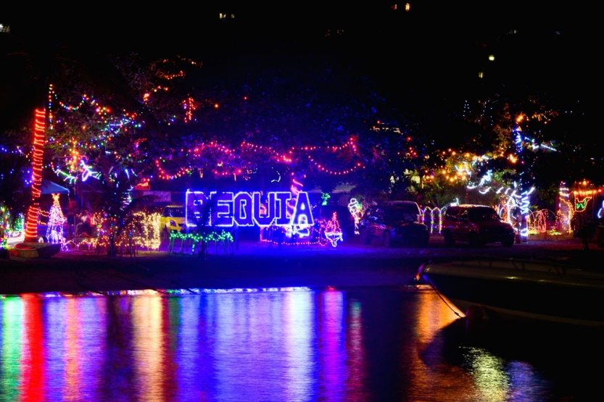
NEW YEARS
New Year's Eve in St. Vincent & the Grenadines is more commonly known as Old Year's Night, and Bequia really knows how to "ring out the old and ring in the new"!

The harbour fills with visiting yachts, and ashore there are celebrations in every restaurant and bar - all the stops are pulled out for this one special night of the year. A spectacular firework display over Bequia Harbour is the highlight of the evening. Made possible by the generosity of private individuals and Bequia's business community.

ST VINCENT AND THE GRENADINES

A necklace of 32 islands and cays, only nine of them inhabited, St. Vincent and the Grenadines is one of the most popular destinations in the world for leisure sailors, who flock here for its numerous uncrowded anchorages and charming ports of call.

BEQUIA
The largest of the Grenadines islands has only one real town, Port Elizabeth; it's a charming, sleepy port of call with a pedestrian footpath that stretches around most of the bay. Shops feature the works of model shipbuilders.
CANOUAN
Home of Grenadines Estate Golf Club; a challenging and exhilarating Jim Fazio 18 hole championship golf course with every hole overlooking the Caribbean Sea. Deemed “Best Golf Course” (Robb Report, June 2005).
MAYREAU
Just northeast of the Tobago Cays; this tiny 1.25 sq. miles island has scarcely 300 residents, but its lovely palm-lined beach, Saltwhistle Bay is dreamy and magical.
MUSTIQUE
This renowned 1,400-acre private island in the Grenadines is known as a favourite hideaway for the world's most discerning travellers. Scattered around the island are 74 extraordinary designer villas each with its own distinctive architecture and atmosphere.
PALM ISLAND
135 acres of tropical paradise; this island houses the exclusive Palm Island Resort with its huge expanse of tropical white sand beach, shaded by cooling palms.
PETITE ST. VINCENT
Home of the ultra-exclusive Petit St. Vincent (PSV) Resort; the island offers the ultimate in barefoot elegance and unobtrusive attentive service.
TOBAGO CAYS
Justly famous for its protected waters is a favourite with yachters and has been identified as a national marine park. The waters of the Tobago Cays are populated with sea turtles which provide friendly swimming companions, making the experience of swimming in the Tobago Cays a magical and memorable one.
UNION ISLAND
With its colourful market and mountain peaks is the ideal place for provisioning your yacht. The island also is a great jump-off point for visiting the nearby Tobago Cays.
YOUNG ISLAND
Situated on this tiny island, just 200 yards off the southern shores of the mainland (St. Vincent). The resort is a haven for rest and relaxation but guests can take part in a range of watersports, sailing, hiking and other activities.

ATTRACTIONS/ACTIVITIES

FORT DUVERNETTE
Beautiful Fort Duvernette is located south of mainland St. Vincent. It is a 195 foot high volcanic plug comprised of hard columnar basalt. It is also known locally as ‘Rock Fort’. One can find two batteries with cannons, which were constructed during the colonial era of St. Vincent and the Grenadines, for the defense of the then important town of Calliaqua. The site is also rich with flora and fauna.
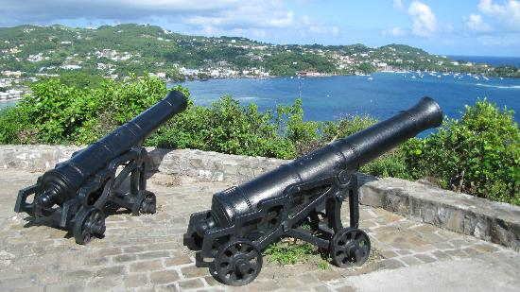

TOBAGO CAYS MARINE PARK
The Tobago Cays Marine Park (TCMP), located in St. Vincent and the Grenadines, houses a series of globally significant habitats including coral reefs, sea turtle nesting sites and feeding areas, and small systems of mangroves. The marine portion of the park surrounds five uninhabited cays, the populated island of Mayreau, and three islets. The four-kilometer long Horseshoe Reef, the longest of the four main reef systems in the TCMP, encloses four of the cays (Petit Bateau, Petit Rameau, Baradal, and Jamesby) with the fifth cay (Petit Tabac) lying just outside the reef to the east.

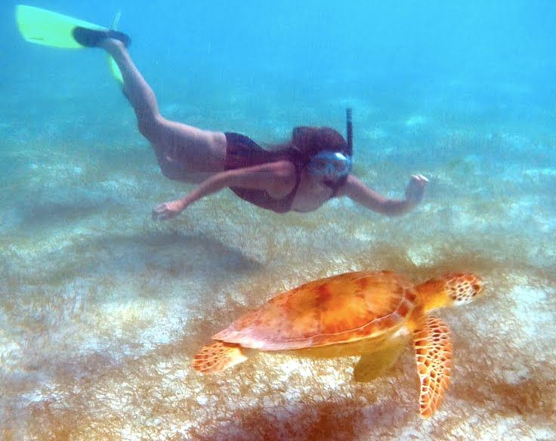
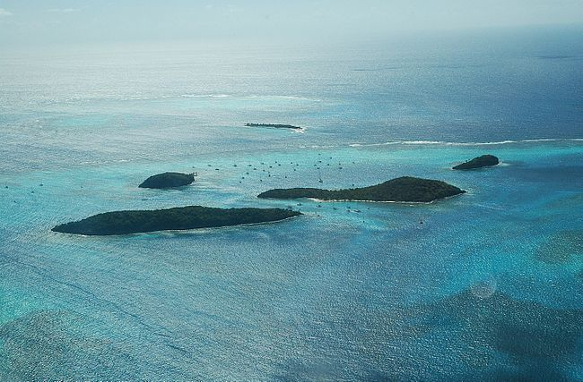
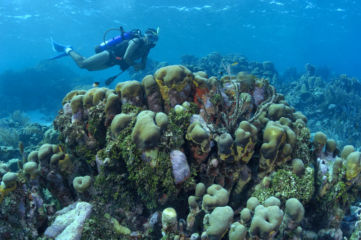

MONTREAL GARDENS

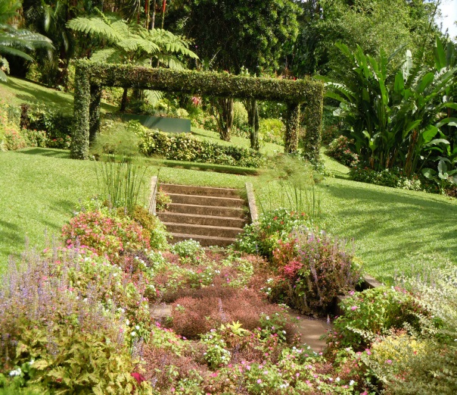
The St. Vincent Montreal Gardens is located at the Montreal Estate, and this attraction is a must see for anyone who enjoys lush natural beauty and a variety of plants. These gardens are situated at 1,500 feet above sea level, and they are surrounded by the rain forest and banana plantations. The Montreal Gardens cover seven and a half acres of the island and the public is always welcome. There are 3 different sections of garden to walk through. The Rain Forest Garden, the Colour Garden, and the Formal Garden all offer something different and appealing to visitors, and each has its own charm and a variety of plant species.
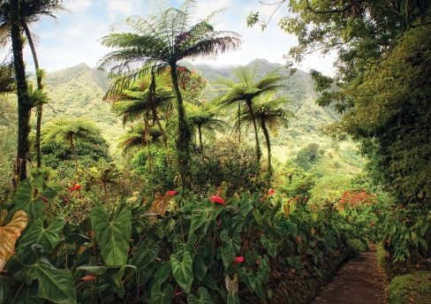
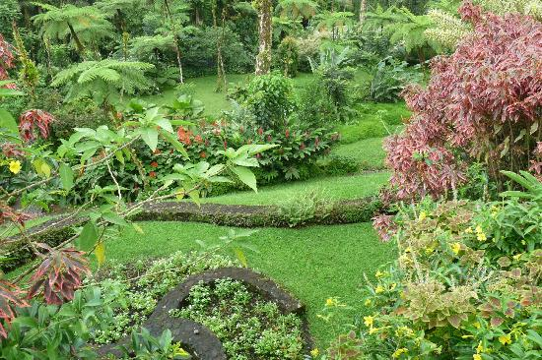
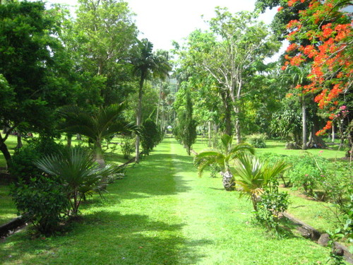

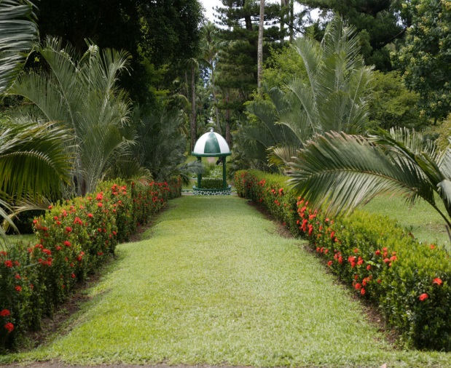
BOTANICAL GARDENS
Occupying 20 acres in St Vincent,, the Gardens were created in 1765 by General Robert Melville, governor of the British Caribbean islands, as a plant breeding centre and 'to provide medicinal plants for the military and improve the life and economy of the colony'. Three acres were set aside for the established of a Government House. The Botanical Gardens is the oldest of its kind in the western hemisphere, and celebrated its 250th anniversary in 2015.
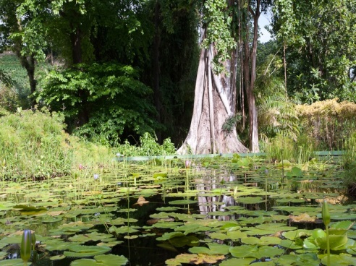
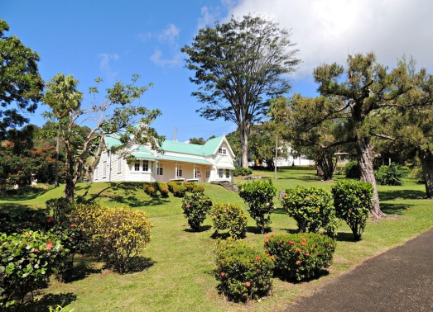
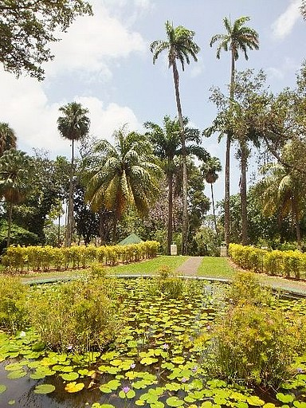

Thank you for choosing to stay at Sandrock Villa!

Please leave us a review and we hope you see you again.
